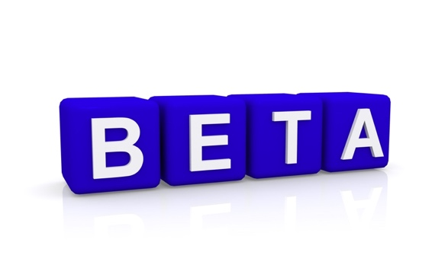

Beta Reading for Non Fictional Work

David R Tollafield

A bit of preamble 2

What is a beta reader? 6

How detailed should you make your reply? 11

In the next section I have highlighted a few steps as a guide. 11

Five steps to critique 12

Galley 13

Indexing 14

# A bit of preamble

This guide is for non-fiction and forms a different basis for fiction. There may be some similarities between the two but this guide will focus on the first.

Why on earth do you want to become a beta reader? Now you may not want to read this but as an author I take beta reader contributions seriously and so the guide is to help you. Of course should you be put off already, that’s fine. No harm done but failure to engage provides no benefit for either of us. The work or manuscript is draft, rough and so do not expect it to look like the final copy. You are receiving a piece of work that has been developed to a particular level.

The first question might be **What’s in it for me?** This is a fair comment as you are going to spend time on a task that might be alien. Authors are rarely wealthy; maybe only the top 5% make the type of money associated with Harry Potter or Star Wars. Perhaps 15% do very well but turning writing into wealth is not so common.

Fiction versus non-fiction

Writing fiction is one thing, but non fiction is a whole new category and most non fiction writer / authors don’t write for money but for personal satisfaction or to help the profession or business. A writer might produce a manuscript; an author is a writer who has his or her work published. Many manuscripts do not see the light of day!

Fiction of course is made up stories that may or may not have truth, accuracy or be based on facts. Non-fiction takes the opposite position and should ideally be current.

The work should mean something to you as the beta-reader. You want to do this or have a vested interest in the subject matter. You know the author personally, most likely but not necessarily. Being involved might be sufficient motivation. Developing a new skill perhaps might be your motivation?

Being the first to read something is exciting especially if the book takes many months to reach the sales platform. You will be provided with an acknowledgement; your name will be in print in the book. A free version is provided, more personal collaboration if you are asked to write the Foreword, and subsequent copies can be purchased at a lower price than the retail sales price. The e-books often come out before the printed version and so there can be a time lag. Having said this, I now look to order a pre-published copy and make my amendments and launch from a bound copy as this helps me check page numbers and formatting as I do all the formatting myself.

Become part of a unique club ‘Hi-Star’.



As someone signed up to my mailing list you can see any new materials being offered, or you may want to beta read another book. You can also cite your contribution in your **Continuous Professional Development** profile.

Busypencilcase Communications Ltd will provide a certificate after the work has been completed as this is part of a professional’s capacity to stay up to date. Just ask if this is something you would find helpful.

Hi-Star contributors follow the author and open up articles and materials or are valued existing reviewers. I like to look after my Hi-Star member and offer them free books or discounts where I can. They also can receive first sight communications of publications.

Find your own words in print

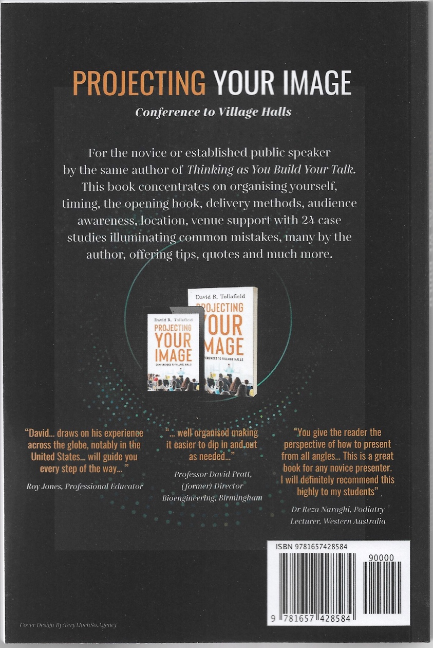Nothing is more satisfying than seeing your own words in print. It is important to respond with something that can be quoted, in part or whole. This is used as part of the blurb or promotional advertising. If you are uncomfortable then please make sure you say this at the outset. Publishing is a fickle market place and we need to boost our product as much as we can. The product being the book, the message and the story.

You will be asked to provide an Amazon review and rate the book after production and have received your copy. This is not a condition but a hope that you will feel promoting the book helpful. This guide will help you in your endeavours.

The back cover (illustrated) shows three reviewers, but you will be used on Amazon’s pages as well and on other forms of publicity. The box and text below represent a book on Hallux Valgus published in 2019. Two beta-readers were used in publicity.

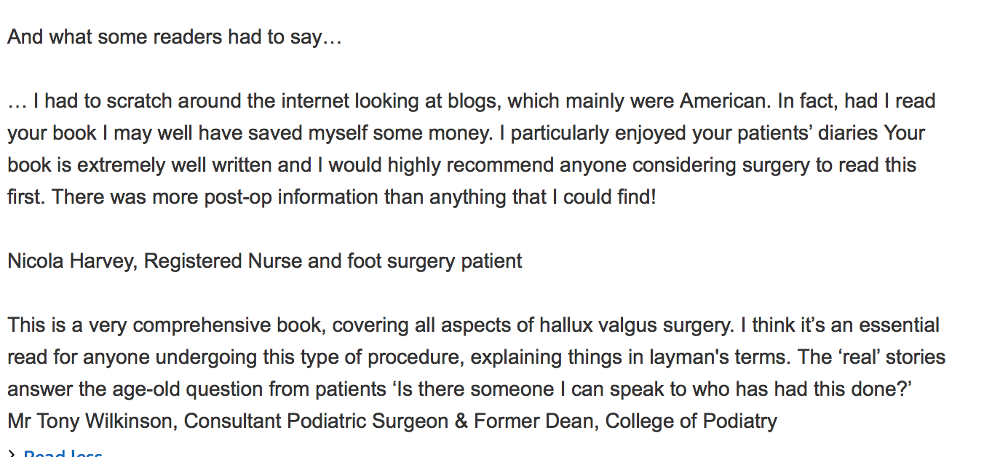

# What is a beta reader?

Editorships & Proof Reading

The **copy editor** is a professional who does the job of polishing the manuscript for a living and produces guaranteed work set to a deadline for financial payment. They will most likely be a published author. They will check facts, alter words to improve sentence balance (punctuation) and change structural layout. This is all part of their role. The **developmental editing** is to do with plot, sequence, smoothing out the direction of the story so it hangs together. The role of copy and developmental editing often overlap. **Proof reading** is usually undertaken simultaneously but can be a separate action.

As a beta reader, you are not acting as a copy editor, developmental editor or even proof reader. These are official terms for tackling manuscripts for authors and are more formal in their execution. Clear contracts need to be made, which for our beta reader is way too complicated.

Of course you participate in many of these activities and one reviewer, who looks over academic work, provided tracked comments against the text section found in Word under REVIEW (as shown). This will be repeated again on page 10. Tracked comments are fine if you wish to use this system but there is no mandation or expectation.

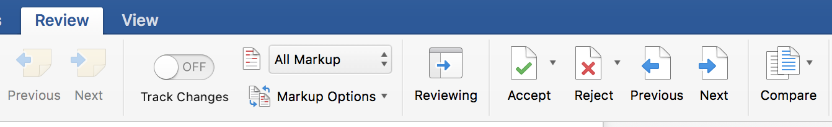

And so while a beta reader does perform similar tasks to the copy editor and proof reader, you are not being asked to correct English or make literary changes unless you wish to. You could look at the task as though you were market testing written prose. Do the lyrics match the melody? Page 11 and Five Steps to Critique may assist you further.

Draft

The manuscript that you receive is a work in progress and is not complete. The word not is underlined because as a writer I make mistakes and do not write a perfect manuscript. However, I will have removed a fair proportion of material that would be unlikely to reach the final draft. You can add more brush strokes to give it colour and dimension. Drafts are often raw and may appear unrefined because they contain the first workings of a person’s mind. Leave a piece of bread out and it will grow mould. Under the right conditions the mould may be the penicillin of life, so a draft will develop a growth because when it is read for a second time, mistakes are easier to identify. This is the writer’s secret and so with any delay the reviewer and writer have an opportunity to improve. Some drafts will already have gone through this penicillin process as most writers won’t let anyone handle a draft manuscript until they feel it is near to the finished but not polished point in manufacture. So draft is not polished and final polish is done at the copy editor stage.

Timescale

The main obligation is timescale. If you cannot get around to finishing a beta-review, then it is better to say so because the production of a book may well be delayed. The advised time scale will be provided. If the deadline is missed and a reminder ignored the author will move on. This is not personal, just good business. Most writers do not mind you asking for longer but just say so. As a rule, I would not ask anyone to return a copy earlier than 4 weeks although I have had beta readers turn work around fast but this is not essential.

Accuracy

The content does need to be accurate and a beta-reader is chosen to ensure ambiguity or plain confusion does not jump out of the page. Is the explanation clear and accurate in what it intends to convey? It may be that you do not completely agree or see where the writer is going and so when looking at several reviews, if more than one person spots a glaring error, then this validates the point. It is best to mention something at the beta-reading stage so that the writer can re-script. This is what a good writer cum author must do.

It may surprise you that everyone has a book in their ability but most people can only write one manuscript so that it never sees the light of day. This happens for a good reason; it comes down to - embarrassment in sharing. Once you overcome this hurdle and accept useful critique then the next hurdle is easier.

**Responses from a beta-reader**

This was a person who had agreed to review written material as a lay reader when reviewing non-fictional work. There IS no financial remuneration and there ARE no legal obligations, but there is a certain etiquette to decline if you feel unable to perform the task. The other obligation is to be honest in your appraisal.

This comes from a trusted beta reader…

**I feel very honoured that you trusted me with your latest literary baby**

These are responses that are helpful as they touch on both diplomacy and effective critique. There is an important message given to all writers, ‘show don’t tell.’

These comments **SHOW…**

‘I’m going to be frank – because I don’t know any other way to be!’

‘I am acutely aware that writing styles need to vary because not everyone needs or wants to consume content or indeed learn in the same way. So what follows are just my observations as a reader of one certain type.’

‘Personally I would love to see more sub headings. There were sections that were titled as being about x, I started off reading about x and part way down you were discussing something that wasn’t x and I had not realised we had moved on to a different area.’

‘The stories you tell to emphasise your points had me laughing & cringing in equal measure.’

‘…struggled to follow the flow of the content, or thread together the different elements of the text.’

‘…I found the chapters wandered round the houses & I was left having to tease the action points or key learning points out for myself.’

The most important part about feedback is to be helpful so that you leave in a little bit of your own preference for the author to be able to re-draft your ideas. In this way you will become part of the book that is being created. Writers will make many drafts during the course of their efforts to bring words to print.

First drafts are usually not sent out but if they are then the crude or raw edges might be visible in any case. The idea behind a first draft would be to see if the general thoughts might appeal to the prospective reader. It is more usual to send out a reasonably correct draft.

Suicide is not one of the writer’s intentions. However, there will still be crude aspects embedded that will need to be smoothed over. The writer is exposing himself here so please allow a little leeway.

A beta reader becomes part of the design, flow and eventual production. I wrote to one reviewer stating an important assurance;

‘It is my rule never to respond to a beta reader to justify why I had done this or that as frankly I believe this rude and a sign of weakness over one's writing…

Thank you so much for completing your review in such an honest and open way…

If all reviewers were this helpful it would save enormous problems later on. I did note that you almost seemed apologetic in part of your reply, for which there is no need.’

Truth in attempting to be kind can have a negative effect on the final production. Here is a professional comment on the subject of health.

‘… I am not too sure about the value of including the wound pictures, they seem a bit gratuitous in a way and I am not sure that patients would really pick up on the fact that this is a very temporary appearance.’

In the case of the above comment, 80% of the original pictures were in fact removed. The comment had great value.

# How detailed should you make your reply?

As detailed as you wish is the answer.

The more information the better. You can write a summary on a word document, post an e-mail back or provide a tracked response. Again, the bar below shows the method of using tracked comments but these are not essential and you can use whatever method you wish. The format is Microsoft Word.



Tracked comments

Beta readers have persuaded me that this is an effective way and without doubt it ensures all parts of the manuscript are considered, but it takes time and time that you may not have.

I know I have mentioned this earlier, but if you want to correct spelling, sentences that fail to make an impact or make sense, say so. Your input is no less valid but to help you manage your time you can keep to a focused script. All feedback holds equal value.

The writer will pour through each of your comments and adjust the manuscript. This improves the copy before it goes before an editor. When you see the final production you may see a very different book and this is because the author will also add new material and thoughts as much from your input as from other areas. In a recent book following beta reading the effect of Covid-19 this became topical in one chapter whereas before it would not have featured.

**Please never** return manuscripts in a **PDF format**.

# In the next section I have highlighted a few steps as a guide.

# Five steps to critique

**Overview**

Look through the manuscript, cover (if supplied), content, introduction and try to get a feel of the book without indulging in heavy reading. How does it feel? Please do not worry about formatting and also note your copy may not have a cover, index or images. It will have a content to show you the direction of flow. Are there sufficient words and material for each chapter/section? Is the prose too long? Could the explanation be simplified? The table below allows comparisons between different book styles. My non fiction books are between 30,000 – 50,000 as a guide. My latest for 2021 is +80,000 as an autobiographical memoir cum novel.

|  |  |
| --- | --- |
| Type | Length in words |
| Short story | <7,500 |
| Novelette | 7,500-17,500 |
| Novella | 17,500-40,000 |
| Novel | >40,000 |
| Autobiography | 80,000+ |

**Read every word or speed read?**

Well that is up to you and your method of reading. I often write reviews and have to read carefully and double back to check. Unless it is a formal academic text book for professionals, the narrative should flow freely without too much effort. The intended message provided by the text should be clear.

**Design of the book**

Layout or design provides comfort in navigating the pages so the content (index if present. P.14) should help. Drafts usually do not have indexes only content lists. E-books tend to have links embedded so you can move back and forwards easily without flipping (P.13). Often I leave these in and it is useful to check that they open up. Chapters or sections should divide up logically and should be helped by the contents page.

**References, glossary and footnotes**

E-books are less dependent on this format as it is easy to click a link to the internet with Kindle, tablets and Smart phone products. Academic texts may have formal referencing. Other works may have an author’s note which helps to identify the source.

**Figures, plates, illustrations**

Such additional information can be powerful and aid the text. Do comment if this is helpful or not. Tables and lists can be added here as Fig.Y or Table. X. Do these add anything or not?

**Galley[1]**

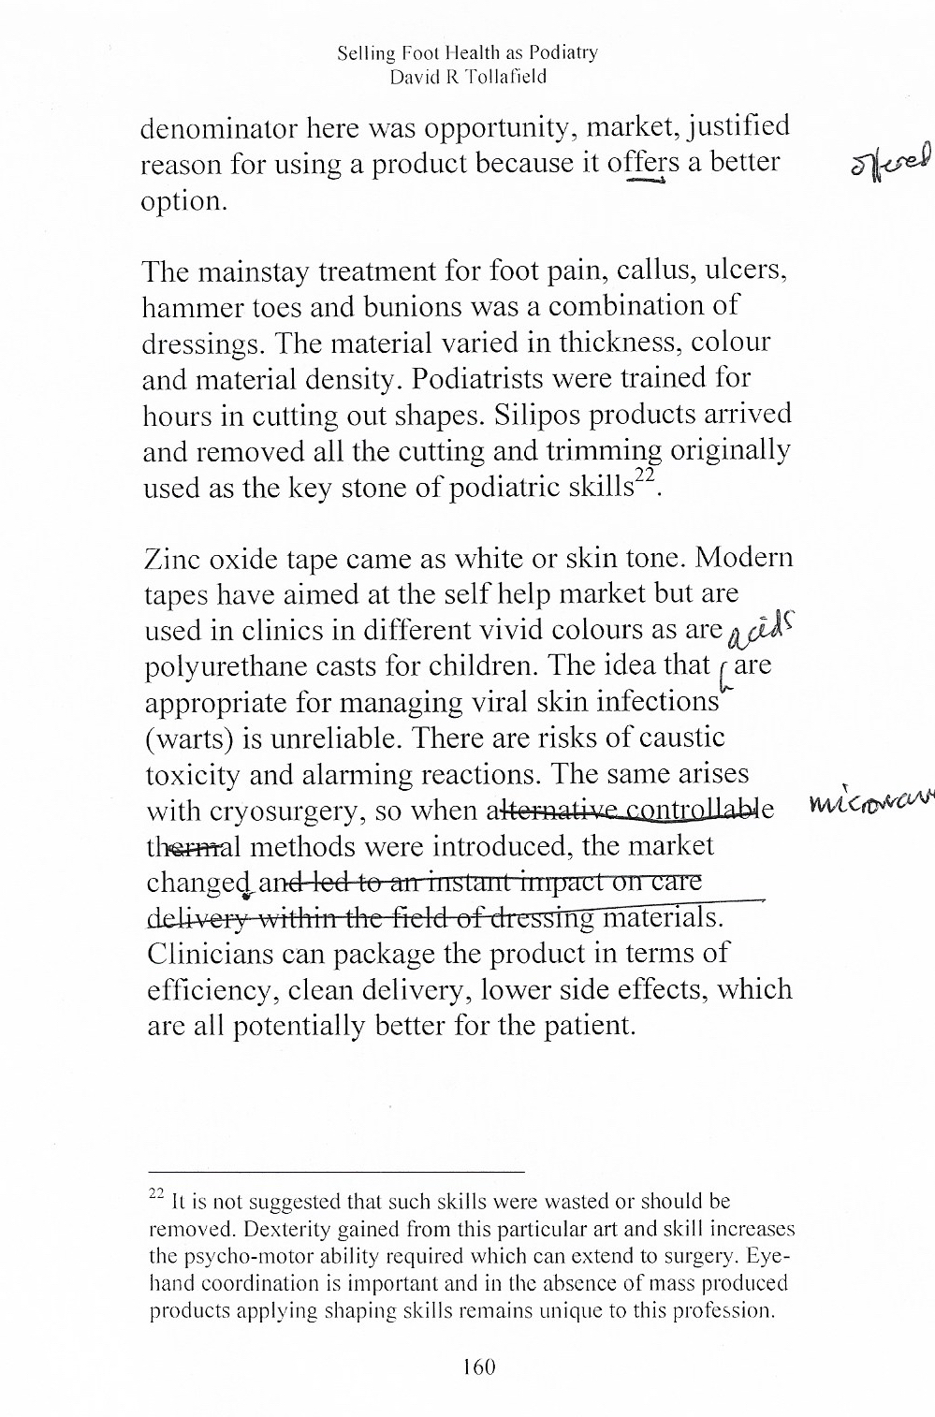

**Working from hard copy**

It can be valuable to receive a galley or pre-published format. The text is laid out as it will be trimmed but sits on the larger A4 page in the case of this book’s size (5x8”).

Going through the final copy is undertaken as one of the last checks. If you receive a galley there is plenty of room to mark a hard copy or to use the review page.

Fine tuning goes right up to the last minute and the example shown is after a proof reader or editor might have been involved. The serious author still has to critique everything and if it does not look right, it never will unless corrected.

# Indexing

On the next page you will see an index and it is clear that this has little value to the reader for smaller books with few pages, while the **content**is much more helpful.

**Footnote**

On the previous page I have used a footnote as an example of how a different method of content extension can be used. Are these of value or not?

Where material is not explained in the text, audiences that may have less extensive knowledge can benefit from a **footnote**, especially for abbreviations. You will see the footnote method has been used with the galley page 160

**Internal linking**

Content is hyperlinked internally to allow navigation between pages. This is intended only for e-books as is external linking.

**External linking**

External hyperlinking is valuable and prevents a need to expand a particular subject within the text saving pages, but leaves the reader with the option to advance their knowledge.

Example [hyperlinking](https://www.google.com/search?client=safari&rls=en&q=hyperlinking&ie=UTF-8&oe=UTF-8).

The highlighted area often in blue is known to most people and has an embedded link or code known as an URL, which when clicked over takes the reader to the intended webpage.

This only works for the e-books but can be used for YouTube video or even Podcasts. Links of course disappear if anything on the webpage changes. The beta reader can check links for the author who will find it helpful if something does not work. When used as a PDF however the links disappear.

A

accurate 7

aid the text 11

Amazon review 5

Authors 2

B

back cover 5

beta reader 2, 6, 8, 9

C

copy editor 6, 7

D

Drafts 6

E

error 7

F

feedback 8, 10

fiction 2

final polish 7

G

galley 12

H

Hi-Star 4

L

lay reader 8

Layout 11

M

manuscript 2, 6, 7, 10, 11

money 2

P

pdf format 10

pictures 9

publicity 5

Publishing 5

R

responses 8

S

sales platform 3

show don’t tell 8

T

timescale 7

tracked comments 6, 10

W

wealth 2

writer 2, 6, 7, 9, 10

writer’s secret 6

Thanks for reading and agreeing to become a beta-reader

1. While 5x8 is commonly other formats sizes such as 6x9 offers better options for images