Shins Splints and Tendon Dysfunction

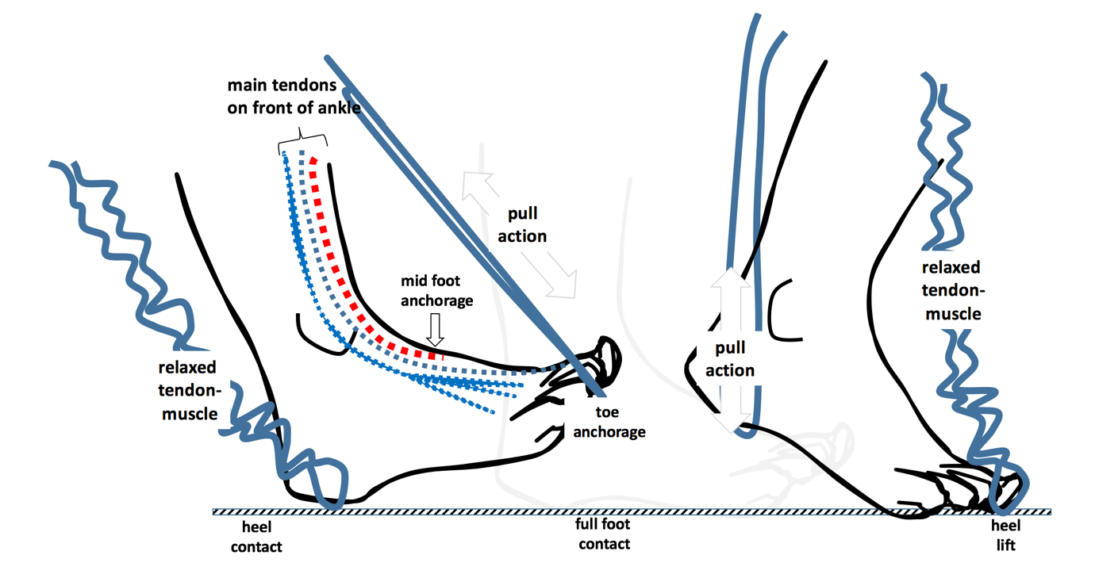

Downloaded from www.consultingfootpain.co.uk

