Corticosteroid Injection for Podiatrists
A little bit of reflection

Ian N Reilly
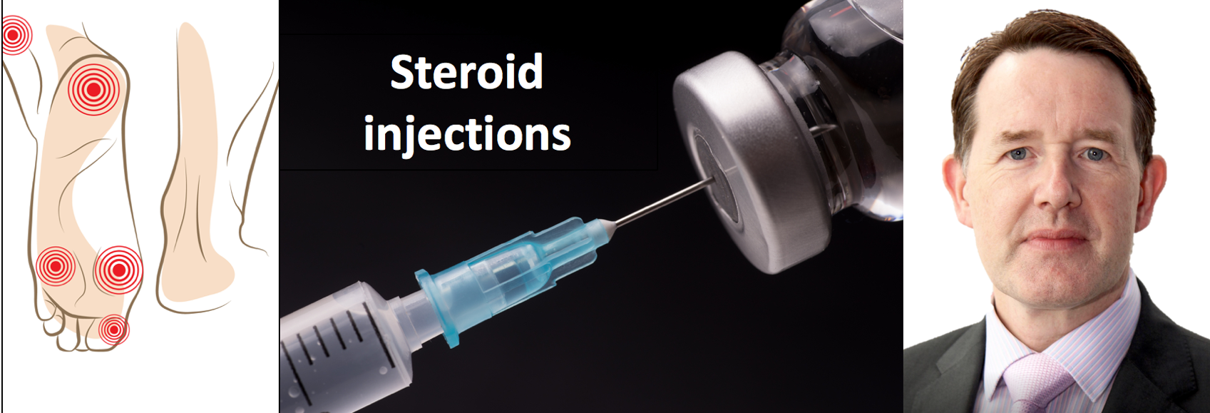

The author of this month’s reflective podiatric practice is well known in the arena of steroid injections and has run many courses in the UK for podiatrists. As with local anaesthetic skills back in the seventies it is imperative for sufficient practitioners to upskill. Podiatry is only one profession amongst several who will take on this extended skill. However, as with so many courses, learning the basics is elementary. Obtaining sufficient hands on experience starts to become the main problem. In this article Ian makes a focus on the all too common soft tissue complaint of plantar fasciitis as well as joint injections. Common concerns arising with injections are highlighted as well as featuring the all important written information.

Introduction

T
his paper will give a brief overview on corticosteroid injection therapy (CSI). The art of successful injection therapy is to place an appropriate amount of an appropriate drug into the correct location at the appropriate time. Following my own extensive literature review applying corticosteroid injection therapy for plantar fasciitis (PF), I came up more questions than answers. While in this reflective piece I have been able to answer some of my queries, some I have not, while others may appear more transparent.

‘Every needle has a sharp end that goes into the patient and a blunt end that is attached to a health care provider. Anyone who thinks that all the action occurs at the sharp end does not understand human behaviour.’ Loeser JD (2004)

Was the diagnosis of PF clear?
Was CSI therapy treatment needed?
Which is the best drug to use?
What injection technique is best, with regard to approach and dosage?
What is the exact point of infiltration?
Is peppering of use?
Are results better with diagnostic imaging guidance?
What are the post-injection requirements of the patients?
When are subsequent injections given?
What are the long-term outcomes – are recurrences noted?
How common are the complications?

Table 1: My Plantar Fascia Questions

Pharmacology and Pharmacokinetics

The endocrine system produces hormones: a chemical secreted by a cell - or group of cells - into the blood for transport to a distant target, where it exerts its effect at very low concentration. The term “steroids” refers to two groups of naturally occurring hormones, synthesised mainly in the adrenal cortex and the gonads: the corticosteroids and the sex steroids. We are interested in glucocorticoid activity which has an effect on carbohydrate and protein metabolism and the immune system.
Glucocorticoids are characterised by their ability to bind with the glucocorticoid receptor. On reaching the target tissue, steroids cross the lipid membrane and bind to inactive glucocorticoid receptors (inside the cell) which exist in a complex with heat shock proteins in the cytoplasm. Steroids exert their effects by modifying the rate of gene transcription and hence protein synthesis. It is this class of steroid we use to treat foot pathology.
In inflammatory conditions of the joints, where there is synovitic inflammatory activity intra-articular injections relieve pain, increase mobility, and reduce deformity. Joints are not the only target for injections where full aseptic precautions are essential. Any infected areas should be avoided and although this may appear an easy distinction to make, and therefore exclude, this is not always the case.

Injections can be a magic bullet for some patients but their use should be carefully considered…

Evidence

Injection therapy is one of the most common therapeutic interventions in musculoskeletal healthcare. Injection therapy for the treatment of joint pain has been performed for over 60 years, and yet there is a paucity of good evidence regarding their use. The challenge is to apply the available evidence in a safe and effective manner. The literature on corticosteroid injection therapy suggests little systematic evidence to guide the type of medication selection for therapeutic injections. The medication used - and the frequency of injection - should be guided by the goal of the injection.

My questions

Diagnosis

This comes from our skill from ingrained patient assessment. If you plan to inject PF with a steroid injection, make sure you have the correct diagnosis. Have a list of differential diagnosis as you take a clinical history. Narrow your list by the end of your history taking and from a thorough physical examination.
Re-visit your differential diagnosis using any appropriate investigations such as X-ray, ultrasound or magnetic resonance imaging (MRI).
Anatomical knowledge is crucial both for accurate diagnosis and proper needle placement. If your knowledge of anatomy is poor, they you cannot seriously attempt corticosteroid therapy.

Is corticosteroid therapy required?

We inject steroids to resolve pain, improve mobility and function. It is important to appreciate that we can also use injectable steroids for their diagnostic value. By relieving pain at a particular anatomical site, this provides valuable confirmation of the provisional diagnosis. The therapeutic value aims for a one shot, complete cure, but it can also provide a temporary window of relieve while other treatment e.g an insole can take effect.
Lastly episodic pain can be relieved in chronic cases and perhaps is repeated more often than acute cases.

What is the best drug to use?

There are a range of drugs available to the practitioner which fall into two categories; soluble versus insoluble drugs and short acting versus long acting drugs. The choice of which drug to use is guided by clinician preference for both drug and dose. From my experience I have found methyl prednisolone for soft tissue and hydrocortisone better and triamcinolone acetonide for joints.

What injection technique is best?

In order to answer this question four steps can assist the overall process.
Make a diagnosis, consider the treatment algorithm, consider the drug of choose, dose and whether it should be guided or not. Provide the injection in a suitable location and follow the patient up after a period of reflection.

The algorithm is based on a clear diagnosis, identifying whether this is the correct treatment pathway and that there are no other methods better suited.

The patient should be involved with these discussion and contraindications taken into consideration. All reasonable side effects should be explained and a clear unambiguous record made that side effects have been communicated and understood.

Injections can be a magic bullet for some patients but their use should be carefully considered as part of an overall treatment pathway or algorithm.

As corticosteroid therapy plays a big role in my management of PF, its use should always be considered as part of an overall treatment strategy. The contra-indications are included in the Table 2.

Intra-articular injection
Overlying cellulitis
Severe coagulopathy
Anticoagulant therapy (relative contraindication)
Septic effusion
More than 3 injections per year in weight bearing joint
Lack of response after 2 injections
Bacteraemia
Unstable joints
Inaccessible joints
Joint prosthesis
Osteochondral fracture
Overlying soft tissue infection or dermatitis

Table 2. Contra-indications to steroid injections – absolute and relative

Information to be given to the patient should include:
The diagnosis and nature of their condition
The details of proposed treatment and the alternatives
The nature and effects of drugs to be given
The most likely possible side effects and incidence
The likely benefits
Your plans for follow-up and after care

Table 3. Patient Information

Dosage considerations

As a typical rule of thumb, small volumes of steroid are confined to locations which include smaller joints and accordingly larger volumes of steroid for larger joints. Consideration should be given previous treatment.
Doses can be adjusted based on previous treatment. For example, if limited improvement has been given from a first dose of steroid, a higher dose might be considered for subsequent injections.

After care should include a patient information leaflet … Personalised information sheets can be detailed.

The Exact Point of Infiltration

Know you anatomy. Some techniques require the use of image guidance, for example under X-ray.
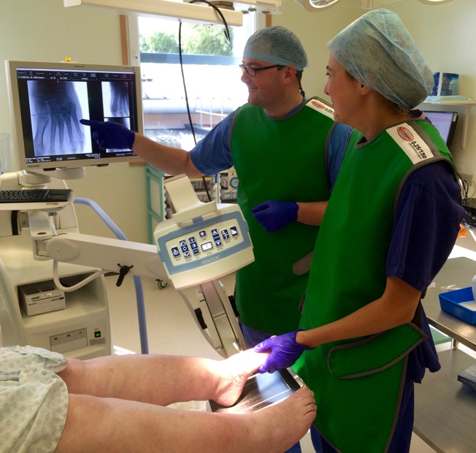

Fig 1. 2nd Tarso-metatarsal joint injected under C-arm.

The consent is always provided before the injection so they know what to expect and meet modern standards which includes providing discussion on alternative treatment.
Any allergies should be noted in regard to previous steroids. One drug may cause sensitivity while another one might not.

Recording data
The location should be noted with a record retained of the drug, dose and batch number. Any after advice and follow up should be included.

Other important considerations
Preparation includes cleaning the skin with a suitable preparation, preparing the syringe and vials, drawing up, needle selection and preparation of hands.
Safety is paramount and aspiration is used to avoid blood vessels and post injection leakage.
Special techniques include guided joint injections, injecting bursae and tendons as well as disposing safely any sharps.
After care include a patient information leaflet and ideally try to persuade patients to rest for 12-24 hours. Personalised information sheets can be detailed and their use (and content) recorded in the notes.

An inaccurate diagnosis is made
Steroid therapy is used inappropriately
An inappropriate drug is chosen
Too little or too large a dose is given
The drug is put into the wrong tissue
Poor technique allows the spread of drugs into adjacent tissues
Injections are given too frequently
Little regard is given to aftercare
Treatment is aimed at alleviating the symptoms without addressing the underlying cause

Table 4. A summary of problems associated with steroid injections

Side effects from the low doses used in injections are rare but can occur. The most common are:

- A steroid “flare” – pain at the injection site. This happens in 10% of patients. The pain can be quite severe but settles down in a day or two. Take over-the-counter painkillers if required, such as paracetamol.
- Facial flushing – this may occur 24-48 hours after the injection, but will settle within a day or two.
- Fat wasting – a small amount of sub-cutaneous fat may be affected by the injection leaving an indentation at the injection site.

Peppering as a technique
The use of repetitive needling has been considered effective for some conditions.

Results of injections

Different practitioners use different regimen following injections of steroids. Insoluble steroids such as methyl prednisolone tend to have more of an inflammatory response.
When patients are less active following injections, this inflammatory flare is less aggressive.
It may take days or weeks for the effects of the steroid to be noticed by the patient. I often say ‘wait 2 days to 2 weeks to see the effects”.
There is a wide view in the literature as to when to review the patient and if and when to re-inject. I schedule a review for six weeks post injection.
When the patient returns there are a variety of scenarios that may have occurred:
The patient could be much improved. The first metatarso-phalangeal joint is the joint injection I perform most commonly. Patients may return reporting 80% improvement in symptoms. The steroid also works as a plasticiser and very often and increase in range of motion is also noticed. At this point one can either discharge patients or keep them on a review only basis.
If the patient is partially improved, one can consider a repeat infiltration. An element of experience comes in as to how quickly to perform the second injection, how much steroid to use and whether to change the choice of drug. For those patients who are only moderately improved I will typically repeat the infiltration and review the patient in a further six weeks.
Where the patient shows no improvement, it is possible that the infiltration of steroid was not placed intra-articularly as you thought. It is possible that your underlying diagnosis was wrong. For both these issues consider the use of image intensifier and diagnostic nerve blocks. There have been times where I have repeated an infiltration where my only other recourse was surgery and on occasion, the second infiltration has had a beneficial effect where the first one did not. The practitioner must be aware of the potential for over dosage.
Unfortunately, patients may return and have an increase in pain and symptomatology following an injection. This could be due to a severe steroid flair or it could be due adverse trauma of the joint from the tip of the needle. In these instances, even if you wanted to re-inject, typically the patient would be disinclined to receive a further infiltration.

Summary

Corticosteroid therapy is a valuable tool for the podiatric practitioner when used correctly.
The practitioner requires:
- an ability to make an accurate diagnosis
- sound judgement on the appropriate use of steroid therapy
- technical skills with needles
All these skills are learnable with appropriate mentoring from an experienced practitioner.

Further Reading
Metcalfe, SA, Reilly, IN. Foot and Ankle Injection Therapies. Churchill Livingstone. 2010.
Kilmartin TE Corticosteroid Injection Therapy in Podiatry. CPD Insert. Podiatry Now 2017.
Loeser JD Point of view. Spine 2004;29(1):16

Previous related articles in Reflective Podiatric Practice

Tollafield, DR. The use of two injectable corticosteroids. July 2018
Tollafield, DR. Why does your treatment not always work? June 2019.

Correspondence

Ian Reilly DPodM, BSc, MSc, Cert MHS, DMS, MCPod, FCPodS, FFPM RCPS(Glasg),

Consultant Podiatric Surgeon
Department of Podiatric Surgery: Northamptonshire Healthcare Foundation NHS Trust and Private Practice
info@podsurgeon.co.uk

Advert
If you wish to submit a Reflective Podiatric Practice article, please send a word document to davidt@busypencilcase.com.

All registered UK podiatrists and students attending a recognised university for podiatry training can receive RPP. You can sign up through my website consultingfootpain.co.uk

