Biomedical Engineering versus Podiatric Biomechanics.

A Reflective view.

David Holland
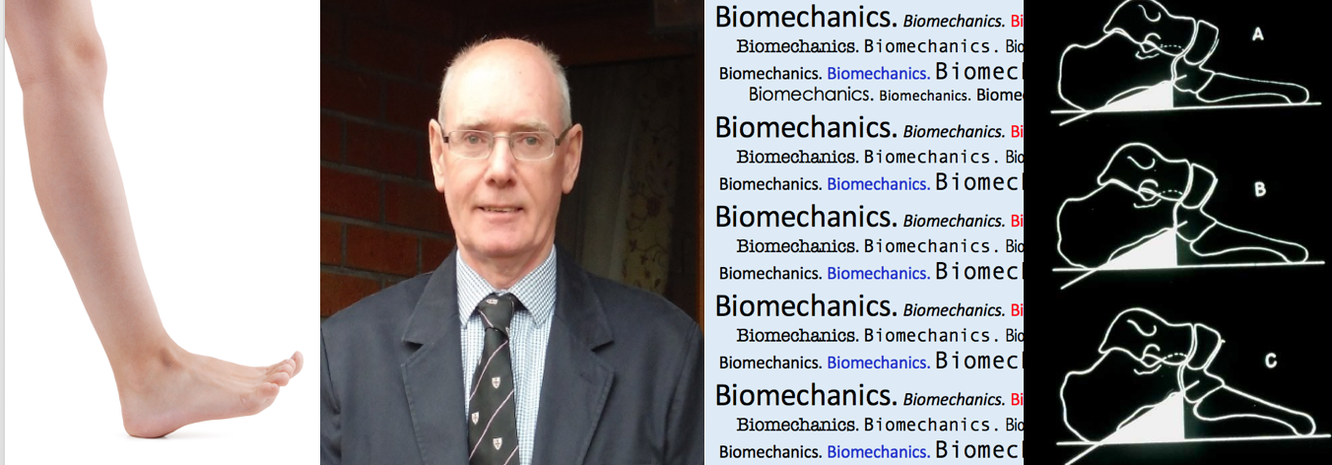

A
nyone who knows about bioengineering will appreciate the gap that exists between clinical podiatric biomechanics and purest theories relating to the science of kinematics and kinesiology. To simplify the ideas of physics acting on the foot was an important part of podiatric progress but since the seventies many elementary principles have been found to be flawed. David Holland lends a hand in providing his take on developments following his own studies allowing him to reflect on the past. [Ed.]

____________________________________________________________________________

Podiatric Biomechanics Theories.

What makes Bioengineering, also known as Biomedical engineering, different from Podiatric Biomechanics is an insistence by Bioengineering on scientific engineering principles in research and practice. These are the same principles used to ensure that bridges stay up, ships float, or artificial hip joints work.
Podiatric Biomechanics on the other hand is far less rigorous in scientific methodology. This was most clearly demonstrated in the 1970’s by the profession when it enthusiastically, and almost

without question, embraced a whole treatment paradigm based on a single research paper Axis of the Subtalar Joint (Root et al 1966). Subsequently Rootian theory, and the spin-off of Criteria of Normalcy (Root et al 1971) which purported to describe normal lower limb biomechanics, was widely criticized.
The obvious faults in the methodology of the seminal 1966 research paper by Root and co-workers of too small a sample size and too wide a variation in findings have been well-described by various authors over the intervening years.

Criteria of normalcy

1. In the sagittal plane the legs are perpendicular to the ground and parallel to each other.
2. The subtalar joints in both feet are in neutral, that is, neither pronated nor supinated.
3. The mid-tarsal joints are locked in their fully pronated positions.
4. The plantar surface of each foot rests on the supporting surface. All metatarsals bear weight, and the plantar surface of the forefoot lies in the same plane as the plantar surface of the heel.

Criteria of normalcy applied for static stance upon a level surface - summary

Testing for Criteria of Normalcy took place in the clinic or the gait laboratory. It is important to note that in both cases uniformly hard and horizontal floors are used. Criteria of Normalcy testing failed to recognise the wide biological variation of normal range-of-motion in the foot and ankle.
Variation of range-of-motion, as dictated by age and sex, was not taken into account (Ball & Johnson, 1996). Neither were the effects of undulating and/or soft supporting surfaces on foot posture taken into consideration, despite clear evidence of healthy feet being adaptable to many types of supporting surface (as shown by unshod holiday makers on beaches, or cross-country running, for example).
One interesting tenet of Criteria of Normalcy is that it dictated that at heel-strike the calcaneus should evert to vertical, or not much more than vertical.
In fact, the literature shows that the position of the ground-reaction-force (GRF) vector in the frontal plane in normal ambulation is through the tibia, which fits with the calcaneus everting only slightly at heel-strike (Adams & Perry, 1994). From there the ground-reaction-force vector moves laterally at midstance (Sliktar & Bo, 1995), and not medially as would be the case if the foot continued to pronate much past calcaneus-vertical. When collecting the GRF vector data, these gait studies, by necessity, due to the sensitivity of equipment, were carried out in a gait laboratory.
It is therefore reasonable to hypothesize that for maximum efficiency in both support and slow and rapid gait on a variety of surfaces the rearfoot should be capable of high flexibility in terms of pronation and supination, but that one of the frontal plane components of pronation – eversion – should be limited to only a little more than calcaneus-vertical to ensure a stable rearfoot structure, allowing the midfoot and forefoot to adapt to the supporting surface.
The other frontal plane component of pronation – inversion – has been shown to be much higher than previously reported in normal subjects (Holland, 2018). This greater inversion-to-eversion latitude may be helpful in allowing the lower limbs to conform efficiently to almost any terrain for support and ambulation.
The need to limit calcaneal eversion to vertical, or slightly more than vertical would also explain the apparent anomaly of the medial ankle ligaments, especially the Deltoid ligament, being much more robust than the lateral ankle ligaments (McRae, 2016). It might be reasonable to assume that since ankle sprains are relatively common in homo sapiens, the ankle would have evolved so that the lateral ankle ligaments were at least as robust as the medial ankle ligaments, but this is not the case.
During weight bearing and ambulation on any surface, the strong deltoid ligament is in an ideal position to offer substantial medial support to both the talus and the calcaneus against eversion much past vertical.

Theories of variable axes
A different biomechanical paradigm to Root, although closely related, is that of the pitched subtalar joint axis (Green & carol, 1984). It continues to enjoy popularity within podiatric biomechanics.
It states that if the axis is pitched away from the norm, as described by Root and co-workers it will affect the triplanar motion of pronation and supination. In fact there is a paucity of scientific evidence to show that a pitched axis is not simply a normal variation, but there is plenty of anecdotal evidence, which is not quite the same thing.

Diurnal variation
For clinical evaluation of patients, simple kinematic data are easy to record by smartphone or iPad. The equipment is cost neutral for the many clinicians who already have one or the other at their disposal. Data can be evaluated against whatever we regard as normal, and it can be played back and shown to patients. However, it is often forgotten that all biological measurement is subject to diurnal variation. Diurnal variation naturally occurs due to biological variation which affects us over a 12-hour period, whereas circadian variation is the same naturally-occurring biological variation, but over a 24-hour period.
The effect of circadian variation affects stiffness in metacarpophalangeal joints. This was found to have a marked increase, up to two or three times, in the resistive torques of male and female joints during the early hours of the morning (Yung et al 1984).
A commercially available gait analysis system showed how diurnal variation could affect the walking ability over the course of a day in thirty-one patients with RA (Backhouse et al 2014).
In a study involving thirty-five high school students tested for maximal oxygen uptake (VO2max), post-exercise percentage of maximal heart rate, post-exercise body temperature, and post-exercise blood lactic acid level. Participants were tested between 09.00 and 10.00, and between 12.00 and 13.00, then between 16.00-17.00. Meal plans and resting schedules were controlled. The Investigators found a diurnal variation effect on endurance performance, as measured by significantly higher VO2max at noon (12.00-13.00) (Chin et al 2015).

Applying scientific measurement of frontal plane motion of the ankle joint complex, with a rig designed specifically to minimize tibial rotation, a known torque was applied to seven subjects at two-hour intervals over twelve hours (i.e 42 measurements in total). Statistical analysis showed significant, non-linear differences in measurement values in each subject. In one subject the difference between four measurements at two-hourly intervals, from13.00 to 19.00, was 16 degrees. In another subject the difference between two measurements taken at 09.00 and 11.00 was 13 degrees. (Holland, 2002).

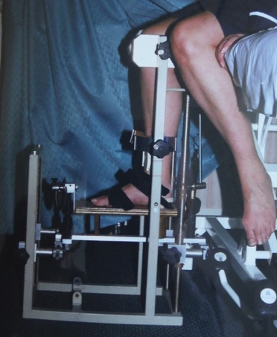

Purpose-built measurement rig

Diurnal variation may present a problem for clinicians using gait analysis as well as a potential problem for researchers who base their findings on an assumption of accuracy of equipment used to collect quantified data. This is because the accuracy of kinematic data is subject to diurnal variation.

Reliance of visual improvement methods
Showing a patient a video of improvement after some interventional procedure is not proof of efficacy of the intervention. It could be argued that diurnal variation may have been responsible for changes in kinematics.

If Podiatry is light on good research to underpin treatment modalities, it is only following on from mainstream medicine

Improvement in symptoms provides a more convincing argument of condition improvement.
In expensive, sophisticated gait analyses, combined measurement of both kinetic and kinematic data may experience the same variable effects. Although useful, especially for assessment of gross gait dysfunction, quantified gait analysis, both kinetic and kinematic can only reliably provide a snapshot of gait for any given day.
Nevertheless, by recognizing that diurnal variation is a phenomenon, we can, if we deem it necessary, factor it into our gait analysis results for more certainty about accuracy.

Research. Quantity over quality?

If Podiatry is light on good research to underpin treatment modalities, it is only following on from mainstream medicine. In 2016 ‘The natural selection of bad science’ was published, (Smaldino & McElreath, 2016). The authors argued that the overall number of papers, and how often those papers are cited by other authors (scientific publication metrics) tends to push quantity of work over quality of work. Seamus O’Mahoney, a consultant gastroenterologist and author suggests that research after the second world war became an industry in its own right
In 1951 a new publishing company was set up by the infamous Newspaper Mogul Robert Maxwell. His modus operandi was to persuade prominent academics that there was a need for new journals in their field, then install the same academics as editors. By 1959 40 new journals were being published. By 1965 the number had risen to 150 (O’Mahoney S. 2019).

Setting standards
It seems that much research is carried out, not in the spirit of scientific enquiry, but to get a name into print – to publish by any means. Douglas Altman, a statistician said
We need less research, better research, and research done for the right reasons, Altman, 1994
In 2015 the editorial of the British Medical Journal which contained this quote by Altman was voted the paper that the journal should be most proud of publishing by a poll of their readership.
The bar for UK Podiatry is set by the Standards and Ethics Code of the HCPC, to which can be added the Standards and Ethics of whichever professional body/bodies the practitioner belongs to. In some cases this bar is not set to a particularly high standard.
While the criteria of normalcy has been discredited, there are elements which do make sense and can be justified scientifically, like the calcaneus everting to vertical, or just past vertical.

Conclusion if not reflection
Does diurnal variation really make a difference in our normal podiatric working day?
It may, especially if we are using scientific-looking graphs and diagrams to show improvement.
If we carry out an extra gait data collection at a different time of day to be sure of results, would that be such a bad thing? Diurnal variation is not necessarily linear. It does not simply depend upon cartilage compression, or ligamentous stretch, resulting is less stiffness or more stiffness as the day progresses.

In the field of MSK the effects of diurnal variation are not predictable. Good research should and does underpin some of our current practice. It should be encouraged wherever possible. It is useful to have an insight into how the medical research industry operates.

Recognising bad research is almost as valuable to our profession as recognizing and utilizing good research. Differentiation in terms of good and bad research is therefore key to building a strong Podiatry profession for the future.

Busypencilcase Communications Ltd was established in 2015 as part of ConsultingFootPain.

Reflective Podiatric Practice is free to all registered podiatrists in the UK, Australia and in countries for sponsored guests which includes, South Africa, Canada, Israel, Cyprus, New Zealand, USA and Hong Kong. The main source of income is derived from talks and books sold by recommendation to patients and fellow podiatrists in order to produce this free newsfeed and website. Your continued support and recommendations are appreciated.

BPCC Ltd does not have a budget to pay authors for writing but is happy to promote all podiatry authors on social media for their contribution. Free published material when available is also provided.

References

Adams J M, Perry J. Gait Analysis: Clinical Application in Human Walking, 2nd Ed, Pub Williams and Wilkins Baltimore USA, (1994).
Altman D. The scandal of poor medical research. British Medical Journal (1994).
Backhouse M R, Pickles D, Matheison H R, Edgson L, Emery P, Helliwell P S, Redmond A C. Diurnal variation of gait in patients with rheumatoid arthritis. Clin Biomech (Bristol,
Avon) Aug: 29(7); 811-814, (2014).
Ball P, Johnson G R. Technique for the measurement of hindfoot inversion and eversion and its use to study a normal population. Clinical Biomechanics Vol 11, No 3, pp 165-169, (1996).
Chin C, Chow G C, Hung K, Kam L, Chan K, Mok T, Cheng N. The Diurnal variation on Cardiovascular Endurance Performance of Secondary School
Athlete Student. Asian J of Sports Med 6(2)e22697, (2015).
Green D R, Carol A. Planal Dominance. Journal of the American Podiatry Association. Vol 74, 2. (1984).
Holland D. Frontal plane range-of-motion at the ankle joint complex. Podiatry Review.Vol 75, No 4. (2018).
Holland D. MSc by research Thesis. Faculty of Science, Durham University (2002).
McRae R. Summary of joint movements in Clinical Orthopaedic Examination (6th Ed). Pub: Churchill Livingstone Elsevier – pp-303.

New next month and early 2020

How do we package Podiatry?

December 2019 – February 2020. A new five-part series on branding and podiatry bi-monthly. Issues:
6th Dec, 20th Dec (2019), 6th Jan, 20th Jan, 7th Feb. (2020)

Non open access papers only

Podiatrists who sign-up to receive this newsfeed agree not to copy or pass on this paper or any others in the series without permission in any format to a third party whether registered in the UK or worldwide. Citation of all articles is permitted. Copies are available for purchase for non registered podiatrists by contacting davidt@busypencilcase.com

