More about Heel Pain & self-help remedies

Thanks for reading my article on heel pain at www.Consultingfootpain.co.uk.

The most common types of heel pain arise from general overuse or repetitive heel pad strain, fasciitis, Severs apophysitis (children) and Haglund’s heel bump. In this next section I will talk about the myth of the heel spur together with these common problems to widen the knowledge.

Heel spur myth 1
Remedy: managing heel pain 2
Heel pain in adolescent children (calcaneal apophysitis or Sever’s disease) 2
Remedy: Severs 3
Remedy: general advice heel pain 3
Remedy: plantar fasciitis 4
Heel bump (Haglund’s) 4
Remedy: Haglund’s deformity 4

Heel spur myth (see comment at end)
A spur exists on the under surface of the heel bone (calcaneus). It was once thought that this represented a projection of bone formed from a spike. There is no spike but an extension of the join between two bone centres (right hand diagram), where the back section (B) and main body (A) come together normally. The darker shaded bone shows the projection sitting above the fascial band, once the two parts have fused together. Whether tension from the plantar fascia band extends the shape due to traction (muscle pull) is difficult to say with surety but muscles sit under the usually thin band unless inflamed.

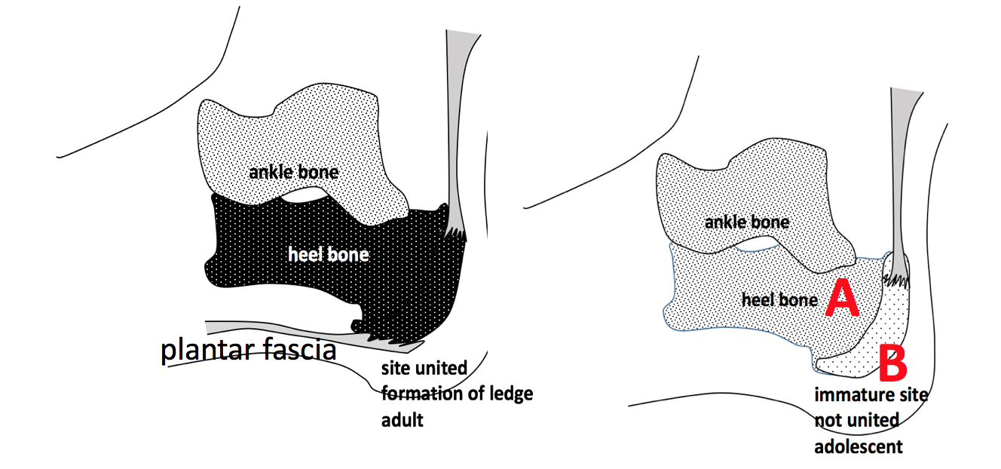
Left A+B joined with projection above plantar fascia. Right side A/B forming a connection around adolescence.

The two centres unite around puberty (14-16). The fascial band inserts into the lower section and runs back under the heel. If we take x-rays of feet we will find many patients with a ledge and yet report no pain. For more than ¾ century we have wrongly ascribed heel pain to a spur. However, many pads do help with patient comfort, including those with a cavity.

You can buy spur gel heels with a premade cavity or part of the gel pad made with lower density rubber.

Remedy: managing heel pain
You go to YouTube and find out about most foot conditions. The USA is by far the most prolific film maker on ‘how to’ but remember there is often a sales pitch behind such films. The first myth you need to be mindful about is the heel spur.

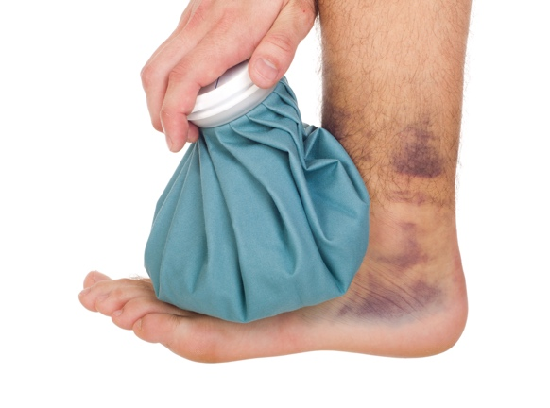
Pain medication in the form of paracetamol or ibuprofen can always be used. Both work in different ways. Ibuprofen is also good for inflammation. Ice also is an important method of managing both pain and inflammation. You can buy a range of ice applications, from chemicals that can be mixed with a catalyst which effects a cooling reaction, to complex systems with pumps. The illustration is a viable middle of the road system so that a bag is filled with ice (although not shown over the heel). Pain medication should not be used for more than 2 days if the condition fails to show any improvement or worsens. At this point seek out advice from a professional. It is important to rule out other reasons for the pain.

Heel pain in adolescent children (calcaneal apophysitis or Sever’s disease)
In a child (10-16) the growth plate can become irritated. It is not a disease and often thought of as growing pains.

The bump is not prominent as shown in Haglund’s disease (deformity) which I will come to later. As with the heel spur, the traction pulls at the back of the heel rather than under the heel in Severs. This arises during adolescence when two components making up the heel have not matured. The achilles tendon is show above (B) in the diagram where the tension created by the tendon produce harmless spurs in most cases, but causes heel pain for the young person. Think of the problem around moving the growth plate too much. The discomfort arises more when the young person is active.
When the traction (pull) does cause pain this is called calcaneal (after the heel bone) apophysitis or Sever’s Disease. The apophysis is the site where the immature hind part joins with the main body (dark shading, left diagram). This is not a disease as it is purely mechanical.

Remedy: Severs
If we lift the heel up with a ¼ in (6mm) pad in dense foam, the tension is removed and the young person will find relief in 90% of cases.
Often sporting activities increase heel pain.

Remedy: general advice heel pain

Long standing periods and work shifts (above 8 to 10 hours) will make this worse.
- Pain killers work to reduce pain but will not resolve the problem.
- Stop excessive exercise for 2-3 weeks.
- Use a foam heel pad such as silicone jelly.
- Sports shops also sell thin heel pads without taking up too much room but pads of this type are short lived. Heel lift pads can be used for Sever’s disease.
- If pain persists, or increases in intensity, then seek help no later than 4-6 weeks.
- gently daily about three times a day using a Thera band as shown or stretch the band against the ground as in tendo achilles stretches. The tendo achilles and fascia share a close relationship.
- Tuli heel cup is well worth considering and works well for many heel pain sufferers. Sourced through the internet so freely available with prescription.
- Check your footwear for any cause of the problem and try to re-negotiate shorter shifts at work, or change roles so some of the time you are sitting.
- If within a month the pain is still present, then seek assistance.
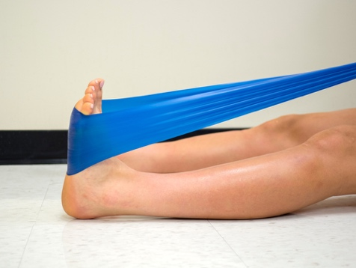
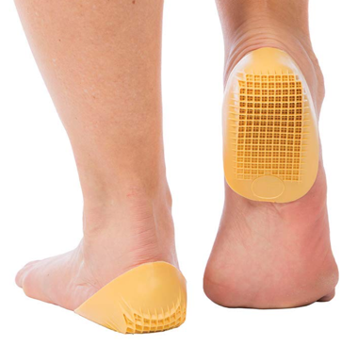

Illustrations show Thera band stretch (L) and Tuli Heel cup (R)

Remedy: plantar fasciitis
- Once pain starts if the area is tender to press, avoid an arch support initially.
- Use localised non-steroidal gel or creams or locally applied warming creams**
- Apply local strapping (see fan design) to remove tension
- Increase heel height inside the shoe up to ¼ in 6mm
- Once pain is easier, longer term help can be gained from an orthosis.
- Stretching once the condition improves helps prevent reoccurrence as shown with Thera band.
- Also use stretches for the tendo achilles
- Use a small rolling pin, cylinder to provide some deep massage

** Warming creams contain salicylates such as methyl salicylate and they are heat making when rubbed onto skin. The idea is to bring fresh blood to the area and speed up healing on non-infected unbroken skin.

Fasciitis is less frequent than heel pad pain. It commonly affects the heel pad and arch and can become disabling if not treated. Follow the same advice for the heel pad pain for the same time periods but remain active, and do not exert the foot.

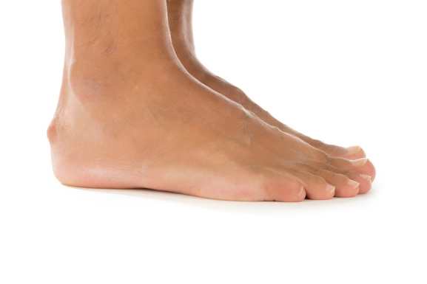
Heel bump (Haglund’s)
This arises most commonly in adults although can occur in adolescents. Known also as a retrocalcaneal exostosis, it is also called Haglund’s deformity. Symptoms are easier to spot because discomfort arises over the bump. Many shoes can irritate the location so selecting shoes around the heel. The tell tale sign is the bump illustrated. Apart from the obvious increase in size to the heel, the inner heel lining is worn at one point. Redness and tenderness can be due to simple friction or chilblains during autumn and winter seasons.

Remedy: Haglund’s deformity

If the skin is damaged this should be protected by a blister dressing or felt pad. Blister dressings are available from high street pharmacies often with their foot care products. Made from a gel this cushions and is water resistant.
Felt pads are often best fitted inside the shoe and should have a cavity created to take away pressure from the bump.
A soft sac or bursa can form over the skin and needs protecting from friction
A heel lift may be useful to change the position. ¼ inch (6mm) felt or foam insert works well.

I recommend the following website FootEducation.com for further information (click)

The opinions stated in this self help sheet are by the author David R Tollafield following a career as a health professional (Podiatric Surgeon). as a patient david has suffered from heel pain and shares some of his strategies. The hypothesis developed around the heel spur came from observing an MRI in a child in 2008 with under developed calcaneus (heel bone) where the spur already existed. The author believes that this may not have been reported before.

