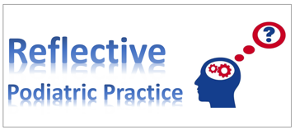

Prosthesis, Patient, Podiatrist

Reflection from Expert Witness days

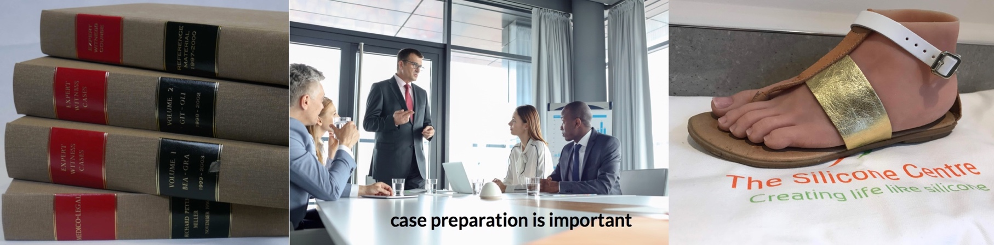
David R Tollafield

This reflective article arises from a 20-year-old case where all the names have been anonymised.
I must have been in my third or fourth year of producing expert witness reports when I met Rachel. Her case would stay with me forever. By digging out the three volumes of notes on my expert witness days I was able to reflect on this 31-year-old woman case at the time of our conference meeting. Michael, a prosthetist comes into the story much later and was not part of this case.

The Conference
S
canning the room, the well turned out barrister sat at the end of the table, the usual pin stripe suit with red tie highlighted sartorial pride. Rachel or as she was known, Miss Franks, sat close to Mr James Briggs, her chosen advocate and Q.C. The remaining constituents around the long table were mixed, mainly represented by a group of clinicians. I was one such clinician. An orthopaedic surgeon sat opposite me, then there was a psychologist, a physiotherapist and of lesser note a prosthetist. This perhaps unfair characterisation was reflected by our perceived lack of his potential contribution toward the discussion of causation and prognosis. Diane, Rachel’s lawyer, thought otherwise.
The prosthetist entered carrying a bag and looked much like a better-ware salesman, redolent of that itinerant man complete with suit case who turned up at the door when I was young. I had of course met Rachel before as I always made it my duty to examine patients rather than rely on previous documents alone. A need to understand the patient and then physically note down any injuries was essential to the ultimate quality of my final report. My attitude had been that I should always expect to go to court rather than assume settlement would arise automatically.

I had undertaken training courses and had naturally listened to the advice about how to go about certain matters. How could I evaluate skin and tissue accurately, let alone pain or assess mobility objectively if I failed to do this?
Perhaps colleagues reading this would disagree with me about the need for an examination, but then we all have our own style when approaching expert witness work. This was my own view. Nonetheless I have included details of my Witness Report which would otherwise have been invalid for Rachel’s conference had they not been part of a physical examination. My observations remain as written 20 years ago.
The lawyer looked down the long light coloured oak table and turned some pages of his folder, the bundle of papers secured with those big D-rings.
‘So, you like to try pilots?’ he asked quizzically, clearly not knowing that the spelling of Pilates had that typical ancient Romano-Greek pronunciation pee-lar-tays.
This was his opener and a side comment that caused a titter around the room. Nonetheless this was far from a comedy, and deciding whether he (the barrister) would win the case for Rachel was more related to how strong the case would be when it came to claiming compensation. Compensation would come down to Quantum.

Quantum was the cost of evert single aspect of her life capsulated into a set of accounts. The effect in monetary terms of ongoing care, support and future needs which tied up around prognosis.
Had she not had the injury her normal income would suffice, but now she no longer had an income.

Psychologically, her injury has made her reclusive to bathing, swimming and certain dress codes

I had formed a close relationship with the lawyer, Diane, running the case, that is to say as close as anyone gets to lawyers. My role in Rachel’s complaint formed the prognosis rather than causation, and therefore related to skin integrity and tissue management within the foot.
The prosthetist kept quiet and his bag remained on the floor unopened as the barrister picked off various points. The orthopaedic surgeon was audible. He spoke with authority and he spoke extensively. Not being a trauma surgeon myself deferment to his greater knowledge in respect of injury was accepted.
The plastic and vascular surgeon had been involved but both were not in attendance, so it would be wrong to suggest the O.S was pre-eminent in his dealings with the injury in question.

My Report (selected sections)
‘Rachel Franks has pain in her foot still and experiences worsening effects in winter…her social life has been affected by her foot injury in two ways. Her inability to walk normally means she can longer keep pace with her friends.
Psychologically, her injury has made her reclusive to bathing, swimming and certain dress codes – particularly associated with warmer periods of weather. In each case she shies away from exposing her foot because of the residual shape and appearance. Many of her past hobbies including pottery have been affected as her right foot was dominant on the treadle wheel.
The right foot presents asymmetrically with loss of the lateral two toes (4th & 5th). The width is narrower due to previous surgery, which consists of full thickness and split replacement skin grafts. The toes are partially syndactylised surgically and move as one between the first and second digits. Tenderness of the toe stumps are noted and likely to be associated with abnormal nerve endings.
The right great toe is 15mm shorter than its contralateral side. The sole of the foot is relatively preserved buy has loss of sensation with tingly symptoms. All skin is intact and there is no sign of ulceration, erosion or necrosis. The foot did not appear swollen. The colour remains well preserved although the areas of skin graft remain pinker. The skin still has pliability except over the medial side – coinciding with the scar line, which runs from the first mtpj to the navicular (inside foot) region. The amount of pliability would inevitably be limited because the top of the foot is naturally thin and does not enjoy the thicker covering associated with the sole of the foot.
A significant unsightly scar runs obliquely across the foot in front of the ankle but does not impinge directly on ankle joint function. Additional areas of pressure include the dorsum of the foot lying just in front of the diagonally sutured skin edge of the graft over the cubo-navicular articulation.’

Moving onto gait…
‘Miss Franks can only walk short distances confidently. She is dependent on a car for longer journeys. On examination contact pressure (reproduced by an ink mat) shows toe contact mainly over the hallux with intact interphalangeal joint taking weight. The high pressure point coincides with the third and fourth metatarsal. The arch shape is slightly lowered but currently still retains a natural arch. The heel contacts the ground fully.’

The report is extensive and goes into more detail ending with an opinion about orthoses.

‘The orthosis made by her podiatrists seemed to be very effective. Unfortunately, the design which I was able to observe is but a short term inlay. This means that the density of the material has a short shelf life (three months) because the foot compresses the material which then needs replacing. The advantage of the blown foam polyethylene material is that it protects the skin very effectively and is easily tolerated in sensitive feet. Three months is effective…longer than less so as holes would start to appear.’

Opinion
Lawyers rely on experts to give percentages. I don’t need to tell an audience of podiatrists that such percentages are crude and can only be considered unreliable estimates. The observational aspects of the 18-page report are detailed and had (57) numerated paragraphs limited to each aspect of the condition. Without stating this one cannot make a case for prognosis.
‘The left foot has not come away unscathed due to donor grafts… she has a 35% greater chance of developing foot fatigue, heel pain, arthritis, fasciitis and callus in this foot.
The effect on her now abnormal foot on her gait is significant. She has a 25-40% chance in suffering low back, hip and knee pain as a result of altered determinants of gait before fifty years of age.
An abnormally functioning foot can impose an acquired, functional limb length shortening on the affected side. The viability of her tissues – skin, fat, fascia and bone around the replacement graft is at risk at three points.
In each case problems may arise due to reduced blood nutrition to the skin, local ulceration and infection.
The need to take antibiotics to quell infection can cause allergies, stomach upset and lower resistance to some bacteria. It is for this reason that Miss Franks falls into the higher risk category as the health of her foot is more likely to deteriorate than not within 10 years.’

The reports include sections on posture, footwear, orthoses and it is at point 51-54 that I consider prostheses.

‘A cosmetic prosthesis would compensate for the toe loss and it has been known for patients with amputated toes to be able to wear sandals where toes have been sculpted for accuracy.

A prosthesis along the lines described by orthotist Mr B King would be essential to assist Miss Franks’s greatest concerns is the abnormal appearance of her foot. The ongoing management should take account of both her pedal and psychological requirements.’

Seeking compensation
If there ever was a case that required compensation it was Rachel. Standing on a London street she was minding her own business when a double decker bus ran over her foot. The ensuing degloving injury tore the skin off her distal foot and after many surgeries she was left with pain, skin damage and loss of her great toe and some shrivelled lesser toe stumps. The residual foot was narrower, darker in colour and had an increased tendency to sweat, compared with the contralateral foot.
The psychologist gave her report which was pretty damning within the arena of complex problems - ability to work, confidence, relationships, agoraphobia; the list went on. Rachel wanted to travel, or that was her desire. She wanted to travel though to tropical countries. Her skin could break down and it did not really need an expert to opine that warm and humid countries formed an incubator for infection. One never knows how one’s expertise would be used but as a podiatrist I knew skin and feet. As a podiatric surgeon I knew about infection, bacteria and the internal damage that could arise. I knew about pain and managing intractable pain, and I knew about the insatiable need for any victim to want to be normal again. My background in orthotic manufacture and gait analysis came into the picture.

The Prosthetist
The barrister finally arrived at the prosthetist having worked around the table. He had remained quiet so far. Diane, the lawyer running the case, had prompted him to come forwards. The area of discussion looked at quantum.
Following his introduction Brendan King lifted his bag onto the table and proceeded to place the most beautiful creations in front of him explaining what he could do for Rachel and what was possible.

Both the white mask and glasses were soon speckled with black rubber particles
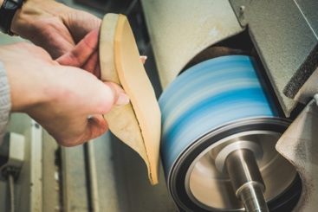

Prosthetics in training as a podiatrist
Part of my past had been manufacturing orthotics and I had been keen on working with different materials from the time that I was a student.
One of my third year examination pieces had been to make a moccasin prosthesis for a patient with Buerger’s disease after a Chopart’s amputation through the talo-navicular joint. The prosthesis was made of a leather design to rest against the skin. The material was stretched and fastened with staples around the plaster cast. The seams were carefully crafted to leave no pressure points and then I built the forefoot up with a series of squares of 6mm rubber. The first rubber was softer in density compared to the stiffer distal black coloured rubber that appeared as a brick block until trimmed and ground down.
The white coats we wore turned black and the weak dust extraction had to be supported additionally by masks and glasses. Both the white mask and glasses soon speckled with black rubber particles after any attempt at grinding. When I removed my glasses I could have been confused with a motorcyclist exposed to dirt from the road after a long ride. My face was black and my eye sockets pink.
If I wasn’t making some type of prosthetic, it would be a latex digital cover. The positive cast would be dipped in a pungent ammoniacal white soup with its rubber latex preserved in a fluid state. As each layer dried the material was strong enough to remove producing an envelope into which the rubber materials could be sandwiched. This was time consuming and the finished product looked like an distorted condom.
Looking at Brendan’s finished product I could see the colours matched normal pink skin.
The texture used appeared more lifelike than a model from Madam Tussauds, not that far away from our meeting room along the Marylebone Road. Small life like hairs were evident on the toes and the prosthetic sample cupped any stump it had been crafted to.
Brendan eloquently described the potential for the prosthesis to be used on a beach to allow confidence amongst other bathers. The product was expensive and could be obtained privately rather than on the NHS. Of course if Rachel had a settlement this would be calculated within the quantum.
As I peered at these wonderful models I contrasted my own efforts born out by teachers from a different era and now feeling somewhat inadequate.
My Buerger patient had found my creation valuable but in time the latex elasticated side that cupped the prosthetic stump withered and tore.

The value of modern silicone could not be understated for its robust nature, aesthetic looks and psychological capability.

Prognosis
Rachel would never be the same person after her accident and psychological counselling would be important to allow her to overcome and address her fears. While the orthopaedic surgeon gave his opinion which came down to whether surgery should or shouldn’t be used any further, he really would have relied on plastic reconstruction rather than bone.
Of course further amputation was considered which would hardly have delighted Rachel, but then pain, lack of mobility and increasing wound breakdown was ever likely leading to the inevitable. And so the conference had to predetermine her future options and likelihood of problems well into her later life. Consideration of suicide was not discussed but for those more empathic, we viewed this as a risk, but something I excluded from my report.
She was taking supportive chemical drugs to help her. The relationship with her latest partner was not working out. The injury had clearly extended the effect of trauma beyond the incident. But then, like dropping a pebble into a pond, the ensuing wave form reaches a location far from the original point of entry.
Brendan packed his bag and left as most of us did, leaving the barrister, lawyer and client to discuss matters of strategy. Six months later I spoke to Diane over another case I was working on.
‘So,’ I asked, ‘how much did Rachel settle for?’
‘Well, I am unable to reveal the sum as this cannot be disclosed, but let’s say the bus company paid six figures!’

Twenty years later as part of my social media communications I came across Michael.

Reflection
Rachel would indeed be able to afford a silicone prosthesis but what of others who could not draw on such funds? For Rachel there was no doubt that she would have preferred to have had her life back than money. My own assay would be that she would never be able to use her silicone device in the tropics. Seeing as this was part of her career in the area of ecology. This would be hard. An infection in her foot would soon grip hold and without immediate medical care her life would be threatened.
Twenty years later as part of my social media communications on Linkedin, I came across Michael.

Michael was relatively new to the technology of prosthetics and yet had established a fine product and created a work base at Didcot. There are a number of such outlets for this work and the extent of the options available for patients is now far reaching.
Michael goes as far as advertising prosthetic legs for below knee amputations. So impressed was I at his work I asked him to write a short article which he did willingly and can be found on Clinician Portal and Footlocker (linked). I decided however to include the story as part of a closed access article linking my own experience all of those years ago.
Both clinicians and patients should find this of value. The fact that there are options for patients is important and surgery as always must be considered carefully with respect to the potential value of other ways of managing problems.

This is Michael’s story…

Foot care using Silicone

It has been 12 years now since I discovered the amazing way silicone can be used to benefit in orthopaedic solutions.
The huge growth of social media is making people more aware, but to be honest I didn’t know much about it until I began my discovery in 2007. Before then I’d worked as an orthotic/prosthetic technician without realising its beauty. Even now I see patients that are so amazed it exists and wish they had known about it years ago.
I started my business ‘The Silicone Centre’ in 2016 to produce silicone prosthetic/orthotics for all types of limb loss and limb correction. As well as creating a successful business, through my talent and passion I would really like to raise the awareness and get the message out there to patients and individuals to highlight the life changing solutions available.
I would like to talk about 3 Silicone devices to support foot care to provide functionality, comfort and appearance.

Silicone toe extension
A single short metatarsal creates a short toe and so the options are to lengthen the metatarsal. While we can do this there is an option to extend the toe itself. While it can be corrected as with any surgery there are risks involved as well as the patient being left with an obvious scar.

Brachymetatarsia or hypoplastic metatarsal usually affects one or more bones leaving them abnormally short so the toe is very obviously deformed and may overlap. Although this condition may result due to a congenital defect it may be an acquired condition. It most frequently involves the fourth metatarsal.

An alternative solution is to use a silicone extension. These silicone toe extensions are made to measure, they are sculpted with fine detail to appear realistic and they also fit well with suction. We as a company during the past 6 months have had more requests regarding silicone toes than any other silicone device.

It can be life changing for a person wanting to feel nobody will be drawn in to staring at their defect. It helps with self-esteem and for most patients they feel they can walk along the beach/pool side bare foot for the first time in a long time.
One of the main benefits is that the patient is able to feel confident in open toe shoes, sandals or flip flops.
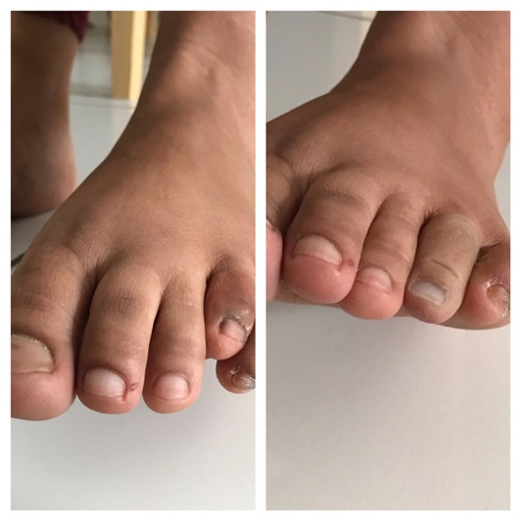

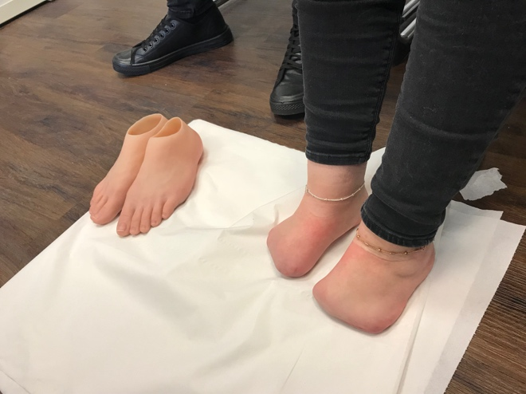
Silicone foot

While accidents might be rare majority of amputations across the foot arise due to circulation problems, infection and poorly controlled diabetes. An amputation to the forefoot (metatarsal) or middle part of the foot (midfoot as shown) has various names such as Chopart (TNJ) depending upon the site.
The objective behind these types of amputations will allow weight bearing on the remaining part of the foot, which means that the person can put weight on the bottom of the foot to be able to walk short distances, or stand in the shower without the assistance of a prosthesis.
Whether because of a congenital condition, disease or by accident these types of conditions are more common than is thought.

Silicone for a drop foot

Silicone is a great way to support foot drop. The best way to describe this is to imagine you cannot lift your foot upwards at the ankle. The drop foot is associated with some muscle weakness which arises again due to congenital defects or associated with nerves after injuries, or may include the undesirable effects following surgery
A cast of the ankle and foot is taken and rectified ready for the silicone to be applied.
Unlike an ankle foot orthosis or A.F.O, the rigid support is applied in silicone across the shin and top of the foot (dorsum). This kind of silicone support is made to measure for maximum support and comfort. It can be worn with or without footwear and even used in water. I made a S.F.D.S (silicone foot drop support) for a successful Paralympian and the results were amazing to see.

Silicone is a great way to overcome so many solutions

Properties & benefits
A silicone foot is both functional and aesthetically appealing. It provides support and can be adapted to support heel raise, arch support, better joint alignment. The formation of a rocker like sole and reinforcement of the missing part.
It is made to measure, is very durable and can be used in water. The silicone we use can be as soft as gel to provide comfort for any sore areas. All silicone feet can be made to fit the patient’s footwear also with the incorporation of a gap between the first and second toe to allow for sandals and flip flops to be worn.
Just as important for a lot of patients is the appearance of their feet, where the silicone can be sculpted to the finest detail and colour to match the remaining foot. The reality level of finish we offer includes hair, veins, freckles, moles, tendons, detailed nails that can be painted, as well as tattoos. The finished product is so realistic it is unbelievable to believe that they aren’t real!
The positive psychological affect this makes to an individual is enormous. but as there is insufficient evidence of the direct health benefits these products are not commissioned by the NHS and only available privately and can be very costly.

Michael Li-Rouse

The benefit of being linked to ConsultingFootPain

Sarah, a podiatric colleague contacted me and asked about information on Expert Witness work. How to, what’s involved and so I produced a sheet of advice for her while seeking an opinion from another colleague who remains an active Expert Witness and reviewed my response. The link takes you to that advice sheet to provide some useful material for those considering E.W work. I enclose part of the introduction for readers.

Guide to Expert Witness Work

This is not a definitive guide but based on personal experience on both the side of the expert and on the side dealing with legal judgements in podiatry as the accused. If you are serious about E.W work please contact the College of Podiatry and attend a course. Courses are publicised in Podiatry Now, e.g Bond Solon.

To become a E.W you need to become educated in basic medical law. This means knowing what is expected of you by the court. Your duty is to the court not a patient or colleague. Selection however is by a specialist lawyer (solicitor) who engages a barrister. The latter represents the case in court as is a Q.C. You can register an interest to commence legal work with the college. You can search courses as well. Here is a guide link but the link is not necessarily a recommendation as I have not used this source.

Qualifications usually include the following:

- 5 years or more in practice (my suggestion)
- A good understanding of written English
- Have a strong personality and be able to stand cross questioning and debate
- Be able to speak clearly and well
- Have a good C.V to support the skills you represent
- Having a number of courses which have been approved and ideally certificated;
- report writing
- presenting material and how to conduct yourself in court
Expert Witness work is not for the feint hearted neither should it be a primary way to make money, despite the fact it can be lucrative. There is a need to E.W within podiatry however and sufficient experience should be attained. Every case has the potential of going to Court and this should be born in mind when undertaking such work.
Many years ago I had to take on a case involving a colleague and soured our relationship. However, unbeknown to the colleague I had reduced the claim from £98,000 to a settlement of £4000.

The fact that our profession is small creates an inevitability that we may come across people we not only know but care about. This creates a conflict of interest and yet without colleagues willing to undertake E.W work the only group who will fill the gap are orthopaedic surgeons in the main. Nonetheless I would suggest today there are more E. Ws available in our field and so passing over a case may be wiser.

Sarah’s guide – the link to Expert Witness Work for podiatrists

________________________________________________

ADVERT

The Silicone Centre

At The Silicone Centre we offer a range of finishes to suit every budget, making it affordable for everyone.

Any podiatrist wishing to place an advert may do so if they agree to write a short article. Tell your colleagues what you can offer patients today.
FREE ADVERT PLACEMENT

Write for Reflective Podiatric Practice (closed access) or Clinician Portal (open access).

