

**June 2019**

***PAIN EDITION No.2***

**Pain all over the foot.**

# **Part 2.** Where does pain come from?

**David R Tollafield**

It should come as no surprise that pain can extend to the knee, hip or back, but it is often due to foot pain in the first case. Hopefully, this article on pain will offer you some insight into treatment but no-one article can explain or offer all the solutions to foot pain. There are several **free** downloadable pain guides in this article with one offering a summary of conditions associated with their location.

There are a number of places in the foot where pain arises which leads to the complexity facing us clinicians. The urgency and action needed can be assisted by determining what part of the anatomy is affected. We must consider all the types of pain based on the type of body material called ‘tissue’. The types of tissue are represented in the list a-j below.

## Orientation of structures – the cells

With exception of nails and nerves, each might be referred to as connective tissue. Put simply, the connective tissue supports structures as well as having a role to play. The smallest structures are called cells. Blood cells carry oxygen; they are more individual than bone and are mobile. Bone has a more complex cellular structure which contributes to an outer and inner component for lightness and strength. Bone forms the tent poles that support the whole body. Skin keeps everything from falling out, while muscles with their tendons connect bones so they can move around a joint supported by ligaments. We only need enough knowledge for orienting around this complex body structure. This all comes under the heading musculo-skeletal framework (MSF). The words in brackets are more formal

1. Skin (epidermal)
2. Nail (epidermal)
3. Fat (subcutaneous)
4. Tendon (tendinous)
5. Muscle (myotendinous)
6. Ligaments
7. Blood vessel (vascular)
8. Nerve (neural)
9. Bone (osseous)
10. Joint (articular)

## Cells and tissues responsible for pain

Nerves are a little different but no less important and we do need to bear in mind this type of tissue is often at the heart of pain. There are nerves that allow information for movement and nerves that provide information about sensations. Such information performs specific functions;

sensory nerves register pressure, temperature (hot and cold), sharpness, dullness and soreness (pain/discomfort).

position means knowing at any given time a reference to whether the foot is on the ground or off the ground. We give the name proprioception to this feature of nerves which are found in joints and tendons.

Movement or power comes from ‘motor’ nerves which have a voluntary meaning where we have a bit more control than the previous nerves which are involuntary (automated).

We still cannot state with any surety that the diagnosis is accurate so we need to talk a bit about first aid and what medication might be appropriate.

# Referred pain

When a problem arises in a different part of the body you feel the symptoms somewhere else. One of the best examples of referred pain is the so called ‘stitch’ pain you feel after exercise. The phrenic nerve is irritated from the diaphragm (below the rib cage) and is felt at the shoulder as a pain. This was the theory taught to me in my physiology class but the internet does give other reasons.

The best example of referred pain in the foot are where nerves become trapped between bones. Here discomfort is felt often at the end of toes as in Morton’s neuroma. Compression over the skin from a shoe can also create this problem. The big toe may have a bump where the bone is larger and the sensation of pins and needles may shoot down to the end of the toe. In each case any nerve that is compressed causes a radiating like pain.

Common locations of pain

The two black circles may relate to specific bone associated problems. These require further investigation. Always differentiate between pressure from shoes first.

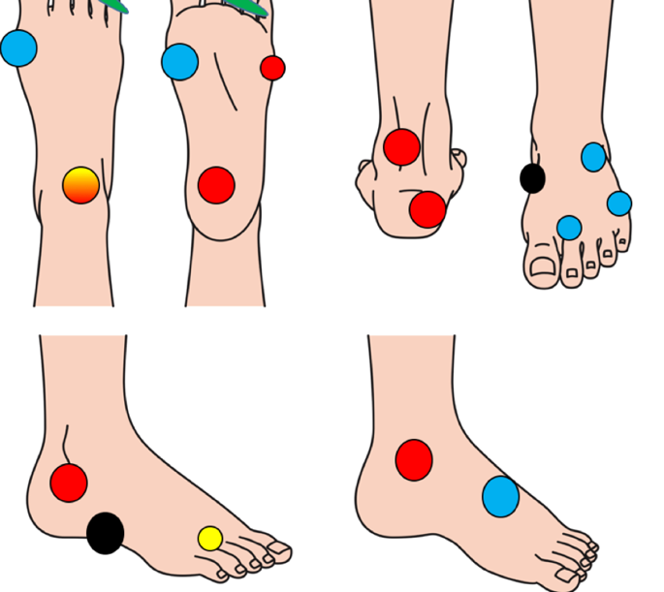The area in front of the ankle (orange/red) is often tendon related. The blue areas are often associated with referred pain while the red arise again with tendon or deeper tissues. In Part 1 tarsal tunnel was mentioned. This condition is an important cause of referred pain. This is characterised by an area below the red circle over the ankle bone on the inside of the foot in the bottom right foot diagram. The nerve lies just below this.

Another form of referred pain is not specifically ‘referred’ but arises due to an alteration of the foot. This was considered when introducing this article. The foot figure with the black arrow provides an understanding of the type of example.

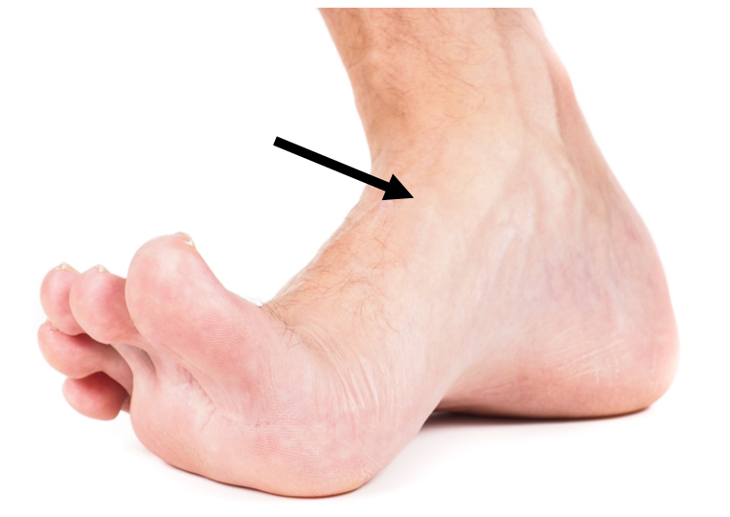

The foot in the figure above alters position so tilts on the outside. The extra effort from the toes caused tendon overuse strain at the ankle.

Pain on the inside of the foot is relieved by adjusting the position. Two areas of pain can arise typically. Tendon pain because the tendon is over used. This is an overuse syndrome and known as tendinitis.

The other quite common problem is the outside edge of the foot can become tender without anything to see. Patients will present with this problem frequently, somewhat baffled by seeing nothing but hurting a good deal.

Once you start to limp you will alter the way you work. Podiatrists will try to diagnose the problem after examination. Once pain can be identified and the origin location treatment may strangely be applied to an area where pain is not obvious.

DO remember pain killers (aspirin, paracetamol and ibuprofen) are helpful but should only be used for short periods as discomfort should subside. Ensure any medicines you currently use are not contra-indicated.

Rest, ice and elevation are all worthwhile interventions that can be used at home.

When you do seek help take your diary with you to help you remember the timeline. That is how long you have experienced pain. When did your condition start? Remember to record what made the problem worse and what made it better.

Here are some ideas associated with pain from different parts of the foot.

|  |  |
| --- | --- |
| Tissue (MSK) | Pain / symptoms |
| skin | Burning frictional, sensitive if inflamed |
| Nail | Toothe-ache, piercing tenderness if compressed |
| Fat | Burning sensation, tender to touch, bruised |
| Tendon | Burning along tendon route, tender if over used, tender to touch |
| Muscle | Pain intense, cramp like, crushing |
| Ligaments | After strain intense acute pain, swelling, bruised, tender to touch |
| Blood vessel | Intense sensitivity along vessel (vein), touch may burn |
| Nerve | Touch or tap causes tingling pain so two type. May shoot signals down or up foot |
| Bone | Deep tenderness, aching, worse if infected, crushing, swollen |
| Joint | Feel tender to move, if swollen pressure can feel explosive, burning. Throbbing |

Matching pain to tissues

# Guides to foot pain and location: Two new guides from ConsultingFootPain

As a rough guide to pain download my free sheet published on my website. Click the link [GUIDE](http://consultingfootpain.co.uk/wp-content/uploads/2019/05/Rough-Guide-to-Foot-Pain.docx)

Pain that arises because of injury, broken skin or following activity should settle quickly. If pain does not settle and it affects your ability to walk let alone sleep, then seek help as soon as you can. Download my illustrative quick reference guide on location offering a summary of different conditions associated with their location.

[PAIN LOCATION GUIDE](http://consultingfootpain.co.uk/wp-content/uploads/2019/05/Location-Guide-Foot-Pain-2019.docx)

Remember there is plenty of information on my website. [consultingfootpain.co.uk](http://www.consultingfootpain.co.uk/)