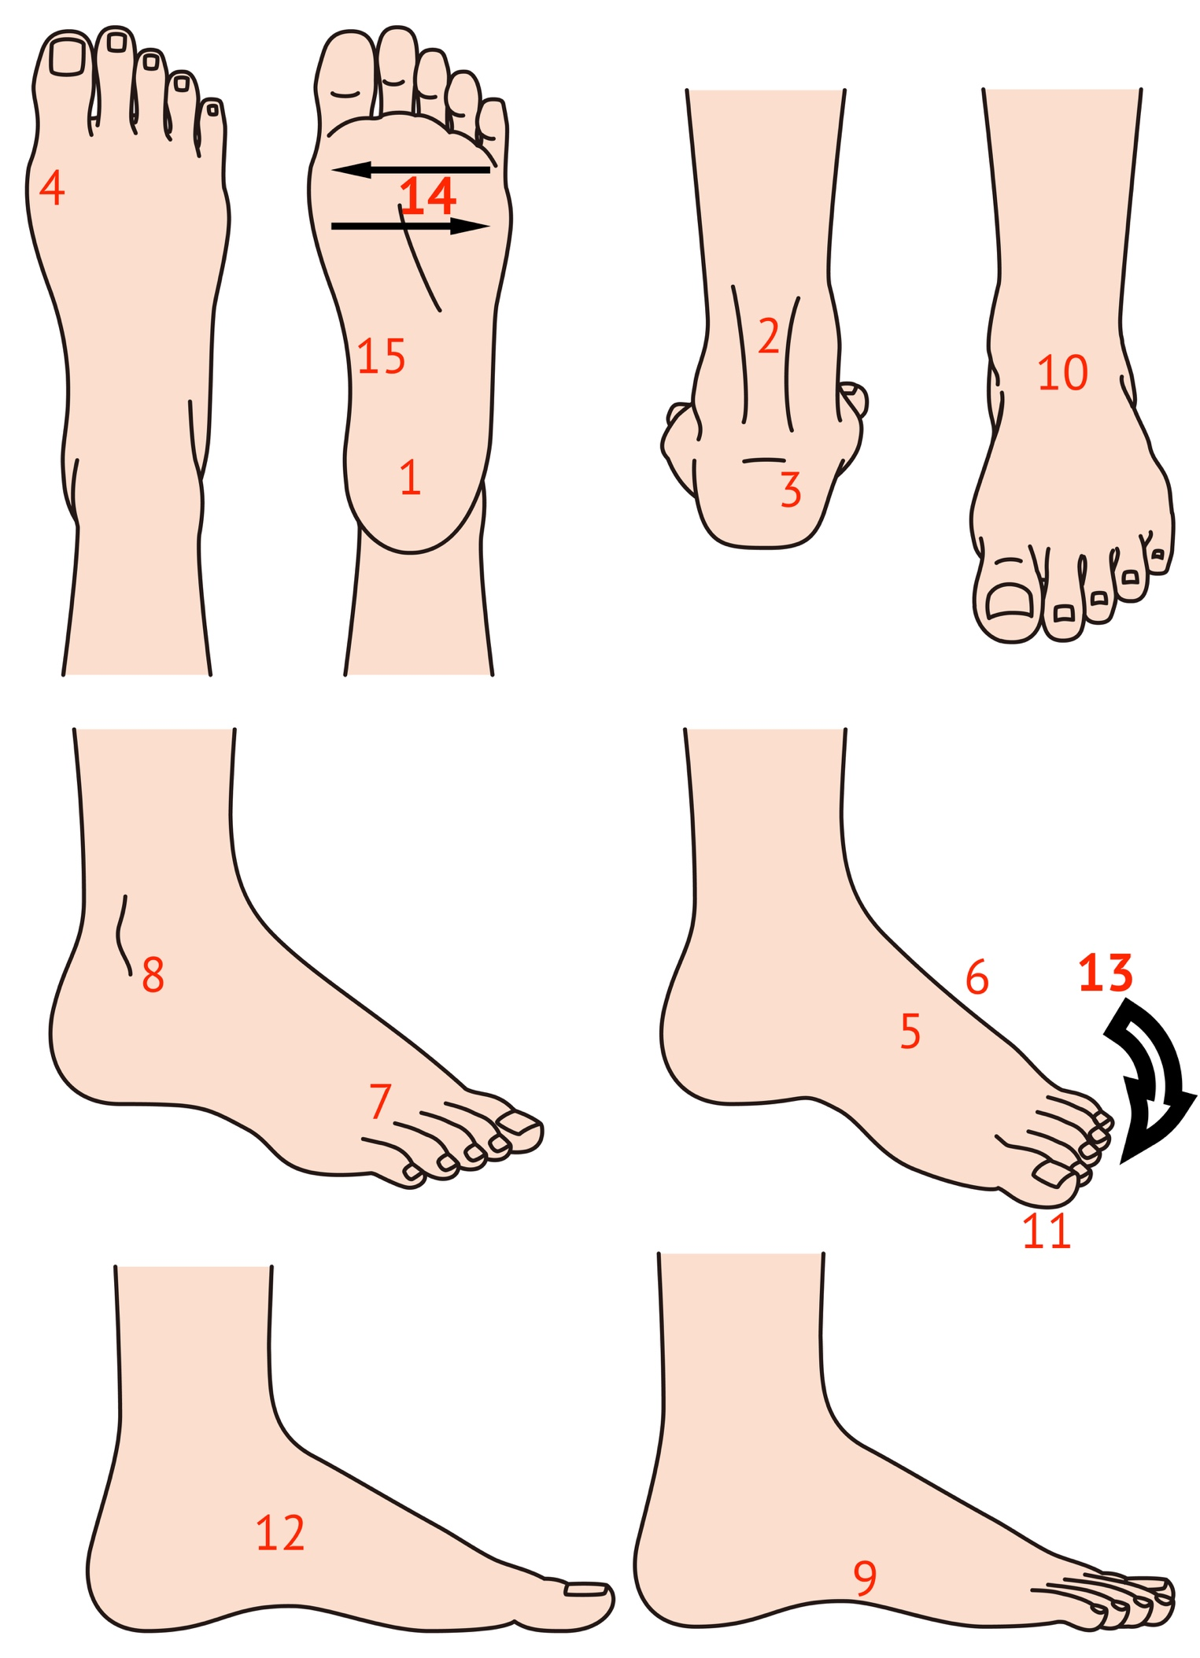

Your first aid location guide to pain in the foot and ankle

The conditions numbered 1-15 are commonly found in the foot but the simple location chart does not include all conditions and is not a substitute for more accurate diagnosis.

Remember that children also suffer from pain as well and this is often related to growth inflammation at specific point. Back of heel and sole (1/3), inside arch of foot (12) and ankle (10) as well as outside of the foot (9). Also to the right side of (7). Tendons often pull after exercise and become swollen and painful to move.

Joint pain may be due to arthritis but not always. Soft tissue inflammation may be the cause.

- Heel pain: Is it swollen, bruised or is the pain further forward? Check the skin for a foot wart or corn. Inflamed? Cannot put foot down. Most likely bruise in foot pad. Localised swelling with redness and slight discharge, maybe a dog or cat hair and can be painful to walk. Also see (15)
- Tendon (achilles): If the tendon has a gap it may be torn. Can you stand on it with the other foot off the ground? Is it tender to touch around the tendon or if squeezed? Most commonly caused by over use syndrome. Paratenosynovitis.
- Heel bump: most commonly heel bone bump (retrocalcaneal exostosis/Haglund’s deformity) in the adult. A soft sac or bursa forms. 1&3 in the child: growth plate inflamed called Sever’s Disease (growth inflammation). It is not a disease.
- First toe joint: May be joint inflammation. If red, hot and swollen it might be gout but this is rarer than overuse swelling. If stiff and painful damage to cartilage or inflamed lining more common. Bone fracture less common unless known injury. Where swollen could be bursa sac, tendonitis of the long tendon over the top of the joint. If toe is deformed see my website for bunions (hallux valgus)
- Hard bump: common in some where feet rub shoe. May have a bursa sac or ganglion which comes from a joint or tendon lining. Difficult to fit into the shoe. Occasionally forms bone projection or spur.
- Midfoot inflammation: small joints become tendon between longer metatarsal bones and smaller brick like bones. Usually in the centre over the top of the foot. Worse on walking and taking weight. If known injury, fracture. Longer standing pain which maybe due to degeneration leading to joint changes.
- Nerve pain with electric shocks into toes. Morton’s neuroma. Tingling and foot pain at the end of the toes and pad of foot. Squeeze test is useful. Pinch above and below. Look out for a click sound which may be uncomfortable.
- Outside ankle. Sprain if known injury. Small area of pain. Tendon tear, ankle joint inflammation called sinus tarsi pain.
- Outside of foot: Bone projects midway and in front of the narrow hindfoot. The bone can be felt and maybe tender. If known injury (Jone’s fracture). Local irritation can cause swelling and could be a bursa. A tendon inserts into the bone projection and can cause pain if pulled. Traction inflammation. In children sometimes a growth plate inflammation.
- In front of ankle: Most common tendon overuse. Three main tendons cross over. The most likely tendon are the extensors. Diagnosis teno-synovitis. Other less common conditions include ankle joint inflammation due to injury, loose flake of cartilage causing a defect. Swollen ankle can include gout, fracture and infection of the talus (ankle bone) or blood supply loss (avascular necrosis).
- Big toe: nail pain. Ingrown nail is painful due to swelling of soft skin and maybe infected. Injury may be associated with a bone problem i.e bone spur. The nail will be discoloured. If a dark area appears under the nail it maybe bruised following an injury. Rarer condition - malignant mole (melanoma).
- Navicular pain: Most commonly associated with large foot tendon called posterior tibialis. Inflamed (teno-synovitis) insertion into this central banana shaped bone. Less common is Kohler’s osteochondrosis and more common in children at the time of growing.
- Toe pain: commonest problem associated with buckled toes, bent over causing hammer toes with corns. Nail problems such as thickening, skin problems including ulcers where poor circulation and chilblains. Can affect all ages but worse in later life and makes walking mobility difficult.
- Ball of foot: metatarsalgia. Commonest form comes from a corn (more local) and callus (more general). Bursitis sac inflamed under ball of foot. Can be a foot wart if visible and tender. Nerve pain see (7). Joint pain can come through to sole of foot from above. Younger patients may have osteochondritis inflammation of metatarsophalangeal joint affecting toe movement especially around 2nd and 3rd toe. Adults suffer stress or March fractures. If there is a known disease this can include psoriasis (skin) and rheumatoid arthritis (joint) and some inflammatory bowel diseases (small intestine).
- Arch of foot: Fasciitis is inflammation and small tears of the fascial band. Painful to walk on and may affect the sole of the heel usually on the inside and front of the heel. See (1).
This is not a definitive guide of all foot conditions but may help you to understand what you have. If a foot pain does not settle within 2 days do not ignore it. Consult a registered podiatrist first if possible as they make a study of feet as a career. If this is not possible, seek advice from your GP or you can call 111. Avoid A&E unless an emergency i.e where the foot changes colour swiftly after injury.

The two main UK bodies are the College of Podiatry and the Institute of Chiropodists & Podiatrists.

Website: consultingfootpain.co.uk

