Reflective Podiatric Practice. 2018. 1(9):6-12
© Published by Busypencilcase Communications Ltd.

Comparison of four disinfecting techniques for clinical instruments in Podiatry
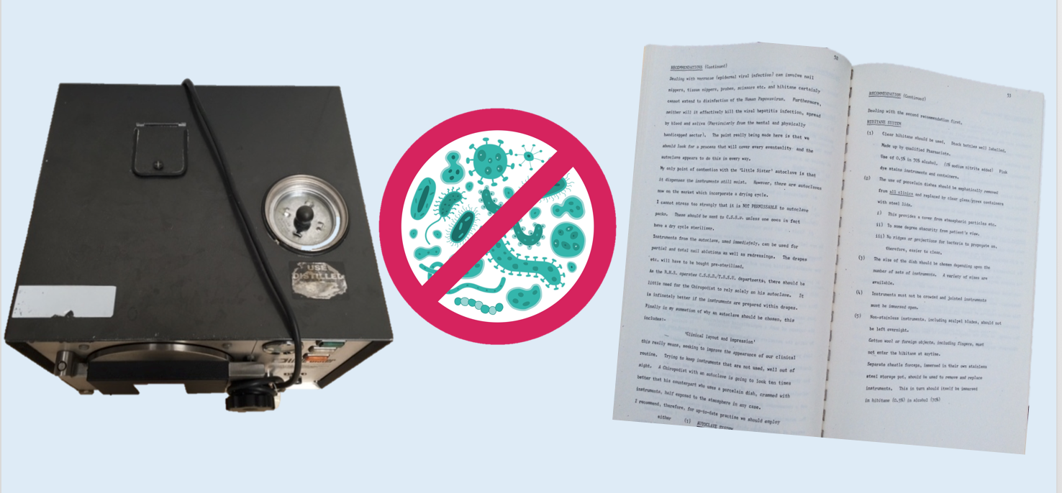
D R Tollafield⁺, M. De’ath, D Prior

Abstract

The integration of autoclaves in podiatry is new and has been tested against two other bactericidal methods with a control. The methods were similarly sampled and bacterial counts was independently undertaken by a microbiology department. The difference between methods was not significant.

While the autoclave remains the preferred method of choice, operative error can arise and the use of an ultrasonic cleaner recommended. Chlorhexidine gluconate (Hibitane) otherwise remains the choice for liquid disinfection but with attention to concentration and frequent fluid changes to provide an effective kill rate. Special attention is required to any jointed instruments and those with asperitous surfaces. The use of autoclave requires multiple instruments to meet the needs of a podiatry treatment session.

Introduction

Instrument disinfection varies considerably in clinical practice, but it is important to understand the principles in order to minimise infection in clinic and surgery. In striving to improve the scope of our practice it is essential that we control harmful
microbia, no matter whether we intend to examine the sulcus of a toe, or whether we intend carrying out extensive nail (phenolic) procedures. Although steam was known to increase pressure in vessels in the 17th century, it was French microbiologist Charles Chamberlain who contributed to the development of the autoclave. Several methods exist for preparing instruments, including the autoclave, but the approach to instrument preparation varies with liquid disinfection remaining the most popular method of preparing routine instruments. In contrast the autoclave is considered the standard method of sterilisation in dentistry. Previous work defining the application and quantifying of sterilising or disinfection for podiatry instruments has not been reported before.
Sterilisation is a process where living organisms on an inanimate object are removed and killed. Disinfection implies reduction in the number of population present but does not guarantee to reduce the whole population or even kill that population. Disinfection frequently employs chemical gaseous methods while sterilisation uses temperature elevation but not exclusively. This discussion is limited to the systems within the range of podiatry with a view to bactericidal reduction of organisms on routine instrumentation.

Known facts
Hibitane
Liquid disinfection used in podiatry relies on Chlorhexidine gluconate as Hibitane (ICI). Reports of low activity against some strains of Pseudomonas (Ps. Rettgeri) and Proteus have been reported. Pseudomonas species showed greatest activity at a pH of 8 and reduced when the pH fell to 5.2. Hibitane is effective against Gram-positive and Gram-negative bacteria. It reacts with negatively charged groups on the cell surface and is quickly absorbed to the bacterial suspension. Cytoplasmic constituents appear coagulated. Once the membranes are damaged the bacterial enzymes are inhibited. Cellular proteins and nucleic acids are probably precipitated. Aqueous Hibitane as opposed to alcoholic was reported to have been contaminated. Hibitane is used widely at varying concentrations. Even when used in low dilution it is capable of effecting a 97% kill of S. Aureus inoculum after 1 minute at 100 ug/ml [ICI Antiseptics in Practise]

Autoclave
Thermal destruction relies on moist atmospheric steam under pressure as opposed to dry heat produced by an oven. Proteins of microbial cells together with enzymes and essential cellular proteins are coagulated within a dry medium such as an oven. In autoclaves proteins from free SH groups give rise to smaller peptide chains. Once loose or mobile they join up when re-bonding so that in their new form they render the cell incapable of normal function and therefore die. Temperature rises above boiling at a pressure of 32 PSI. The combination of pressure raises the temperature to 134ºC. One of the lesser attributes lies with the fact that the instruments at the end of a cycle cause condensation making this method unsuitable for bagged instruments. The benefit of the autoclave is the effective kill time of around 3 minutes, while the cycle lasts 10-15 minutes depending upon how frequently it is used and the number of instruments. The first cycle is usually the longest.

Formaldehyde
Gaseous destruction of bacteria involves the use of formaldehyde as a strong reducing agent which reacts with amino acids. The liquid is formed from germicides (unknown) and 37% formaldehyde in water with a small amount of methyl alcohol. The mode of inhibition involves preventing protein synthesis and secondly homocysteine which is removed from the site of action resulting in the formation of thiazine-carboxylic acid. The formation of an essential amino acid methionine is prevented from joining with homocysteine. Bacteria and spores can be killed by formaldehyde gas but organic material must be removed first from the instrument. The killing time depends on the virulence of the organism and humidity but some coated spores can survive for 24 hours. Raising the temperature will help the efficiency and provide greater penetration.

Method

Aim
To establish how effective each method would be in a typical podiatry environment.

Objective
Quantitated analysis forms the main direction of this study directed at: –
(1) Evaluation of three methods to establishing any variation. Null hypothesis would suggest no difference between the control and other techniques although the focus remained to evaluate the Little Sister autoclave (SES) available to the clinical service
(2) To discover a method of satisfactory disinfection whilst being painlessly integrated into the routine.
(3) To consider the best method that would be presentable to patients, colleagues and other staff.
(4) In considering the whole spectrum of present-day routine treatment specifically:
(i) to establish reliability of reducing pathogens without contamination of the medium used
(ii) Quick to use, in view of time between patients
(iii) Economical
(iv) involve no chemicals producing hypersensitivity or skin damage
(v) the method that could be used in the event of antigen viral hepatitis
(vi) a method that serves dry instruments where possible; now recommendation by Central Sterilisation Supplies Department (CSSD) / Theatre Sterile Supply Unit (TSSU)

Technique

Environment
A clean clinical room with hydraulic chair, sink, means of central heating without drapes, carpets and curtains. Safe electric supply and socket for the autoclave.

Inclusions
Patients comprised elderly (>60 females, >65 males), children for the most part, occasional diabetic patients, mentally handicapped and pre-/post natal mothers with no known infective or open wounds.

Exclusions
Wounds that were considered open and at risk were managed with sterile dressing packs and plastic forceps and sterile scalpel blades. No known contaminated instrument was introduced into the study.

Designated instrument
A pair of nippers was used as the only instrument selected for bacterial count with a smooth surface without serration. Scalpel blades were rejected due to tarnishing in the autoclave leaving one instrument alone as the subject of the study.

Disinfection (sterilisation) techniques

Four media include:
(A) Hibitane (Liquid)
(B) Autoclave(Steam/Pressure)
(C) Formaldehyde vapour
(D) Clinical control

(A) Hibitane
Chlorhexidine gluconate 0.5% prepared by pharmacy was diluted with isopropyl alcohol at 90% (made up with a measured proportion of water to bring the strength to 70%). A pink dye Carmosine had been added for identification. This antiseptic and disinfectant was chosen for its good all round antibacterial properties and lack of toxic effects.

(B) Autoclave
The autoclave featured in this paper was a commercial brand name ‘Little Sister’. The unit is endorsed by the Medical Research Council and adopted by the Department of Health. The autoclave requires a means of heating (electricity), water to produce steam (from a reservoir) and a strong inner casing to withstand high pressures. A Brown’s tube changed from amber to green based on reaching the correct temperature. This came in a small glass ampoule.

(c) Formaldehyde
A product called Bacterol (formaldehyde) produced by Bacterol Ltd was used within a plastic cabinet with hinged doors and a plastic seal. A small electric light bulb provided heat to cause the formaldehyde in liquid form to vaporise and diffuse throughout the cabinet. Instruments were laid on a metal grid like shelf.

(D) Control
This method involved wiping away macroscopic particles from the metal surface with clean cotton wool alone any no other media to reduce bacterial counts.

Preparation & Sampling

The sampling technique involved using an alginate swab in a consistent pattern of movement between the open blades and back of the nippers. This was then placed in 9mls maximum recovery media (MRM) with 3% Tween 80 and then labelled disinfection method A, B, C or D. The time the swab was taken, date and the patient’s position within the session was recorded. Specimens were delivered within 4 hours and where this was not possible, stored in a fridge at 40ºC. Subjects were recorded in regard to the position of attendance in the session.

Upon arrival in the laboratory the alginate swabs were dissolved in 1ml 10% sodium hexametaphosphate. Ten discrete drops of resultant fluid were dropped onto the surface of a well dried (labelled) blood agar plate with a 40 dropper pipette. The plates were incubated at 37 C aerobically for 18 hours. After incubation the plates were examined for colonies, counted and recorded. The total number of colonies for 10 drops were multiplied by 40 to give the viable colony forming bacteria per instrument (org/Inst). The minimum number that could be recorded was above 40 org/inst and so anything less was recorded as <40 org/inst. It was felt impractical to count more than 50 colonies per drop. The maximum bacterial count if greater than 2000 org/inst was represented by >2000 org/inst. Hibitane liquid was sampled after each session and expressed as orgs/ml by using a 1ml sterile syringe and placing the liquid sample into a universal container with 9mls of MRM and 3% Tween 80 broth.

Results

All methods achieved a minimum of 60 samples each. Hibitane (69), autoclave (60) and the formaldehyde and control (61) giving a total of 251 samples. The organism counts ranged from <40 up to >2000 where the two extremes were not counted beyond these points. The graphs have been arranged in ranges but typically counts for the three bactericidal methods recorded 40,80,120,240,480 organisms per instrument etc. Once the control method was recorded the counts increased above 480 up to >2000 and separate graph has been used to ensure the histograph appeared clearer. With more data across such a wide range the clarity of spikes diminishes. In the case of Hibitane (A) the graph has been truncated after 541-560 counts as a single outlier at 2000 org/instr. (Figure 1). The results for the control demonstrated a wider range of bacterial counts (Figure 2).

Method | Sample size  <120 org/Inst | Percent  <120org/Inst | Sample size  <40 org/Inst | Percent  <40  org/Inst
(A) Hibitane | 59/69 | 87 | 37/69 | 54
(B) Autoclave | 48/60 | 80 | 28/60 | 47
(C) Formaldehyde | 54/61 | 88 | 34/60 | 56
(D) Control | 5/61 | 8.2 | 0/61 | 0

Table 1. Effective reduction of bacterial count below two values 40 & 120 org/instr.

Discussion

The aim behind the analysis was to establish any significant difference between methods of disinfecting instruments that were applicable to podiatry with a special interest in the autoclave. The null hypothesis was rejected as clear differences existed between the bactericidal and control methods. The control managed to reduce 8.2% compared to the other methods which had a mean reduction rate of
85%. Our statistician (D.P) did not consider that any test would be of further value without the benefit of a larger sample.

It would have been expected that the autoclave might have reduced the bacterial count to a negligible level but in fact on 10 counts the number of bacteria ranged from 120 – 400 org/instr. Based on Table 1 for similar samples, the autoclave performed less effectively for counts left on the instrument when it might be expected that counts should have been uniformly <40 org/instr. or zero.

Operational error
The position within each session showed no significant influence in numbers of organisms. Two high counts were recorded at the end of the session but too many outliers existed so that high counts could also occur at the start of the session. The autoclave was the only method that had a standard controlled time lasting around 20 minutes. The other methods had no focal time which might have influence bactericidal effectiveness.

The increased counts with the autoclave were considered to be associated with the joints of the nippers being closed and lack of careful cleaning where small particles were retained and baked to the metal. The organic material was protected and likely to survive.

In the case of Hibitane, the outlier of 2000 org/inst occurred on two occasions 15/1/79 and 19/1/79 positioned 1st and 6th in the session. Six counts occurred where the number of bacteria ranged from 120 – 480 org/instr. An independent microbiologist suggested that the Tween broth might not have been sufficient to neutralise the Hibitane when this was sampled, although the sample demonstrated <40 org/ml at the end of each session.

The three bactericidal methods all behaved within a narrow band reducing the instrument below 80 counts in most cases. The histograph shows data slewed to the left with another small cluster between 100-160 counts. Elevated spikes above 160 counts were limited. Formaldehyde spiked independently at 280 and again at 560. Hibitane spiked at 240 and 2000 org/instr. The autoclave spiked at 400 org/instr.

Larger data would have reduced spurious data trends but sample size was not considered to smooth the confounding errors out. Operator error almost certainly caused the spikes and were inconsistent. The control data shows consistent organism counts ranging from under 40 to over 2000 org/instr. although gaps arose between counts 480-600, 700-900 and 980-1200 like missing teeth. The quantity of counts varies but even without any bactericidal medium counts lie below 2000 in 82% of counts. The qualitative analysis of the organism was not sampled although the organisms that populate the skin and nails were cultured randomly demonstrating gram-positive, gram-negative bacteria and aerobic and anaerobic isolates. Seventy-two percent of bacteria cultured from routine swabs appeared associated with the limitations of hygiene, the remainder had an association with mycotic infection around nails.

Conclusion

Hibitane and formaldehyde seemed to perform similarly while the autoclave performed less effectively although the margins associated with percentage difference were narrow. All methods recorded some outliers put down to operator error.

Hibitane was produced with careful attention to the correct strength but it is recognised that incorrect dilutions and irregular replacement could increase liquid contamination. Aesthetically the autoclave is more presentable and theoretically harder to interrupt cycles. The formaldehyde cabinet while effective was considered less attractive because of potential problems with sensitivities to the operator and environment.

Recommendations

Correct placement of hinged instruments (scissors, nipped and forceps) is critical and overall recommendations include an ultrasonic cleaner to remove particles and prevent baking onto the metal surfaces. Autoclaves would have primary use in clinics especially where nail surgery would be carried out. It was recognised the longer preparation time required for the autoclave, but effective reduction of potential pathogens would fail with inadequate attention to instrument cleaning. Sufficient numbers of instruments sets would be required to meet the new requirement of busy sessions.

Bibliography

Sykes, G Disinfection and sterilisation. Theory and Practice 2nd Ed. Chapman and Hall
Turk, DC, Porter TA A short textbook of medical Microbiology
Abramson, C Normal ‘Opportunistic Flora of the Lower Extremities related to Post Operative Wounds. J. American Pod. Assoc. 1977;1,67
Skinner, FA, Carr, JG Normal Microbial Flora of Man. Academic Press
Taplin D, Basset DCJ, Mertz, PM Foot Lesions associated with Ps. Capacia Lancet 1971; ii, 56
Antiseptics in Practice. Imperial Chemicals Industry (ICI) 1978
Turvey, JWJ, English MP Tinea Pedis caused by Hendersonula Toruloidea. The Chiropodist 1979:3,34
Kelsey, JC, Maurer JM. An in use test for hospital disinfectants 1966 Ministry of Health & Public Health Laboratories

Acknowledgments

Mr T Ward FIMLS, BA, Mr JL Honigman MPS, Mrs P Oliver Manager CSSD, Mrs D Butcher, Northampton General Hospital Medical Library, Mr G Parker MChS, Mrs J Hales MChS, Mrs A A’Barrow SRN, Mr DFJ Hext-Fremlin (Bacterol Ltd)

⁺This paper is dedicated to my mother Elizabeth (Betty) Tollafield (1928-2012) who typed up the original manuscript in 1979.

This is an original unpublished paper compiled in 1978-9 from research and has been modified from the original report as a paper. The data remains unchanged and graphs have been reproduced in modern format from mathematical graph paper. The original report was peer reviewed.

Figures 1 & 2 below

Figure 1 Bacterial counts. Hibitane reaches 2000 as a single outlier as has been excluded from the graph

Figure 2 Bacterial counts for the control method range from <40 - >2000. Counts between these ranges were to nearest whole number

Clinical case (Answer)

(1) Your diagnosis? (2) What pathology is identified? (3) Why was surgery indicated?

The diagnosis was crystalline gout which was part of combined morbidity with controlled type 2 diabetes. Histology confirmed the pathology. The importance of access to x-rays cannot be overstated and represents principles of alignment, bone quality, cortex, cartilage and joint condition as well as general relationships with soft tissue. A minimum of two views should be ordered and in the case of toes DP (dorsi-plantar sometimes antero-posterior or A/P) /MO, or medial oblique weight bearing.

Tracing the periosteal lining continuity helps with cortical breaks. Osteomyelitis can be found but the case suggests the skin lesion breaks down because of the interphalangeal dislocation (3rd toe) and pressure build up because of callus. Because the centre is damaged and forms a nucleus this is a type 4 callus lesion. The internal inflammatory change evoked by the effects of gout forms a dense sticky white mass which adheres to soft tissue. This has the consistency of crushed almonds. Cleaning the precipitate is next to impossible and treatment is by excision of the joint (arthroplasty), fusion (arthrodesis) or amputation (digital disarticulation).

Amputation in this case provided a clean low risk resolution for the patient with intended shortening of the toe. The patient had right hip OA and therefore the consequences of treatment meeting the four designated principles of podiatric care. Pain relief, tissue preservation, correction of deformity and establishing mobility. In an 80-year-old such an approach is indicated and considers the effective use of surgery for rapid resolution, minimal long term consequences, effective reduction of routine management with dressings and further antibiotics and cost savings.

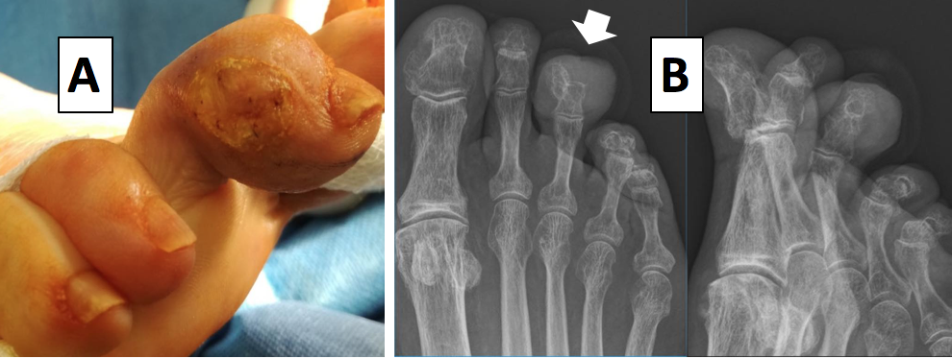

My thanks to Mr Lee Murphy for submitting this case history for reproduction in Reflective Podiatric Practice

ADVERT

Devon Branch. 15th November at Newton Abbott 7.30. Patient Communication. Making an Impression. The Painful Foot: Morton’s Neuroma. Contact the branch secretary for more details
kate@mypodiatrist.co.uk

