Conditions in General
risk and impact: The facts
Information booklets from ConsultingFootPain published by BPCC Ltd 2018

What is this factsheet about?

A low risk might be rare but can have a significant effect on recovery and later life. Read this before making a final decision.

- a summary of the condition
- the operation
- the main aim behind the surgery,
- things you need to know,
- general information,
- Impact scores
- useful resources

All surgery carries risks. Some are minor and are expected. Others are unexpected. These are known as complications and can take many months to deal with. In rare cases these problems lead to longer lasting effects and we grade these at a higher level.

The operation or treatment

Your operation or treatment will be described and you can have as much detail as you wish. Look at You Tube although it is better to be provided with a guide to the best to watch. Some are too long and unnecessary in detail. Others are poor quality and the spoken part delivered badly, some out of focus. Beware of sales pitch and people who say there is NO risk. It maybe that they have low incidences of problems after surgery, but all surgeons have problems, albeit mostly of a minor nature.

Aim of surgery

Surgery is usually offered when there is no other alternative, or when weighing up all the choices, surgery seems the best solution. Do not be fooled that surgery has no risk therefore. The often spoken comment by patients, “I can’t be worse off” is not accurate. You can be worse off and may not make the recovery you want or think. What do you want to achieve from your treatment? Avoid just leaving it to the specialist to decide

Things you need to know

The operation is performed by qualified podiatrists called podiatric surgeons or orthopaedic surgeons. Both have extensive training but use different routes to reach their final qualification.

- Recovery time and healing varies between different surgeries.
- Mobility – getting around is more critical after foot surgery as it is the first part of the body to make ground contact
- Getting back to work. How much can I do?
- How can I get about and when can I start bathing?
- When can I wear shoes?
- When can I use a plane for travel?
- Can I go to the theatre or cinema?

Where to find this information?

Ask the questions, write them down so as not to forget if you become flustered. The internet is awash with information on most things, but can you rely on this source? The College of Podiatry have collected data for many years and electronically since 2010 providing a good idea of risk incidence and more recently working out the real impact. We look at a lot of feedback we call data as percentage figures. You can look at the reports published each year on the site called PASCOM-10 database and resource site. You can use my own site as I have forty years of experience as a podiatrist trained in foot surgery.

General data

Size of data is usually large often many thousands. Benchmark scores show patient satisfaction score and are expected above 70 for most cases but these are not percentage scores. Scores for surgery of this nature are marked down because return to footwear is considered or delayed healing. Only simple surgery can be expected to consistently reach (90-100). Return to footwear is taken as a closed in shoe. Many cannot wear shoes for at least 6 weeks and in some cases much longer. We consider how patients feel about their treatment (surgery).

How patients felt about their surgery

Aims met for patients can only be achieved if the patient is happy and of course we cannot make everyone happy, but better at least so that the problem is not as bad as it was. We look at patients willing to repeat the experience and measure this in percentage terms. We look at pain after surgery and divide this into excellent, some discomfort but coped, and poor pain control. Expect poor pain control sometimes but it is usually recorded around 7-10%. At six months or there about, we ask About your condition. Is it better or much better, about the same, a little worse, or has it deteriorated? What is the discomfort now (after 6 months)?

Making decisions

Now we talk about problems after surgery in different ways. No problems at all, minor (e.g dressing problem or wound) or a major problem (extended care or infections). This is where we need to be sure you understand what we mean by problems, risks and how it will affect you. If you had a serious accident you would have no choice but to have treatment to save you from death. If you had a problem that was not life threatening, it is you who have to make that final choice. We call decision making ‘consent’. As podiatrists we go a long way to ensure you know about your condition, the prospects and alternatives, should they exist as sometimes there are no alternatives that work especially if the foot problem is painful.

Relative risks
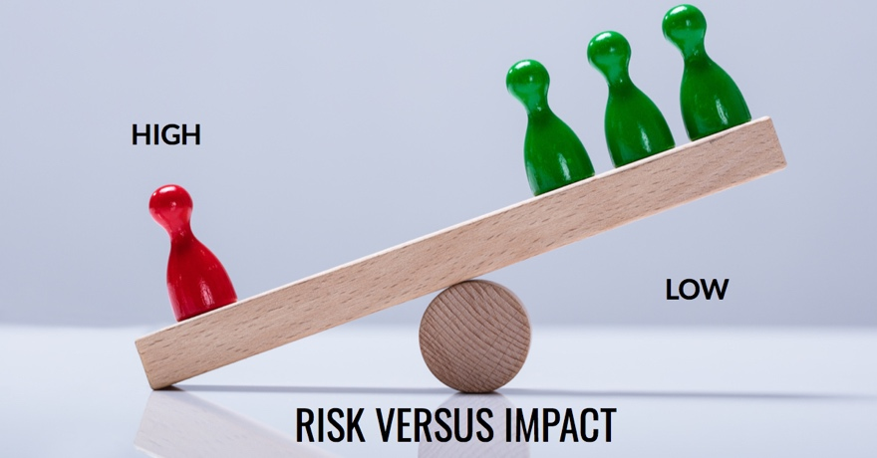

If you had treatment and a problem arose it would be comforting to know that any problem can be fixed. We have divided risks up and assigned different levels of impact as well. Look at the seesaw. Despite the higher chances of having a problem (green) the impact is low because most problems can be fixed. However, the red pawn on the left is less common but outweighs all the other risks. So what does this mean to you?

We know that in some 70% of surgical cases there is NO problem, in fact it is only broadly around 30% or less that a problem arises. Risk is measured in percentage terms so a 1 in 100 means 1% and 1 in 1000 0.1%. The 0.1% sounds low and therefore gives the impression there is an unlikely risk of such a problem occurring which is true. If that 0.1% risk did arise and had 100% consequences would you want to agree to treatment? Oddly enough we cannot advise patients and where it goes horribly wrong is when a patient believes they were inadequately informed. Sadly, turning the clock back is not an option.

Impact scores

Because a problem may have a negative impact we call these Negative Impact Scores and grade them 1-5. So for the smaller number of cases where a problem occurs, say less than 30%, which means you have a chance of just over 1 in 3 of having something arise of inconvenience. Of this thirty-percent only a tiny group have a problem that affects life or success of the treatment. To make it easier I have provided a grid.

Impact level | 1 | 2 | 3 | 4 | 5
 | minimal risk, no effect | slight risk minor effect | moderate but correctable but inconvenient | notable recovery longer than expected | significant with permanent effects

Days Years

National Data from the College of Podiatry

The data was collected over a 2-year period 1/1/16 – 31/12/17 and covers over 22,000 different treatments at 108 centres. Seventy percent had no problems so did not fit into the box above. Just under 30% fitted the boxes. Level 3 is usually the highest purely because it contains more options and suggests moderate and correctable problems. Level 5, which has significant concerns records 0.036%. This means for every thousand patients under 4 were affected by a level 5 impact. Compared to level 3 at 11% this is very small. Levels 1 (2.9%), 2 (6.5%), 4 (4.2%).

What are these high levels of risk?

Fact sheets from ConsultingFootPain include high impact levels 4 & 5 although other risks are represented. Figures below are as percentages

Osteomyelitis bone infection 0.03 4
Blood clot leg 0.29 4
Infection proven 0.74 4
Wound breakdown (healing) 0.18 4
Complex regional pain 0.13 4
Loss of large sensation 0.05 4
Failed surgery 1.6 4
death at surgery 0.009 5
Loss of muscle power 0.15 5
Lung clot 0.04 5

Further information & disclaimer

This is a free factsheet and has been independently written and updated by a former podiatric surgeon without sponsorship.

Surgery is not risk free no matter how well performed. Do not consider surgery without understand other options. ConsultingFootPain aims to provide free impartial information to a wide reader interested in foot health. This fact sheet provides links to other information.

ConsultingFootPain factsheets do not replace advice offered by your consultant or specialist neither are they intended to replace correct consenting before surgical management or replace additional information your specialist may offer.

Numerical data has been gathered from the College of Podiatry and is one of two professional U.K providers for foot surgery. PASCOM-10 is a national database for podiatry and was commissioned originally in 2000 and is wholly owned and administered by the College of Podiatry.

Please sign-up to my website consultingfootpain.co.uk. for further information on foot health problems.

Reliable resources- from NICE and NHS choices

https://www.nice.org.uk/
https://www.nhs.uk/conditions/consent-to-treatment/

Useful websites include: https://www.scpod.org/, https://www.bofas.org.uk/

