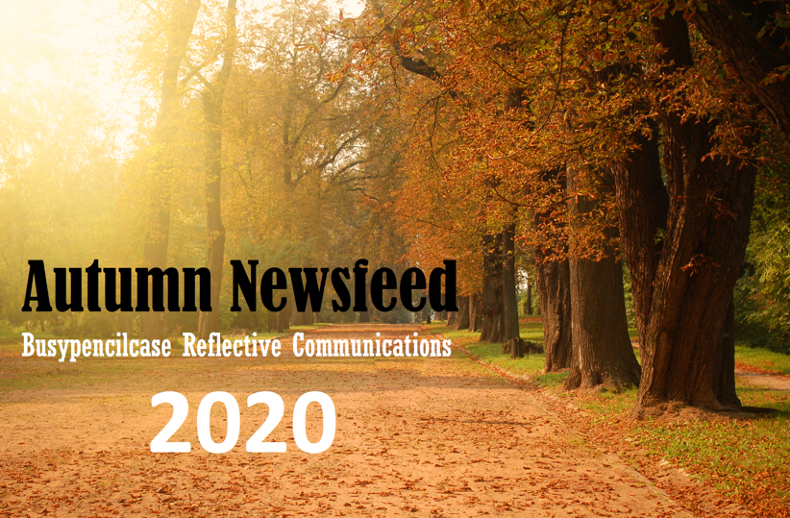
Autumn Newsfeed for reflective readers
Welcome to this printed version of my Autumn Newsfeed for reflective readers.

Fed up with hearing about Lockdown and The Virus?
This newsfeed is a transcription of my Podcast released with my Mailchimp September 2020 drop which you can pick up by clicking here for Podcast. It’s a pithy overview of the past season we have all come to know as Lockdown. We could select different phraseology for this period of viral confusion, but this is a family show. And of course I will try to remain apolitical.
I don’t know anymore than any other reader when we will see NORMAL again. I guess we can say that our first Lockdown is over and hope that the powers at be don’t start another national seclusion programme. Enough of this talk as we are doubtless fed up with the recurrent themes that say little, but cause much distress. However, Covid has crept into our lives unexpectedly in different ways.

Reflection on Output
I pondered over my website’s list of articles during the same period March to August. Last year I wrote 19 articles. For the same period of our so called freeze this year, I have notched up 72 articles and published one book and completed several professional articles. I’ve carried out over 25 zoom interviews and webinars and set about designing a talk for a local branch. My autobiography (that’s Part 1) is nearly complete. This of course this leads to that wonderful saying, how did I ever find time to go out to work!

Anxious state?
Although not amused at the time I developed a rash on my stomach and backside so I couldn’t sit for a week. It was all rather embarrassing. Frankly I’m only telling this story as I wonder how many of us have been affected without the formal conditions on the viral hit list. I didn't have Covid as I had isolated with my wife in one of those bubbles. Okay I hadn't been tested but who has unless they were on the expiry list at the start?
I thought my GP might want a picture of my backside! Fortunately, I managed with antihistamine and some natural medication - valerian. I even had to stop writing which for me was unusual. Not least I had attempted standing up to write but this did not work. Was it a plant rash? We had no Japanese Knot weed thank heavens, only hemlock in the garden. While poisonous, hemlock was not an irritant like knot weed, but I dug it up anyway. Was it grass or another allergy? Whatever it was I put it down to that creeping anxiety which overwhelmed me despite my stoic attitude toward life in the UK. I must add we had cancelled 2 holidays abroad. The idea of flying now seems reckless and so I am astonished at droves of people caught by the sudden turn of events. Of course we both worried about family and an elderly father in particular... more about him next.

When I get older losing my hair
Many years from now...
You know I find I am writing about things that as a younger man I would never have conceived as being remotely interesting. The Government decree 65 as an age for those who were at risk when we started this viral intrusion. Thank heavens I'm not old as I'm only 64, although the Beatles may have disagreed when creating the album Sgt. Pepper featuring the very song. Like many, my wife and I relied on good neighbours for food deliveries. Now we go out with masks and social distance avoiding crowds. The Lockdown did not come without other downsides. Concern maybe for my aging father as I could not see him for 4 months. And so I have just finished an introspective view of dealing with falls in the older age group, hence an article about Dad and falls. Through my father I see the Grim Reaper of age changing my life in small chunks. Am I ready for that time of life where my independence is threatened. Read more here

Feature Spotlight this month
The growth in my literary output allowed me to look at spotlighting contributors to my freelance offerings; I have called these Clinician Spotlights. Recent contributors have their own articles, one in particular is featured in this issue. There are others so do keep an eye out on more newsfeeds or check out my website content.
Dr Jill Halstead-Rastrick pressed me to think about Black Lives Matter from the clinical point of view. This topic is featured in my Autumn Newsfeed. However, she threw down the gauntlet causing me to reflect on my own thoughts as a white man. Was I racist? Read more here
For those who know some of my other colleagues... their contributions have been valuable...
Tony Wilkinson, a podiatric surgeon has also produced a great story of his achievement as a consultant so look out for this in my October Newsfeed. Of course if you dip into my website you will see articles before they are officially reported. Signing up just keeps you informed as well as providing a reminder about what's been published and what’s coming.
Trevor Prior interviewed for his series called the Covid Diaries keeping people alive in a hospital ITU after the ravaging effects of Covid. This was well received all round. The last part was published last month so you can read all the articles together. I was rather delighted that the College of Podiatry sought to publish a heavily edited version. I commend the full set to the readership as much was chopped out. Read more here

Surveys, Podcasts and Hyperlinking
You see we cannot really depart from the topic of this wretched virus as much as one wants to!
Telling stories of true life events is so much more interesting. I originally wrote formally back in 2018 about healthcare but feel readers want something different. Some of my interviews will be published over the coming months as we head into 2021 plus I have a new project to be revealed on the horizon.
A survey conducted earlier in the year allowed me to change direction. Admittedly only low numbers responded but it has a baseline value from those who were active readers. I know surveys are the beast that lurks in our daily inbox so no hard feelings. The outcome led to the idea that some wanted easier downloads. Avoiding the hard copy style that read less well on tablets and smart phones was something I needed to address. I am going to keep some print offs for those who want hard copy from their computer, but in this fast world of the internet many want to read things on the run. I also appreciate that the Podcast has become more popular so I have hooked up with Podbean to expand on this medium.
Like it or not we are moving into an even more dependent on-line world of purchasable items and written works. Listening to this Newsfeed allows you to cook, walk, drive but perhaps not swim (yet), but you can still catch up on the go. I now have ceased writing professional newsletters. I will be running another survey in 2021 to check on how readers feel about items and new look presentations. This doesn’t mean you cannot contact me earlier with your suggestions. These are always appreciated and I DO LISTEN.

Hyperlinking
Hyperlinking allows the reader to pick and chose what to dip into. I have now produced a new contents page on my website with linked articles. My website search facility has been strengthened so all you need to do is type in your preferred term or phrase and you can see all articles related to that subject. I have even produced a Loom webinar on navigating the website. This can be found using the link here. Download Loom and you are set to go. My teacher daughter gave me the idea and if this become popular I will do more Looming for readers. In the meantime, I am trying this out on one of the professional branches next month as we still need to social distance!

Book Reviews and Writing for readers
While I am both a supporter of medicine I am a critic of medical practice. Sadly, GPs are going to experience a rough ride presently as they are not meeting everyone’s needs because yet again, that virus. The topic of on-line consulting will continue to become news. Our health service is a great institution, but like the mental asylums of old, and now disbanded, our health service is in tatters and does not fit the overall needs in the 21st century. It is the ‘people’ who work in this colossus that hold the NHS together as sticky plaster holds a paper framework.
Rachel Clarke’s book for me was an eye opener. Journalist and medic she left me shuddering at the wanton destruction that politicians are able to demonstrate all in the name of their personal hegemony. I reviewed the book with the passion that any author has for another.
Readers often prefer the lighter touch articles, and for this I am pleased because I find even the world of professionals find formal publishing less engaging. The language is frequently uninteresting and an abundance of statistics make consumption heavy going. I have used WordPress's guide to the Flesch Score to help with aiding reading complexity. You will know when reading one of my articles the level of difficulty. However, I have found with interviews the score drops steeply and sentences are lifted from speech rather than written for their prose. This article for example has a score of 67. The norm here will be 50-70. If you want to learn more about this interesting score and how it came about I published an article on reading scores.

Stories from the past...
Writing from the heart is more fun and engaging. It reaches a wider audience. Readers often find that they are more in tune with anecdotes bringing life to case stories.
I am a greater supporter of evidence and best practice. I deplore poor research and encourage my own profession to team up with researchers and statisticians to undertake quality work. The NHS frankly does not encourage research by rank and file clinicians and I like many have fought with the institution over this subject. I spent a whole year putting together a research project together with colleagues. At the 11th hour those wiser than me discharged my waiting list and all those I had recruited to the study were lost. The patients did not benefit and were sent elsewhere often with unsatisfactory outcomes.
Nonetheless I set out to bring the field of healthcare into the living room. I used two premises.
Firstly, I don’t want it to sound over complicated and wish to avoid treatment that does harm. As a former foot surgeon I remembered those I failed to help, or could not help. Those who were disappointed and even felt I was doing it just for money. These sorts of accusations hurt. I only know now I want to share my experience from the inside and that is why I wrote two books for patients and put all the serious risks in.
I will be saying more about risk and consent in a later edition of newsfeed as I am not sure everyone understands consent. A sad story from the past saw a patient suing because of perceived poor consent and losing in court because she had not be appropriately advised by her legal counsel.
Secondly, I dislike the cheap sale of anything to do with health. Cheap as in 'naff' but not inexpensive is unfair. I read internet articles that just want to sell products with false promises. When writing my bunion book behind the scenes (inset), the products and books written that I had researched filled me with scorn for their fake news and deceptive intent. My promise is to write articles that are reliable. Sites are scanned for relevant information and regrettably do have adverts but if the content is fine then I will use this. Likewise illustrations and diagrams can be better viewed from a linked website.
Trust and facts
I retain my registration, not because of my professional title, 'podiatrist', but because I want to assure readers that I am accountable and trustworthy in what I write. And of course I want to ensure that the content is accurate and up to date. Now I may not get it right all of the time but I do my best. My recent articles on hammer toes were intended to consider the subject from the lay reader’s point of view, with a second article written for clinical colleagues. Read lay article on hammer toes here

Themed series are in...
In this Autumn Newsfeed for reflective readers I want to say that it has been much more fun creating stories and articles that link to each other. Usually they stand alone but consider a theme. To do this, articles around 2-3000 words work well and can be divided up into bite size chunks. The Covid-19 diaries for example and Afni Shah-Hamilton’s series on cancer at the start of 2020 were important contributions. They also provided a record of life in the 21st century. I have just launched my first gym diaries this August. Earlier series covered pain and the foot and one on walking.
Returning to the gym or fitness centre after months away was a great opportunity to look and learn about equipment. My waist has expanded a little so I was grateful to my gym for surviving and welcoming me back in July. I had wanted to write about fitness centres for some time and this has grown into a series; actually 12 articles. This continues and follows this lump as he struggles to shape up. The second series will include Barney Stanton who will be writing about nutrition in January. Read more here

Failing or succeeding?
My publication on ‘Selling foothealth as Podiatry’ sends a message that the professional bodies do not publish patient and people friendly information. Read a book review by Beverley Wright in a future newsfeed covering this recent contribution to the profession. One professional body is allegedly promising a new site. You can be sure I will write an article on that! Will this up the information game or just be another membership site?

More patient Journey Stories
It is great that people are willing to share their worries about foot health write. I continue to collect these through my email address, myfootjourneys@mail.com. I look to publish more about these journeys in 2021.

Linking up with other sites
Many companies write asking to be linked and I am happy to link anyone IF it has value for my readers. Linking is free but, I do not advertise for sales unless it has added value. Likewise, any person can write and share their thoughts and experiences. My message aims to cover reflection and if you are able to undertake this, it’s fun if you can remain objective and open minded.
Broadening subject matter supports everyone. My own key message is associated with reflective communication. This reminds me that if I fail to reflect I will continue to make the same mistakes. It’s good to remember that making a mistake is not a crime. The crime however is failing to learn from the mistake and repeating it. My Black Box article still resonates this message. Maybe some politicians could learn from this as we can see from the pages of Rachel Clarke’s book?

Around the corner
I wish you all well and hope you continue to read, listen, write and enjoy my scribbles. Do follow me on the social media platforms of Facebook, Twitter and LinkedIn.
My next main Newsfeed will be a Winter edition in December, but reflections in communication will continue each month for those signed up. If you visit my website consultingfootpain.co.uk you will find a big sign-up button on the landing page where you will receive a reply and a link to this newsfeed. You can also download two free archives books on Foundation Orthopaedic Biomechanics and Podo-paediatrics on signing up.
While my books are available on Amazon and help to fund this free website, you can visit my bookstore and save on postage.

David R Tollafield is an author and editor for ConsultingFootPain and Newsfeed. Read more about him here
To receive regular Newsfeed Mail drops sign up on the landing page

Thanks for reading my 'Autumn Newsfeed for reflective readers' from Busypencilcase Reflective Communications
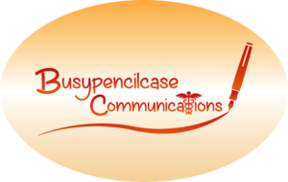
Est. 2015 September 2020

