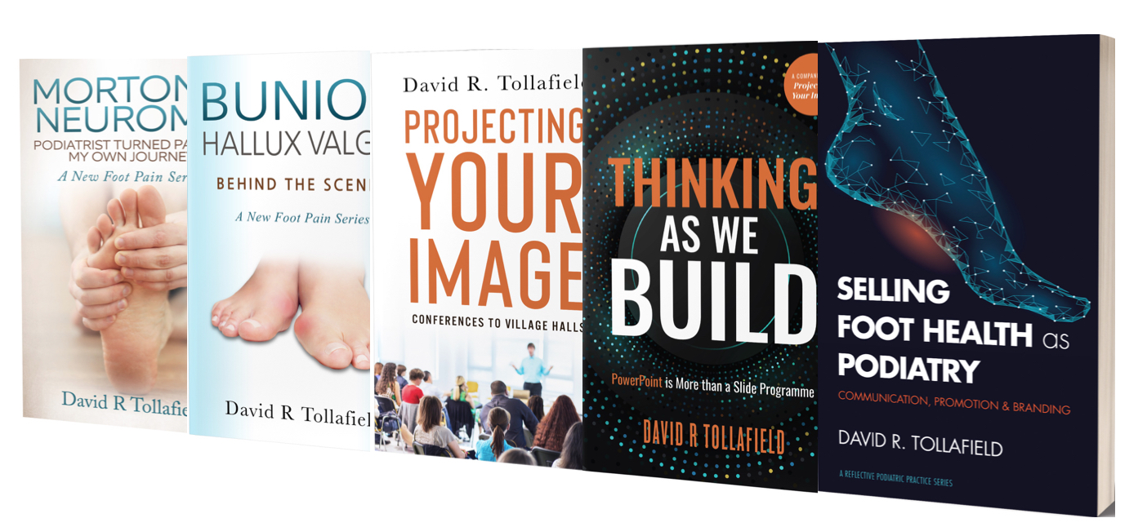

Busypencilcase Communications Ltd

Paperback Bookstore
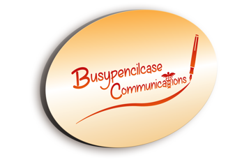

Why not buy your book direct?

You can save between 30- 40% including postage to UK and N. Ireland addresses. Unless you use Amazon Prime, you will need to add postage and packing which may vary.

Another way of saving is to become a Beta-reader. Download a free 4th edition copy of the guide here. All e-books are available from Amazon

Bunion Behind the scenes £12.00
Projecting Your Image £7.50
Thinking as We Build £6.00
(Power Point is More than
A slide Program) £6.00
Selling Foot Health As Podiatry £7.50
Morton’s Neuroma £15.00
Buy ‘Morton’s’ with ‘Bunion’ £25.00

Current methods of payment by bank transfer or PayPal.
As these methods have not been set up as an automated service and are subject to demand, please contact davidt@busypencilcase.com first.

