The Impact of anti-cancer treatment on feet
Part 2. Podiatric Adverse Events

Afni Shah-Hamilton
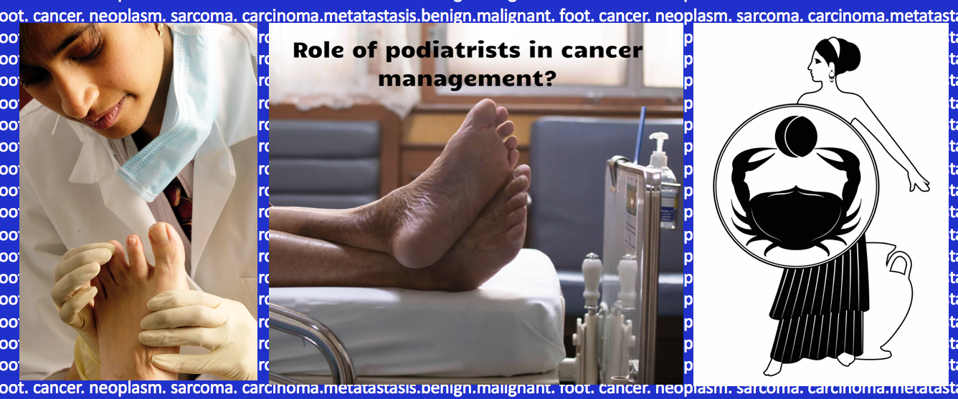

In her previous article, Afni looked at the crucial role that podiatrists played in detecting early signs of potential malignancies with an overview of a number of conditions. In this second article dealing with cancer care, the focus moves toward the role that our profession contributes to the cancer pathway; from detection to treating patients during their cancer management, to rehabilitation after treatment and supporting cancer survivors. Afni endeavours to guide podiatrists new to this aspect of health care under the heading of complications or adverse events associated with anti-cancer medication and treatment. She will focus on five examples over this and the next article, the first being peripheral neuropathy. (Ed.)

T
he field associated with understanding the complications of anticancer therapies and implications for the podiatrist is likely to be a key growth area and important. Minimising complications from therapy remains a chief aim of any practitioner whilst educating patients at the same time. The aims can be associated with reducing:

- Pain,
- Depression,
- The risk of infection arising,

As well as

- Preventing premature cessation of anti-cancer treatment, and leading to improving the patient’s quality of life.

Five Podiatric Adverse Events
Five podiatric adverse events (see box) are considered warning signs and form the objective when considering categorising vulnerable patients and their appropriate treatment.

Peripheral neuropathies
Hand-foot syndrome
Xerosis
Nail Toxicity, inflammation & infections
Thickened & mycotic toe nails

A report documented that anticancer therapies may result in adverse events that can negatively impact the normal functioning of the feet and lower extremities and most importantly have a considerable impact upon the patient’s wellbeing Lacouture et al.. Few articles (in podiatric literature) discuss preventative management. Improved awareness amongst professionals and patients would be of great help.

Podiatric adverse event
An increasing population is being treated under the term ‘treatable but not curable cancers’ and many of these will need podiatric treatment as symptomatic podiatric adverse events (PAEs) are common in patients treated for cancer. Originating from US sources, Lacouture (2018) considers the effects of cancer treatment on foot health. The following regular pedal problems include:

Changes within the foot cause new footwear problems.
Painful walking and weight bearing.
Changes to tissue integrity i.e skin and nails
Painful arthropathy.
Basic self care and daily life activities are difficult to engage (e.g. cutting toenails or caring for the skin)

Podiatric-medical intervention is paramount to avert the rapid development of complications associated with the undesirable effects of anticancer therapy. By working in partnership with the patient and their cancer team many concerns can be resolved. Podiatrists will need to understand adverse events related to anticancer therapies in anticipation of complications arising from their own intervention.
At present, there are no widely available educational tools for patients highlighting likely PAEs and the potential consequences of failing to treat them. There is also no lower limb screening or direct referral system into podiatry that naturally guides them towards appropriate professional help. As a result, patients may be unaware of the connections between their foot issues and their anticancer treatment or that many of these issues can be managed. It is important for all podiatrists (within the NHS or private clinics) to create an awareness that they can help treat PAEs and improve patients’ quality of life. This knowledge not only empowers the patient to take the right action at the right time but also helps them to be more resilient as they are better prepared for the challenges ahead.
As 1 in 5 cancer sufferers also have diabetes, adding to the overall high risk, diabetic patients should be encouraged to see their podiatrist more regularly, or at least early in their treatment cycle in order to reassess their diabetic foot status. The aims from early intervention ideally will help reduce the risk of ulceration, infection and amputation.

Key anticancer drugs that can cause CIPN
Biological agents- bortezomib (Velcade) | Thalidomide
platinum based drugs: cisplatin, carboplatin and oxaliplatin | Taxane drugs- paclitaxel and docetaxel
Vinca alkaloids- vinblastine, vincristine, vindesine and vinorelbine | Antimetabolites- cladribine, cytosine, fludarabine and methotrexate
procarbazine | etoposide
Ifosfamide | thiotepa

Peripheral Neuropathies

The first of our Podiatric Adverse Events is peripheral neuropathy which manifests in two main forms - peripheral neuropathy and chemotherapy induced peripheral neuropathy.
We will look at these together as the treatments are largely the same. Peripheral neuropathy (PN) is one of the most common conditions associated with anticancer therapies and can be highly debilitating. A neurological assessment is recommended at each consultation when undergoing anticancer. Peripheral neuropathy normally starts after several months of anticancer treatment and patients complain of the following

Numbness or tingling;
Diminished or absent temperature sensitivities
Reduced ability to discriminate between
temperature,
sharp and blunt,
light touch,
vibration.
Altered muscle strength which can lead to imbalance and
an increase due to loss of ground awareness

Symptoms may include a ‘glove and stocking’ distribution that can extend to the knee. The severity depends on the dosage, frequency and length of each treatment cycle. PN negatively affects proprioception feedback to the brain, disrupts normal gait patterns and creates variations in the patient’s movement.
It is relatively common for patients to complain of a burning sensation in their hands and feet and some have found this to be so severe that they have had to take morphine lollipops to help manage the pain. Meanwhile, as numbness leads to changes in a patient’s mobility, there can be an increased risk of neuropathic ulceration and infections.
Patients who have other risk factors such as diabetes mellitus and obesity, as well as those with vitamin B₁₂ anaemia are at a higher risk of developing PN. For example, some cancer drugs affect blood sugar levels, which can instigate or aggravate problems faced by these groups.
Patients who exhibit acute onset of PN are more likely to suffer from falls and injuries as the foot and body hasn’t had time to adapt to the neurological changes. They are also more susceptible to neuropathic ulcerations. In these cases, it may be necessary to suspend or reduce the dosage of anticancer treatment in order to mitigate the risks associated with these side effects.

Chemotherapy induced peripheral neuropathy (CIPN)

Where PN is specifically chemotherapy induced, it mainly affects sensory neurones rather than motor neurones. This may be due to the lack of protection by the blood-brain barrier and less myelination of the nerves. Patients being treated for solid tumours or hematologic malignancies are particularly at risk.
Various studies have looked into managing the pain associated with CIPN. Trials of duloxetine and venlafaxine had positive results. as have a topical combination of baclofen 0.75%, amitriptyline 3% and ketamine1.5% gel^{8,9}. In my experience, patients have benefited from applying three layers of Opsite film or Tegaderm to their feet to calm the sensation.
On the other hand, Vitamin B12 deficiencies have been found to increase the onset and severity of CIPN . Further studies are needed into the role of B vitamins but it has been recommended that clinicians monitor these levels and some of my patients have anecdotally reported that they have found taking vitamin B12 is very beneficial in reducing the pain felt. As a podiatrist, you may therefore wish to discuss the potential benefits of the patient taking B12 supplements with their oncologist.

How can podiatrists help with peripheral neuropathy?

One of the main areas that podiatrists can assist PN patients is with footwear issues. Patients who have lost sensation will tend to wear shoes that are too small, in order to be able to feel the shoe is on the foot. They also wear the wrong shape shoe evidence by deformities forming and exacerbating problems. Gait pattern changes may place increased pressure in certain areas on the foot, resulting in the footwear feeling uncomfortable or painful. This is particularly common in elderly patients.
As a simple solution, some PN patients prefer lightweight sandals with a moulded foot bed and a tight fit to help their proprioception. However, the following advice and using our wider footwear knowledge, podiatrists can be invaluable to someone suffering pain due to their PN;

Highlight if shoes are too tight/ loose (causing potential nail damage or ulcerations),
Put memory Poron into footwear to aid cushioning, particularly if soles are too hard,
Add anti-shearing materials such as fleecy web on the feet,
Use deflective pressure padding on areas of high pressure (such as the balls of the feet) or orthotics to provide additional support,

Advise on different shape shoes or different depth toe box to accommodate any new deformities,
Provide advice on seam free shoes and hosiery (such as recommending bamboo fibre or rich cotton Socks to help improve comfort and reduce shearing).

Bamboo fibre socks offer additional benefit to the patient:

- Moisture managing - preventing anhidrosis and maceration,
- Thermo regulating and breathable to prevent the foot from overheating,
- Reducing the risk of hand foot syndrome,
- Reduce friction and anti bacterial infection (due to a bacteriostatic bio-agent, Bamboo Kun)

Checking the last (sole shape) of the shoe is particularly important, as patients often start wearing trainer-like shoes in the hope of gaining comfort. However, rather than a straight last, which allows the foot to stay in its optimum position, these have a growing trend of being cut on a semi-curved or curved last. This can cause the foot to form an abnormal (banana) shaped position and forces the foot into greater supinated position with pressure through the arch and midfoot. Altering the position of the ankle and forefoot joints can create further discomfort.

Footwear advice
Footwear advice can minimise the risk of neuropathic ulcerations. This is crucial as ulceration and infection can stop treatment cycles and, due to the delayed healing time of the patient, lead to hospital admissions for treatment and potential amputation. Where ulcerations have already formed, management with surgical debridement and appropriate dressings are important.

Autonomic Neuropathy
Finally, whilst not directly podiatry related as it generally affects motor neurones, patients may also present with autonomic neuropathy in your clinic. These symptoms include dropping things, splaying of fingers, constipation (if the nerves to the bowel are affected), loss of bladder and bowel control, impotence, and difficulty chewing or swallowing. By asking about a patient’s more general health during an appointment you may discover they are experiencing difficulties in these areas and can then report this to the oncologist, leading to more rapid treatment response and better patient outcomes.

Afni Shah-Hamilton runs Tiptoe Foot Care, a private podiatry practice in Barnet, London as well as sitting on the Macmillan AHP advisory board. She has previously worked in the NHS and has significant experience of dealing with high risk patients through her close relationships with oncologists and a local cancer charity. She is passionate about the role that podiatrists can play in improving the quality of life for both cancer sufferers and cancer survivors.

In the next issue Afni will deal with the remaining concerns associated with podiatric adverse events.

References

Lacouture M, Kopsky D, Lilker R, Damstra et al: Podiatric Adverse events and Foot Care in Cancer Patients and survivors. Nov/Dec 2018. Journal of American Podiatric Medical association Vol 108. No.6
Lacouture M, Kopsky D, Lilker R, Damstra et al: Podiatric Adverse events and Foot Care in Cancer Patients and survivors. Nov/Dec 2018. Journal of American Podiatric Medical association Vol 108. No.6
As footnote 1 above.
Macmillan Cancer support www.macmillan.org.uk
Lacouture et al same as foot note 1
Smith Em, Pang H, Cirricione C, Et Al: Effect of duloxetine on pain, function, and quality of life among patients with chemotherapy-induced painful peripheral neuropathy: a randomized clinical trial. JAMA 309: 1359, 2013
Durand JP, Deplanque G, Montheil V et a: Efficiency of venlafaxine for prevention and relief of oxaliplatin-induced acute neurotoxicity: results of EFFOX, a randomized, double-blind, placebo-controlled phase III trial. Ann Oncol 23:200,2012
Schloss J, Colosimo M, Airey C et al.; A randomised, placebo-controlled trial assessing an oral B group vitamin in preventing the development of chemotherapy-induced peripheral neuropathy; Support cancer care 2017 Jan 25 (1):195-204
Schloss J, Colosimo M, Vitetta L.: Chemotherapy induced peripheral neuropathy (CIPN); Supportive Care in Cancer 2015 23(7) 1843-1850
Paton JS, Roberts A, Bruce GK et al: Does footwear affect balance? The views and experiences of people with diabetes and neuropathy who have fallen. JAPMA 103:508,2013
Same as footnote 10
Kim JH, Dougherty PM, Abdi S: Basic science and clinical management of painful and non-painful chemotherapy-related neuropathy. Gynecol Oncol 136: 453-459, 2015.

