Critical reading improves your judgement

Reflections from authorship

David R Tollafield
Timothy E Kilmartin
This month we look at reading rather than just writing. To educate yourself you need to read around the subject and hence the appeal behind this month’s reflective article. If you are going to read professional literature it is important to develop a method. Although the BSc degree provides this skill, it is well to reflect how to approach different elements; formal paper versus clinical article, social media and letters written to editors. We consider how we should read clinical papers critically. This will mean identifying the make up of scientific papers, having leaned on some of our own reading and research.

Introduction

Reading requires a formal process where we aim to extract information in order to judge its value. One golden nugget however can be all that is needed if that is what you are searching for. You need to decide what do you do with the information you read? Self interest, acquiring information to answer a question or preparing a talk may take preference over writing. Reading is a life long skill and starts with fictional stories as a child. At a young age stories start as fables but provide the basic tools of language for communication. Good parenting raises questions from these elementary sources which in turn fosters creativity to forge an enquiring mind. In many ways nothing changes as we age, except that we should be able to cope with more challenging reading.

Most of us will use the internet to locate information which will almost certainly override traditional sources for speed, i.e the library and cross-referencing drawers. When the authors started out, their papers were stored and then filed. The location of papers usually came from Medline (medical) type Searches and Cinahl (Nursing). The papers would be read and their references digested and used to drive further searches, expanding as propagating bacteria divide. E-journals have made life easier for both storage and rapid planning. The advent of on-line journals called Open Access can be downloaded and stored on the hard drive memory or now sent to the ubiquitous Cloud, a generic term of which Dropbox is but one example. It is very easy to read from one source and believe that this is gospel. Errors creep in from resurgent write ups and the reader has to be wary that mistakes are not copied across.

Many on-line sources may be specifically linked to other subjects and are overcrowded by adverts which overlay the main body of work. Some of the links in this article do just that.

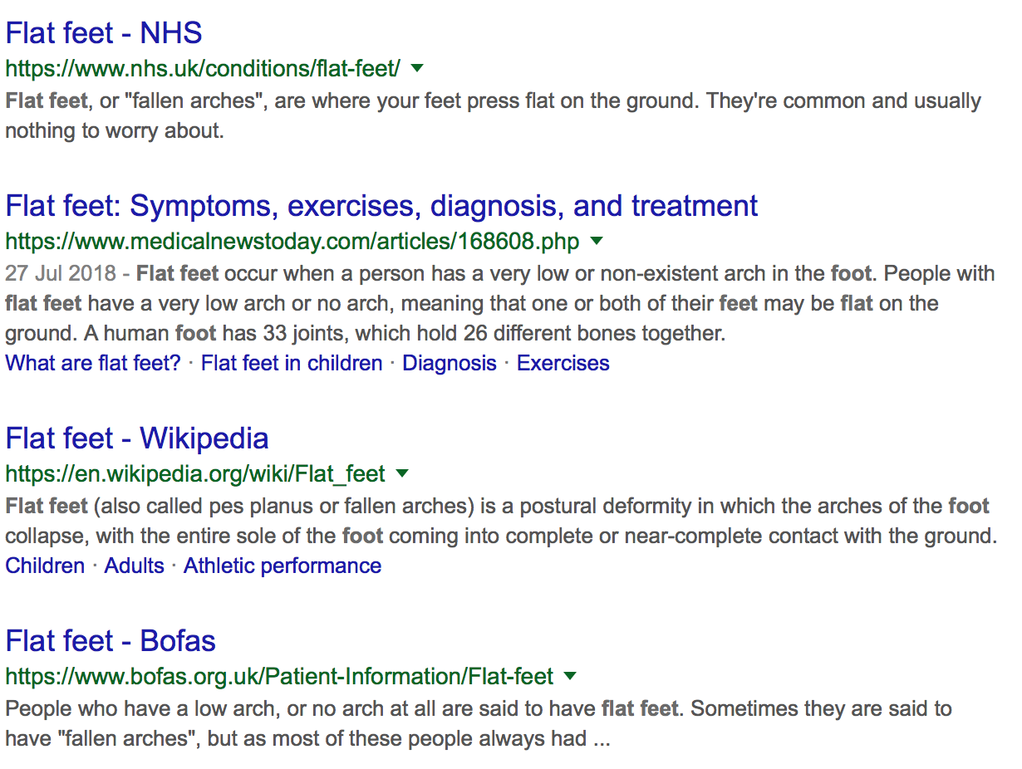
The question you may need to ask first is how reliable is the information you seek? Haruko Obokata, a researcher from Japan was found guilty of falsifying data when writing about stem cell research. This was an unusual case as the report went viral in 2014. What you write can be what you become! But in so identifying information the value of that information has to be analysed. Retrieving a statement which fits with one’s enquiry is helpful until you find the method of data collection flawed or ranks rather lowly in scientific circles. The rankings have been consistently viewed as a pyramid, the top replicating the more reliable methodology. The link to the University of Canberra provides an overview; evidence based practice in health.

Claire Shaw of the Guardian (2013) says it has been reported that the UK produces considerably less research than the USA but "punches above its weight as a research nation and reflects the underlying well-roundedness and high impact of UK research across most disciplines."

Scientists in the healthcare field today are rigid over many principles. For the most part this is incontestable. We have to have scientific writing standards as we have standards within our clinical practise. However, the Case History or anecdotal story still has value and should not be dismissed. Case quizzes in ‘Podiatry Now’ have become popular and have a good education value. The case history provides observational experience and the learning value can relate as Black Box awareness. The downside of the case history will always be the potential for lack of impartiality.

The hardest thing of all is to find a black cat in a dark room, especially if there is no black cat; Confucius

Selecting the source

There are Podiatry Forums but these have an invitation only policy as they are in-house. The value of citing material may be limited although as a straight read different views are highlighted. If you are reading only for personal interest, then fora and social media articles (posts and blogs) are probably a useful way of finding questions, but without references to peer reviewed material one will need to be cautious.

“Google, Yahoo!, Bing, and Ask.com are by and large effective search engines for helping lay users get health and medical information. Nevertheless, the current ranking methods have some pitfalls and there is room for improvement to help users get more accurate and useful information. We suggest that search engine users explore multiple search engines to search different types of health information and medical knowledge for their own needs and get a professional consultation if necessary.” Wang, L 2012

Figure 1. Typical internet search with Google

It is important to start off with the question and reject anything that does not relate to this. Pruning down the lists from your preferred search engine is important. The question of Peer Review will inevitably crop up and it depends how well screening is conducted. Not all Peer reviewed articles are reliable and even a review panel can be biased toward their own ideas.

Let us look at ‘FLAT FEET’.

You want to produce a new information sheet for your patients so you may have an objective target. NHS information websites are written by clinicians but are generally simplistic with little academic detail. This may be helpful for your own clinical information leaflet. Figure 1 shows the top searches accessed 31/10/18. Amongst those listed, The College of Podiatry fails to appear although BOFAS, the orthopaedic foot interest group, although credible is limited to generic information alone. Credibility is one of your first requirements.

Never be afraid to ask new questions and challenge old ideas

The next question you need to ask is, is this enough information? It may be that you seek to consider the value of orthotic management against a question such as, should the arch of the foot be treated and what happens if it isn’t? You could go back to the search engine and refine your question; should flat foot be treated? The key or focus words are flat foot and treatment. The ‘should’ will help if an article contains the focus words. This leads to another quick ‘google search’ and up comes material like ‘Quora’.
The Quora article is based on replies, some from podiatrists, but this is only a forum and cannot really be taken as hard evidence, only opinion. In this case the sources are US and so the language is loose. We come back to Claire Shaw’s article above.

As a professional clinician you are likely to need harder evidence. That evidence means it has been tested by a recognised process. Newer journals such as JFAR can win out with open access. The serious reader however would use more than one foot journal and this is a principle taught on BSc courses. Electronic references will have a digital objective identified, or ‘doi’ reference and can be used in citations instead of the formal year; volume: page numbers format, e.g dx.doi.org/10.1016/j.jor.2014.01.004. This allows for fast access to a journal if you are connected to the internet. Reflective Podiatric Practice (RPP) uses several methods and the hyperlinked underline is a fast way of offering more information. Some of the RPP articles are Peer reviewed, but not all because like social media articles there is a strong desire to share information. At the other end of the spectrum the value of established reliable sources such as the Cochrane Library and NICE are regarded as important open access sources. An insider’s insight into literature searches appears a useful resource and dated 2016.

In putting together a lecture in Tel Aviv a few years ago the subject hovered around myths around flat feet for the author (DRT). The source base from a University on-line library indicated Shekyhi-Dolagh et al (2015) as a viable reference. The material supported contentions about evidence of orthotic value for flat feet. This however did not answer the question about whether flat feet should be treated, but rather a different question arose around ‘can any orthotic be used for flat foot?’. The question dictates the search and hopefully drives the answer. Furthermore, you may not have thought to change main focus until you carry out a so called literature review. Never be afraid to ask new questions or challenge old ideas. The ‘research paper’ may direct us to equally interesting papers that the author has chosen and this is why references are so important.

Authors and contributions from the literature

Journals today still allow large numbers of author submissions but there is a ground swell trying to set stricter criteria by which an author can have his or her name at the top. In the case of Kubota, nine authors share the top line from 2 orthopaedic departments. It may seem as though everyone who is employed is cited. We can of course shorten this to Kubota, M, Ohno, R, Ishijima, M et al 2015. Wang’s paper cited in this article has three ‘Wang’s’ representing 50% of the authorship. An author should have contributed significantly. Design of method, literature review, part of the writing up, being part of the actual practical research and collecting data, interpretation of tests and of course undertaking the crunching of data form the contributory work load of authors. Mostly, the first name holds the key to these elements but if multi-skills are required for a paper then mixed disciplines seem reasonable. Those assigned to papers are all technically responsible for the content in a legal sense and should ensure probity surrounding the original features of the work. A similar case arose with Schiffer et al 2013. This retrospective review of injection therapy was at the 5+-year period and so could have been out of date. There was sufficient detail to provide data but not submitted for publication. While Schiffer produced an abstract attributing four authors, Shibata used 7 for a case history. The value or chance that seven authors could produce equal value is unlikely, let alone in a case history, but today multi-authored papers are growing not receding. There is no doubt that a hierarchy exists but everyone wants their name on a publication. There are rules about author name inclusion. The Economist offers more opinion on the subject of ‘Why research papers have so many authors’.

Plagiarism

The biggest controversy lies within plagiarism which is an academic crime and can in certain cases lead to being stuck off a professional register. Plagiarism is of course important to avoid when writing, but recognition of the so-called rip-off work is important although the subject of this article is critical reading. The case of a registered nurse heard at a Nurse & Midwifery hearing makes for unpleasant reading.

Abstract
Most readers will look at an Abstract or Summary heading up a paper first. This first paragraph of any paper functions similarly as ‘the blurb’ found at the back of a book, teasing us to read more. In scientific circles this represents the paper in brief and allows the reader to consider the relevance of the material, the strength of the construct and decide the quality of the research. Reading an abstract of 200-500 words probably consumes little more than five minutes. If the abstract looks good, then download the paper.
Some articles are only published as letters or as abstracts alone e.g Potter & Aiken 2007 where there was only an abstract was available to define callus classification. While this makes reading easier than having stacks of papers, the downside is when there is no body of study, only the abstract given at a conference.
Dangers of using the abstract alone

At a glance the abstract/summary may have results but the discussion will be superficial and details found only in the body of the paper. The references used cannot be assessed from the abstract so assumptions might be made. It is easy to criticise a paper as much as extol the value of a paper erroneously. Submitted as a thesis or serious piece of work could leave the author savaged for lack of probity. It is okay to pass over papers directed by the abstract, but it is bad practise to use abstracts within a formal body of work and NOT read the paper in full.

How many papers do you need in order to draw a conclusion?

It is a question of identifying material that fits the research or clinical question. A default of around 5-7 years depending upon the question, diagnosis and treatment may offer an unofficial guide. However, looking at original works can be helpful as there are a certain amount of ‘Chinese Whispers’ that arise from one publication to the next over the years. Original works are helpful to ensure interpretative slippage does not arise. Old data can be unreliable. Tollafield & Price 1985 published a paper thirty years before a reworked (2015-16) version by the primary author. The difference between the studies was too great to compare, but the original paper, provided a useful reflection. Podiatric research has matured as the profession has moved forward, underpinned by an improved scientific network.

Some papers fail to check source accuracy. The problem arises when there are hundreds of papers and overcoming legitimate copying of similar material. A good paper, with a well researched background forms the introductory element of most papers. It is tedious to see the same material regurgitated but patience allows a few nuggets to appear when all the papers are placed side by side. Meta-analysis has become popular and offers critique over different papers taking some of the hard work out of searching. Meta-analysis will search thousands of papers and find the elements that allow better comparison of scientific value. But, do we always need the scientific approach?

New treatments, where tested, that offer insufficient data or are limited to single studies should be avoided unless you are the researcher involved in raising such a treatment regimen. Such studies form a ‘pilot’ and popular where data is limited. It is easy to be caught by new product previously untested without a control or blind. While someone has to be the first, ethical guidelines limit the scope of some treatments.

Most papers will use literature reviews in two key places. The first is in the introduction. This considers relevant past material and sets out the ‘why’ new questions are being asked. The second part comes mainly in the discussion where reference to findings reflect strengths and weaknesses from the evidence gained. The author of the research paper will consider his or her findings against the findings of others. Conversely the discussion may be used to suggest previous hypotheses are no longer likely to be sustained.

There is no considered maximum length for reference citations. The quality of the references form the most important marker to assist the reader identify how the piece of work was composed. A paper that reflects on literature alone is a popular theme for both BSc and MSc theses but lacks personal collected data by the author. The case history offers more in regard to clinical observation. To answer the question, ‘how many papers are required?’ is clearly not one that has a simple answer. Enough to cross check different ideas and attitudes is critical. Pastides et al (2012) and Mahadevan et al (2015) looked at a similar question on neuroma evaluation and came up with slightly different answers. Both were important observations but because data size was small in both studies (40-50) the reader could make inferences by using two studies aligned to each method. We need to consider numbers further under data and design.

Data and design

Is the population representative?

The defining issue of any research is the methodology that was used to collect the data. One reliable test of methodology for any reader is to ignore the outcomes of the study be they positive or negative and just go straight to the research question which is usually framed in the last paragraph of the introduction and then onto the methods used to collect data. Read and consider this first before going on. Then ask yourself these questions:

For a study to be of any value, the data must be representative. To be simplistic, it is no good claiming that the effect of orthoses in children with flat feet is being studied if some of the study population are over 16 or even older. Likewise, if outcomes in diabetic foot ulcers are to be studied, the population must be diabetics and not some diabetics and some patients with peripheral vascular disease.

Generally, the more homogenous the study group the more representative it will be. The best possible surgical research would have a large group of the same sex patients presenting with the same symptoms and of a similar age. For example, women in their 50s, complaining of first MTP joint pain associated with moderate hallux valgus and no second toe involvement. If such a group was then randomised to receive one of two procedures that would inevitably produce some robust results.

Were there enough patients in the study?

The sample size is critical. If the sample size is too small it may be impossible to determine a trend or obvious outcome simply because the intervention was not repeated often enough to create a trend.

Alternatively, everything in life can happen by chance and the size of the sample is critical otherwise the outcomes could simply have occurred by chance. The probability value is a way of establishing if the outcome occurred by chance or if it was a real and likely to be a repeatable event which would happen time and time again if you were to repeat the same experiment in the same circumstances countless times. However, the probability of chance versus ‘real’ and ‘repeatable’ relies heavily on the sample size being adequate. The sample size must be calculated using a so called power equation. If the power of the study is not shown to be calculated it greatly diminishes the reliability of the study findings. As a rule of thumb we would suggest that studies should never have less than 30 participants.

Was the data analysed before or after the intervention?

If the outcomes were studied long after the intervention, then this is called a retrospective analysis. An example of this would be measuring the range of motion of the 1st MTP joint after surgery. If data was however collected before the intervention, then it would be a prospective study and there would be a record of the range of motion of the first MTP joint before and then after surgery. Clearly the prospective study is going to give a much better insight into the effect of the treatment and how it improves or doesn’t improve a stiff arthritic joint. Retrospective studies that ask the participants to try and remember how much pain they were in before treatment and later state how they feel now, form a particularly poor method likely to provide unreliable data and outcomes.

Which statistical tests were used to analyse the data?

The purpose of a statistical test is to provide a summary of the trends to be found in a pile of raw data. There are a huge range of statistical tests available and generally readers feel comfortable to see reference to the commonly used tests such as the t test or the Wilcoxon test. However, the statistical test must be selected on the basis that it is appropriate for the type of the data being analysed. The most basic criterion is the normal distribution of the data. In statistical terms normal refers to the bell shaped curve graph where most data points are found around the mean value. 95% of the rest of the data is found within two standard deviations of the mean. But some data sets do not fall within this normal distribution and the so called parametric tests cannot be applied to such data. The best designed studies will briefly explain why the statistical test used was the most appropriate. Failure to do this is a weakness in the study methodology and potentially undermines the conclusions of the study.

How long is the follow up?

The effect of treatment may be brief or more long term. Some interventions are intended to cure or at least provide long term relief. Clearly, complete relief of symptoms would be the preferred outcome for all treatment but this outcome cannot be established if follow up is short. Moreover, some interventions, such as surgery on the foot will give rise to a litany of short term problems such as swelling, wound healing issues, joint stiffness and shoe fitting difficulties. There is little point trying to measure the outcome of any intervention too early and gain a realistic impression of the success or failure at such an early stage. It is now conventional with some surgical methods to allow at least two years for follow up. However longer term reviews will give even more information about issues such as the development of secondary problems like osteoarthritis in adjacent joints.

An example of the value of long term follow up

In a study of the rotation scarf akin osteotomy for the treatment of hallux valgus (TEK), one of the outcomes measured was the need to remove internal fixation. It was found that over a 9-year period 25% of cases had to have the fixation removed from the first metatarsal due to backing out of the distal screw. This was a great surprise not least because nothing previously published had indicated such a high incidence of fixation removal. Patients are universally disappointed when metalwork has to be removed because it requires a second operation. The incidence of metalwork removal has now become an important part of the consent process for hallux valgus correction and all patients undergoing rotation scarf akin are now advised they have a 25% chance of needing a second operation to remove their metalwork.

Conclusion

The reader will wish to ensure that any selected material on a subject matches their own area of interest. The design of a formal paper provides a useful layout as in an abstract, introduction, method, results, discussion and conclusion. The importance of the reference section should not be underestimated. Each section allows a quick dip, starting with the abstract. If it is data you need then reliability is important, knowing how it was collected. We rely on the honesty and integrity of the author which as stated when commencing this article shows that even esteemed researchers may bend the rules. Reading is no different to writing in that reliance on work produced by clinicians must demonstrate some type of standard. Whether it is an article from social media or from our own stock of high quality peer reviewed journals, you want to feel comfortable in the assumptions being made.

References

The on-line sources were accessed December 2018

Horman College. How to avoid plagiarism. https://wagner.libguides.com/c.php?g=27318&p=168076

Hu J.C Why do scientists Commit Fraud? SLATE 6.08.13 https://slate.com/technology/2014/08/fraud-in-stem-cell-research-japanese-biologist-yoshiki-sasai-commits-suicide-at-riken.html

Kubota, M, Ohno, R, Ishijima, M, Hanyu, R, Sakai, K, Sugawara,Y, Ochi,H, Muka,H, Kaneko,K Minimally invasive endoscopic decompression of the intermetatarsal nerve for Morton's neuroma https://doi.org/10.1016/j.jor.2014.01.004

Mahadevan, D, Venkatesan, M, Bhatt, R, Bhatia, M. Diagnostic accuracy of clinical tests for Morton’s neuroma compared with ultrasonography. J. Foot & Ankle Surgery. 2015; 54:549-553

Niche Science & Technology. An insider’s insight into literature searches. http://www.niche.org.uk/asset/insider-insight/Insider-Literature-Searches.pdf

Nursing & Midwifery Council Case of Sesay H R. Conduct & Competence Committee Substantive Hearing. Misconduct- Plagiarism. https://www.nmc.org.uk/globalassets/sitedocuments/ftpoutcomes/2015/apr/reasons-sesay-cccsh-40725-20150408.pdf

Pastides, P, Ell-Sallakh, Charalambides, C Morton’s neuroma: A clinical versus radiological diagnosis. Foot and Ankle Surgery 2012; 18:22-24

Shaw, C UK ranks above US for research quality in government report The Guardian 6.12.2013. https://www.theguardian.com/higher-education-network/2013/dec/06/uk-ranks-above-us-research-quality

Shibata, T, Yoshimura, I, Kanazawa, K, Hagio, Tomobu, H, Monokawa, S, Nagatomo, M, Naito, M. Neurectomy for Bilateral Morton’s Neuroma. A case report of a Male Patient. Journal of Am. Podiatr Med Association 2016;106(3);229-234

Schiffer, G, Chan, O, Jalan, R, Padhiar, N Retrospective review of injection therapy in Morton’s Neuroma. British Journal of Sports Medicine. 2013;47: e3

University Canberra. Evidenced Based Practice in Health. https://canberra.libguides.com/c.php?g=599346&p=4149721

Wang, L, Wang, J, Wang, W Li, Y, Liang, Y, Xu, D. Using Internet Search Engines to Obtain Medical Information: A Comparative Study. J Med Internet Res. 2012 May-Jun; 14(3): e74. Published online 2012 May 16. doi: 10.2196/jmir.1943

All articles published can be cited. Some papers are accessible on-line via the website ConsultingFootPain but are also available on request by any non podiatry party.

Next issue: Evolution of the UK Foot Health Profession
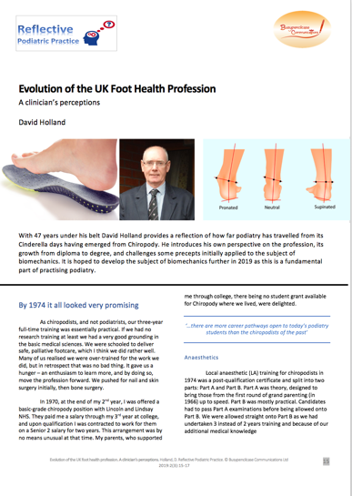

Please do not copy or share the material as the copyright is held by Busypencilcase Communications Ltd.
All registered podiatrists can have regular copy at no cost and only have to sign-up.

