Podiatrists promoting their product

Thanks for reading this information. If you want to provide an article to go in the self-help book please submit using Word, or attach a file containing information that you have found helpful. The aim is to include anything that can make a patient’s life better. Providing information promotes your practice and the profession. Give aways = publicity + communication + more business.
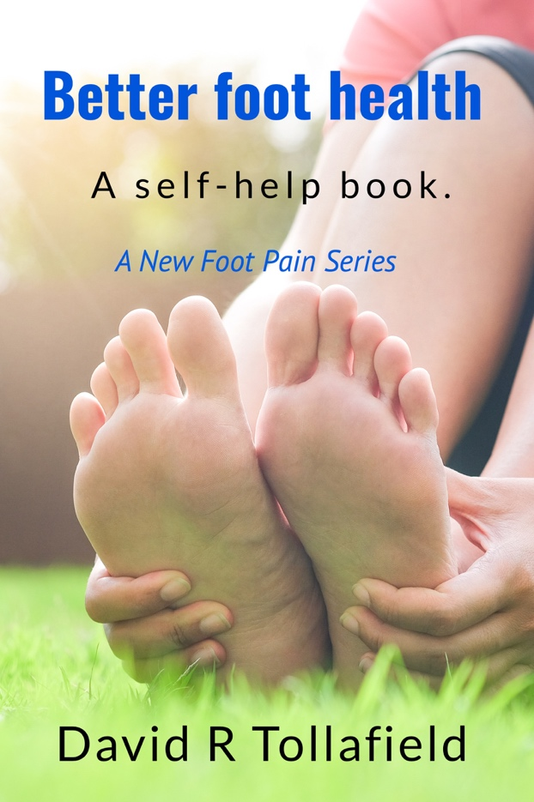
The contents will include the following but more can be added. The size will be 20,000 words.

Industrial injury and protection
The skin and foot
Infection
Nails
Heel problems
Toe deformity
Flat foot
High arch
Metatarsalgia
Tendon pain
Arch supports and orthoses
Padding and principles of dressings
Stretching

Your contribution will be recognised within the pages.
Acknowledged if you provide comment and anything up to 500 words.
If you provide more then your name will be part of the article.

Busypencilcase Communications Ltd will bear all the costs of production and publishing. If you supply material from your practice, you can advertise your location and receive 2 free books and be able to market the book to patients to earn money or as a give away.

Until the final galley (manuscript) is in, costs are difficult to estimate but the gain is good with a likely mark up of 50%.

This should be great news for all podiatry practices wanting to provide something for patients. Production in black and white as opposed to colour will be easier to market at a lower cost. On the back of the book a space can be allocated for practice labels. The cover is a mock up and may not be the final cover.

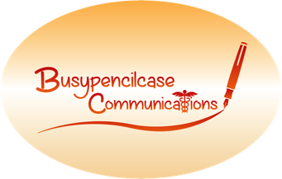
David R Tollafield
Busypencilcase Communication Ltd (Est.2015)

