Reflection!

‘Sorry, I should have been a bit more specific!’
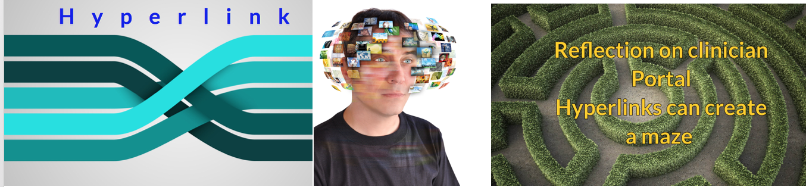
David R Tollafield

Let me start with an introduction as usual…
A colleague wanted to write an article and I realised my message was not clear about what REFLECTION was and how to go about it. It seemed reasonable therefore to produce an article as an example of reflection.
Sticking to one medium of writing is sometimes less exciting so I thought I would try out an audio version, although you can still read the written article if you prefer.
So I want to highlight three key parts to writing an article by exemplar.
FIRST - GETTING CREATIVE. We need to start somewhere. This is a form of preamble to set the scene. Next comes the main STORY LINE (the idea) which in this case will relate to ‘hyperlinking’. Lastly – The CONCLUSION. That might conclude with reflection around the piece written. However, you can reflect throughout, there is no strict formula as long as the message is conveyed. But, you must actually attend to reflection at some point, not leave it hanging.
The aim is to SHOW you how rather than just TELL you how to do it.

So to the first part or beginning;

GETTING CREATIVE
A
blank sheet, a draft title, and a story angle to fit the title. These are the 3 raw ingredients that will kick start an article. An idea, setting up up the material into a start-middle-finish then formatting the piece with headings and some references, if applicable.

The finish part is the conclusion, the part where you sell the story that you have just told. During the writing you should ideally challenge your own answer. In my story I need to ask whether hyperlinks are a good thing or not?

Headings?
‘Good idea. Yes, we need them.’
They break up the narrative and help to balance the story, giving it order as we write.

Style?
‘Well that’s yours. You own the style and if you are happy don’t change it as it’s precious to you. Keep it.’

The subject?
Hyperlinking. ‘But why?’
Find justification for your subject. Any article on reflection should consider your subject of interest. Mine focused on using links within media platforms. However, hyperlinks can take on the shape of a maze.

Rationale
You can go to a link which is usually coloured blue as an external link. This will take you to locations outside of the article such as YouTube.

The angle?
Try and find an angle not written before. You might ask,
‘How can I, I’m not smart enough?’
But you are a podiatrist. Everyday patients sit in front of you. You therefore discover something new every day. A new problem, a new condition, a condition that is not easy to manage. You only need to find one piece to write about.
We need to share material on a wide platform sometimes. There are now more podiatry groups out there than ever so find one you like. One that fits your special interest.
So now you have an idea. You can take information from these help groups.

How complicated?
So, returning back to that blank sheet. It could be any subject so go with one that attracts you, stimulates you, seeks a question you may not know the answer to. Or even one that amuses.
I have underlined the word complicated above so that it has a relevant internal link within these pages. This will help the reader bounce between passages helpfully.
While my colleagues are smart people and can read at a complicated level. Do they want to?

Length
Colleagues often say I can’t write and the number of words seems daunting. — Henry David Thoreau, American essayist, poet, and philosopher says

“Not that the story need be long, but it will take a long while to make it short.”

Words soon grow! This is almost Churchillian. So how long should you make your article?
It needs to be long enough to tell the story.
‘So What’s too long?’
It should be long enough to answer the question but not disorientate the reader.
You could ask how short? then I would say as an editor, our articles for reflective podiatric practice are generally between 1500-3500 words.
Try not to turn an article it into a long tweet. Interestingly tweets often use text language, make little sense and rely on, guess what, hyperlinks…
…Back to style and how complicated to make your story or article?
Is there a happy medium? And, what makes a happy medium?
Happy is the audience that wants to read what you write. So a subject has to be interesting. An engaging title, catchy even. This works well.
‘HOW TO MAKE MONEY, is interesting. Yes?
HOW TO WRITE, perhaps not so much. There are so many other things better to do than write. Would you agree?’
However, if you want to write, then the motivation is already there. With social media attracted to smart phone videos, we see podiatrists making films with simple techniques. A click away and launch. The world of communication changes rapidly. You just have to be smart to know how, and confidence to not mind getting it wrong.
I want podiatrists to write. While I can help, the story has to be yours, not mine.

I’ve dealt with the preamble or the ‘start’ now to develop the idea in the second part or middle…

THE STORY LINE
To get back to the story line I need to develop the subject of hyperlinking.
We were working on the database called PASCOM. Great if you have heard of it, if not this is not a plug.
My good colleague Tony said,
‘I’ve set up a link.’ I nodded nonchalantly, not understanding the term, let alone what a link could do.
The words were blue amongst the black colours reserved for text, so they were easy to spot. My mouse hovered and suddenly the screen altered shape and before me material exploded as a new image. To be honest the word hyperlink before that event could have related to an episode of Star Trek as far as I was concerned.
What I had not realised was how valuable these hyperlinks were. I saw that Tony constructed them because he had taken the time to learn about Hyperlinks.

I start writing a bunch of factsheets for patients. The NHS team and I build an encyclopaedia over the years and then it becomes custom to add references to such sheets.
Then we had a problem with storage of those fact sheets. Numerous photocopying of sheets soon meant that they faded, and of course became illegible. Then we wanted colour.
Colour printing was expensive and of course finding a colour printer in the Trust was not always easy and when we did have colour, budgets were tightening so we had to be selective.

Podiatry and the website
To solve the endless factsheets being printed a new idea came to me. It seemed logical, create a WEBSITE. Some might criticise reliance on the website concept.
‘You can’t use a website for patient information because what about those who don’t know anything about IT?’
‘What about those who do not have a computer?’
‘What about those who struggle with word sizes; those with A.M.D.’
Don’t forget to write out abbreviations in full first - Age related macular degeneration (AMD).
Okay so we now have two groups. Those that can, those that can’t use IT. We have to ensure that fact sheets and information are available to both groups. I can see a big debate already going around in some minds.
‘No, I’m going to stick to the solid A4 sheet that I can hand out.’
Fine. That’s good. There’s much to commend this, but there’s no way the hyperlink can be used.
‘Let’s move on then…’
We have a factsheet and it has now been installed (uploaded) onto our well designed website. It can be retrieved (downloaded) easily. But how much do we put in? I mean how much factual material should we pack in.
‘Should we put everything in so that we appear exact, or do we keep to the essentials alone?’
The answer may lie in what the fact sheet is trying to provide.

- Details about a condition?
- Details about a treatment method?
- Or what do we do after treatment?

Sometimes it has to be broken down into smaller chunks. This makes for better communication.

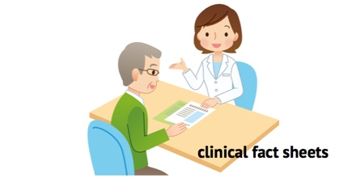

A podiatry team wrote a book that was copied and given to patients before surgery. It was impressive but the information daunting. It should have been the answer to all problems about informed consent.
The website can take a good deal of the dross away by allowing us to build smaller sections that can link to further information as required.
If you use a book it has to be specific for the condition. It needs a content reference section and above all it should not be faded by re-photocopying which is time consuming.
Now printed quality leaflets are different and this is the style used by many organisations. The only downside is their tendency to be brief.
I might have written a couple of books on foot conditions but these reflected common conditions and contained various pathways of care with patient stories.
And now we come to the last part, having dealt with the start and middle, this is the end or conclusion. A place to draw things to a logical close.

CONCLUSION

This article is an example of reflection and comes in at around 2000 words, a good length to cover one key subject.

Benefits
You can write your material and use external hyperlinks so that patients can look at the material as they want or need to. Your leaflet of information can be viewed on the computer, a tablet or phone and so will allow access to other sources. If we use internal links cleverly we can link to other resources that we have written. The idea of writing loads of links instead of references is appealing.
Hyperlinks minimise space on a page. As a method of providing information above and beyond your text, the system is brilliant. I use this all the time when I publish now. Hyperlinks have made my own world easier. Admittedly I am older and a slow learner maybe, but even I can get there in the end. Talking of the end, we need to conclude so let me reflect.
To reflect you have to be open. You have to be open with yourself and ask yourself how could I have missed an obvious fact.
Voltaire wrote;

‘Every man is guilty of all the good he did not do.’

Never feel silly about writing the obvious. I know it isn’t easy when you are young and start out, or maybe older and have lost that passion to do much more than go home at night and retreat from work.
For many the story is not about hyperlinks but there will always be a subject that maybe should be shared to reflect on what happened, how it happened and what influence it brought to bear on your practice.
How did it influence your life? Continue to write academically as there is no better way to show reflection, but bear in mind your audience. Complicated and over technical is not always best.
It is easier to SHOW than simply TELL. A link tells by presenting a new image rather than relying on words alone. This makes it real time.

The major flaw
There is a major flaw with Hyperlinks. Use them too much and you will turn your audience off. Help manuals today are full of Hyperlinks.
By the time you have clicked and linked and have been redirected numerous times, you will need to hit Rx, the abbreviation for ‘prescription’ because for this condition there are no hyperlinks only paracetamol!
There is an eternal feeling of travelling in circles. As Mark Twain says…

Get the facts first, then you can distort them.

Good luck

You can read more articles and blogs on reflection at www.consultingfootpain.co.uk

CLINICIAN PORTAL or if you prefer download the podcast read by David Tollafield

