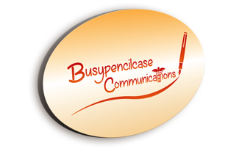

September

Pain Edition 3

Myths and facts associated with the ingrown toe nail
David R Tollafield

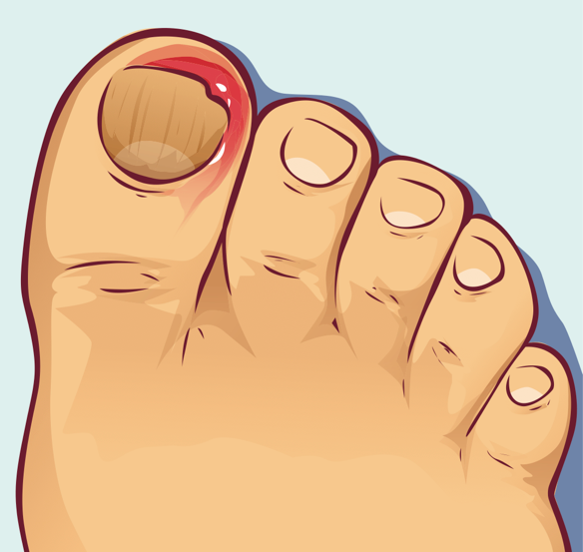
Continuing my pain articles affecting feet it is worth looking at one of the common problems patients seek help for. While the young may suffer from traditional nail infection, no person is free from some type of nail pain risk.
It is a matter of record that surgeon chiropodist Lewis Durlacher treated the Royals. In fact, in his own account he treated George IV for an ingrowing toe nail which predates Queen Victoria’s ascension to the throne in 1937. Durlacher died in 1864 and worked in London contributing to the management of this painful nail problem at the London Hospital.
The provenance of the ingrowing toe nail was a great deal older of course than patients handled by Durlacher, but details diminish with the lack of quality recording. Durlacher was probably one of the founders of modern podiatry in the 19th century.

Introduction
W
hen Mark Walberg described his nail on national TV with Ellen DeGeneres it was obvious that this condition was going to achieve a ‘high yuck factor’!
Walberg who had flown in for the interview with his nail problem is asked by DeGeneres,

‘are you shot up with pain stuff?’
He responds,
‘It’s worn off now!’
‘So now you are feeling it?’
‘I’m feeling it,’ he replies to an audience packed with excited ladies.
‘The energy’ however is helping him he explains to DeGeneres.

Publicity and the nail are bedfellows, often for the wrong reason. The blunt if not misinformed joke, and reference that someone is disabled and inference that they shouldn’t be as, it is only an ingrowing toe nail resonates in anecdote.

As a podiatrist I have had an ingrowing toe nail, albeit mild compared to many of my patients and the inconvenience and discomfort is far from funny.
Whilst training I was informed at my old Alma Mater that you could in fact die from an ingrowing toe nail. This was stretching the true by more than a mile. The only way you can die from such a condition is IF you develop a rapidly spreading infection through cellulitis and septicaemia.
Those with poor immunity are at greatest risk and include patients being treated with powerful drugs to suppress cancer cells. We are reminded that immunity is about having sufficient specialist defense cells to ward of disease.

Naming the beast
Ingrowing toe nail has a number of names. Ingrown is the commonest and suggests part of its origin is growing into the flesh. If you are playing scrabble or want to impress others, you could say I have an onychocryptosis (on-ee-koh-kryp-toh-sis). IGTN for ingrowing toe nail is the short hand version we in the health care professions like to use.
The problem here is that IGTN has many appearances and three types of nail pain associated with IGTN can be described.
In hands we see the ‘Whitlow’, the skin on one or other side of the nail bed is inflamed and painful. A small amount of white discharge (pus) may be visible. I will leave the NHS site to explain the origins of Whitlow (click NHS).
Paronychia refers to the inflamed skin around the nail and common to both toe and finger, so Whitlow just adds a name to provide further confusion. To really appreciate the three toe types of IGTN we need to know a bit of anatomy. Don’t worry I will keep it simple.

Ingrown nail variations
The hard nail made from packed cells called keratin sits on the softer part at the end of the digit covered by the nail plate. It comprises a nail bed and the side grooves. The grooves form gutters that we call sulci (sulk-eye) or sulcus if singular. It is in the sulci that the problem occurs. The nail builds around a small area of inflammation. This occurs due to one of three factors.

SHAPE | The shape of the nail in the groove curves and so irritates the skin.
BREAK in SKIN | The nail is sufficiently thin that it makes a break in the groove setting up a small wound, or a wound that becomes infected or one that fails to heal.
BRIDGE | Lastly and little known is that the nail the grows forward with a small attachment in the groove causing a bridge. Call it sticky nail cell if you want but the nail is inflexible as it grows forwards, albeit slowly, and sets up inflammation under tension.

Let’s deal with each separately.

Shape
This varies widely from almost flat to curved. As the nail sits in the sulcus. The more curved the nail at this point, the greater the pressure against the skin and irritation arises. The skin responds to pressure and thickens as a protective method. As the bulk of skin (callus) increases it causes discomfort.
Some nails are so curved (U.S.A– ‘incurvated’) that the skin is pinched off. The diagram shows three variations. Some people may be affected only on one side. The incurved nail is the most common and will form callus in the sulcus. This has the unique name – onychophosis. If you wonder about the names, anything starting with onycho- means nail.
Hard skin in the groove is not always painful but given the right environment such as a sporting activity that pushes against the great toe, or a pair of shoes that squeeze the nail against the groove and the underlying bone (phalanx), then pain can arise. This is often called by people as an ingrown toe nail. It is not.

Break in skin
This is the true ingrown toe nail or onychocryptosis. The nail edge penetrates the sulcus sufficiently to create two important conditions. Firstly, the skin is inflamed and secondly the wound created cannot heal. The last ingredient that arises is infection.
As the skin attempts to heal, the repair process sets up a weak network of tiny vessels that if disturbed bleed. The colour is red and looks like a cherry on the side or end of the toe. This does need professional help at an early opportunity. Sweat makes matters worse and of course can cause that offensive smell which gives feet a bad name.

The Bridge
Of all the nail conditions mimicking the ingrown nail one remains unwritten about. The bridge is my own reference to the top layer of skin (epidermis) adhering to the nail plate within the sulcus. As the nail moves forwards the resistance of the bridging effect sets up an inflamed state. This condition can overlap with onychophosis but is more likely to be at the start of inflammation or callus build up.
No podiatrist recommends that you try to poke down the sulcus. Maybe it is not as bad as poking around in the ear, but it is difficult to see what you are doing. As ear professionals have specially designed instruments that minimise damage, we use similar instruments. An added local anaesthetic can ease discomfort and make inspection more thorough.

Modern foot care involves being offered a local anaesthetic as a standard today.
You should not experience more pain than needed as you would expect from a dental examination and treatment. If the clinician is unable to provide this service, then ask to see someone who can provide a local anaesthetic in an outpatient location.
Only registered people trained as podiatrists or medically qualified people can provide local anaesthetics.

Treatment

What to look for?
Pain is the give away; tenderness to touch. The red swollen component shows that it will not improve without treatment. Discharge implies the damage is increasing. The lack of healing then is demonstrated by the appearance of the cherry red bulge. The larger the bulge the greater the chronic state. Chronic is our medical language means over a time period nothing improves and the conditions smoulders without improvement. The cherry red bulge is known as hypergranulation.
In adolescent boys and girls, the occurrence is not dissimilar today as both carry out similar activities and wear trainers a good deal of the time. Boys do have the additional unpleasant odour called bromidrosis or pongy feet) more frequently than girls. The smell that arises is due to bacteria living within the sweat and producing chemicals which form the smell. Fresh sweat on skin does not smell.

Antibiotics do not treat the ingrown nail.

Given all of these findings, treatment is no longer possible by self management. Antibiotics are not the correct treatment but will clear up infection temporarily. Nail eruptions will continue until professionally managed. Antiseptics and good cleaning are imperative.
While patients should help themselves to solve problems and prevent foot ailments progressing, there is a narrow boundary between self help and seeking professional help.
You can see that onychocryptosis is not a condition that can be managed without experience. At the first sign of inflammation use a sterile plaster and cover the skin and nail for 24-48 hours. If inflammation spreads, or the toe swells seek help.

When should antibiotics be used?
In truth never. In reality it depends if there is a true infection and whether it has spread. Antiseptics still offer a place to help people offset against mild or early signs of infection. If you are healthy and you do not have uncontrolled diabetes or have immunological conditions then use antiseptics first. Any blood condition where the white blood cell count is lowered as in leukaemias should all be dealt with urgently and antibiotics will be required.
Antiseptics will reduce the bacterial count lowering the risk of spread.
A covering for a short time may soften hard skin and inflammation may settle. If no improvement can be achieved at 48 hours, then do seek professional help.
Antibiotics do not treat the ingrown nail. All antibiotic do is stop the infection for a period. If you are given more than one course of antibiotic by a doctor, then ask to see someone who specialises in managing ingrown toe nails. Today more than ever, antibiotics must be saved for serious infection and not heralded as a cure all.
Unless your infection spreads to your ankle or up your leg, DO NOT use an A&E department. The level of skill varies enormously.
A&E departments are best for saving lives and stabilising serious medical problems and this is where their primary skill lies. Other than this junior doctors are happy to learn on your foot.
The worst ingrown nails include abscesses and enlargement of the toe by x2. This means you have avoided seeking help. See more about surgical management below.

What options are available?
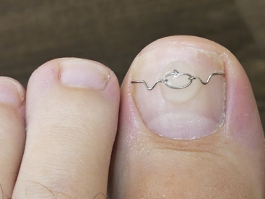

Nail management by reshaping the nail is temporary and can often be carried out without local anaesthetic freezing. The nail is reshaped and the sulcus padded and packed with a soft dressing that remains in place for days to a few weeks.
Thickened skin in the sulcus can be reduced so penetrating creams can be used. Again no anaesthetic is required.
Infection is treated with antiseptic solutions, creams and sprays provided hypergranulation does not need managing.
Tightly curved nails may benefit from gutter protectors which slide into the groove a little like an ear grommet. These should not be fitted when infection is present.
A nail brace has existed for over 40 years. The metal brace and now plastic tensioners can reduce the curvature over many months.
Chronic repetitive infections with onychocryptosis / hypergranulation tissue will require surgical remedy, mostly under local anaesthetic. Where patients show great anxiety, local anaesthetic can be provided with sedation or under general (go to sleep) anaesthetic. Most people tolerate local anaesthetic for majority of procedures.

Who to go to?
When Clare Laxton carried out an audit study between the medical profession and podiatry profession in 1994, she reported that podiatrists performed better than the medical profession for nail surgery results. The group she looked at included GPs, orthopaedic and general surgeons.

Laxton C. An Audit of Forefoot Surgery in Suffolk. I. Epidemiology & Community Health. Conference proceedings from 38th Annual Scientific Meeting from the Society of Medicine, Leeds 14-16th September 1994

As with any procedure you should only have treatment by people qualified to undertake these procedures. All doctors of medicine and podiatrists are trained to give local anaesthetics. Those with fellowship qualifications (higher clinical academia) can offer wider choices. The commonest surgical fellowship is the FRCS and the commonest podiatric fellowship qualification is FCPodS. At the time of writing the registers i.e GMC, HCPC, may not provide any clarification as to the differences with other professionals in the same group.
DO Select people who do operations on feet regularly as part of their normal role and routine.

What is the most common surgical option?
By the eighties the P&A (phenol & alcohol), now referred more commonly to as PNA, or phenolisation, the common procedure being the partial nail ablation, became the primary choice over surgical cutting methods.
The older technique called the Zadik procedure surgically excised (removed) the nail bed and the regrowth failure rate was as high as 50%.
All types of surgeons would have a go as would doctors and junior casualty officers who thought this a good training ground. As a foot specialist I was mortified to see an ENT surgeon having a go one day; but that’s private practice for you!
Phenol is a chemical acid smelling like TCP. It attacks protein of which keratin (nail and skin) is one such material. Other chemicals have included sodium hydroxide but phenol still ranks the number one choice.
The other surgery is known as a Winograd (skin excision) procedure which uses no chemicals. Technically both are surgical and require an anaesthetic, usually by the local freezing method.

Chemical. Advantages | Chemical.  Disadvantages | Surgical.  Advantages | Surgical.  Disadvantages
90% effective | 5-10% regrowth | 80% effective | 10-20% regrowth
Can shower earlier |  | Delayed showering but ok with special cover
Return to activity sooner 3-10 days |  | Activity return 7-21 days
 | Often wet and moist wound | Clean wound
 | Delayed healing | Better healing
 | Deep bone pain chemical periostitis | Better in slower healing & older patients
 | Chemical burn to skin |  | Forms inclusion cyst
Comfortable pain medication minimal |  |  | Pain medication may be needed
 | Slightly great infection risk | Lower infection risk
No stitches |  |  | 2-3 stitches approx. removed at 10-14 days
Primary procedure choice | Avoided in high risk patients due to healing risk & infection | Useful for chemical regrowth

Dressings and care afterwards

Anyone providing care should provide an information sheet about care after nail surgery.

The questions you need to ask might be associated with:

Who do I call or how to contact someone if I am concerned? Should it bleed, what do I do? Do I need pain medication, when to return to have a check up, can I bath / shower, can I dress the wound myself? When can I return to normal activity, sports, shopping & driving, what shoes can I wear.

The PNA can be redressed at home, the winograd should ideally be managed by the clinic/hospital.

What problems to look out for?
Infection, regrowth, skin peeling, inclusion cyst (healing swelling along scar line) and deeper ‘bone’ pain chemical periostitis. This can take 5 months to settle. You will not find this on many fact sheets.
An inclusion cyst is a skin lump that can be painful.
Currently the National Institute for Care & Health Excellence has nothing published as of 1/7/19. The NHS site provides some information but it is very general. Click NHS information

Author’s Note

David Tollafield is a former podiatric surgeon and has treated ingrown toenails for over 40 years. The advice given is broad and may not apply to all patients so please treat this sheet as a guide. Be aware that not all centres can offer surgery or sedation / general anaesthetic.

Many clinicians might say they have few problems but after undertaking many thousands of these surgeries it is not unlikely that problems arise even in the best hands. I have had to undertake repeat surgeries and have known other surgeons have a go first. The worst was five surgeries before success. There is no such thing as simple surgery and none of us have not failed at one time or other.

This information is free and published under the brand name ConsultingFootPain for Busypencilcase Communications Ltd (2015). Information on other conditions is available from the website consultingfootpain@co.uk

Others in the pain series on the website above:
Bunion Pain. Avoid Surgery. April 28 2019
Burning pain in the foot. May 13 2019
Where does foot pain come from? June 20th 2019

Books (available from Amazon)
Morton’s Neuroma. Podiatrist turned Patient. My Foot Journey 2017
Bunion. Hallux Valgus. Behind the Scenes 2019

