May 2019
PAIN EDITION

Pain and the foot
Part 1: What to look out for?

David R Tollafield

Pain is an unpleasant response to something that arises within the body. Men are supposed to handle pain by ‘manning up’ but is often woman that cope better. The truth behind this is spurious as everyone seems to have an ability to tolerate pain differently, which runs through race as much as gender stereotypes. Slow ascending pain is better tolerated and hovers in some ways at a level where the person manages such an unpleasant series of uncomfortable changes. This fits the chronic pain scenario as it embeds into daily life.

Links used in this article worked at the time of publishing.

Acute pain is like hitting the red scale on the high riser (right) and can create a greater response at the time of an event. This contrasts to the lower scale of pain which is more background, perhaps represented by the yellow or green scale. And yet I have had patients walk in with a fracture of the foot and knew nothing about it. Pain is about chemicals, tissue damage, and nerve pathways in the body. Smaller nerves called C fibres seem to make more noise when stimulated than other nerves. So the first thing we learn is that pain is different for different people and pain arises from different sources. Different parts of the body are affected and we need to take time to consider these.

Some types of pain are better managed than other forms and both layman and professional must understand that success can only come from working out what caused the problem originally. By doing this we can predict (hopefully) what the end stage or outcome will be.

Figure 1 shows the high riser or strength machine on the right where red would be bad pain and green okay or none.
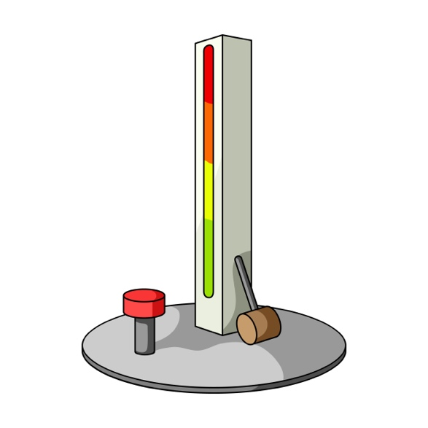

Common questions

Clinicians have turned this whole subject into quite a complex subject so we need to introduce terms such as acute, sub-acute and chronic pain. The definitions seem to focus on length of time so that if the injury causing pain lingers for 3-6 months it is known as sub-acute. Chronic pain pain is characterised by substantial distress or impairment in functioning and lingers until some intervention can help. For the patient reporting pain, the questions posed relates to how long the episode has been going on for a long time, or if there are many such episodes?

We always ask the question how long have you been suffering and what makes it better? Does it happen all of the time or only when you are active? Of greater concern, pain should not occur when you are at rest or asleep.

Signs and symptoms

Table 1: Symptoms

superficial | Knife like | Pressing | Tearing
Sharp | Radiating | Aching | Vice-like
Dull | Crushing | Ripping | Deep
Throbbing | Pulsating | Stretching | Intermittent
Burning | Cold | Bursting | Tooth-ache
Stinging | Buzzing | Stabbing | Pins & needles
While we can talk about ‘type of pain’ it is useful to have a word dictionary for best fit symptoms (Table 1). The terms signs are more to do with what it looks like.

Symptoms
Symptoms can a vary during the course of any known problem where discomfort emerges. The face that cries appears more in pain than one that does not. A patient with an injury who is quiet cannot be dismissed though and the unconscious should be considered more at risk.
For the purpose of this article we do not need to consider the event an emergency at this point.

‘Awful’, ‘worst pain ever’ and’ hurts’, is less helpful than trying to describe a sensation. Looking at the high striker one can only imagine the hammer coming down with maximum striking power on the foot.

Signs
Signs are really what we see: colour red, dark, yellow, white, green, flecked, raised, bruised, open, blistered, rash-like, streaky red lines, oozing, pus like (purulent).

Smell comes into it but usually with open wounds. Bloody, offensive, cheesy (caseous), antiseptic, musty. The symptoms are to do with feeling rather than seeing.

Hearing sounds can help so we hear crinkling, cracking, crackling (crepitations) celery, squeaking, popping, graunching, squeaking.

The idea of describing what you feel, see, smell and hear can be helpful and direct treatment. We also need to know the extent and impact of pain. This comes down to restrictions and when pain arises. It also can be helped by considering the effect you feel emotionally.

Restrictions mean limits imposed by the pain on the foot; short distance, cannot put foot down, or heel or ball of foot, move toes, touch the foot, put socks on, wear shoes, limp across a room, use crutches or a wheel chair.

Impact might allow some activity or restrict activity, it might occur all of the time or some of the time, during the day, during the night. Length of time pain lasts is important. Cannot go to work, able to drive or not offer a significant indication how your life is affected by the problem.

A visual scale, often called a visual analogue scale (VAS) is counted in ‘whole’ numbers and provides a useful indicator. i.e 0-5 or 0-10 or 0-100. No pain equals zero, worse pain imaginable is give as 5,10 or 100. Many clinicians like to have a facial expression added to a chart as in Figure 3.2 and is generally easier for patients to follow.

We can now make judgement about the type of pain and how it affects us so that when attending a healthcare professional you can express your feelings rather more explicitly than before. The emotion of pain is also important and so you may feel shattered, lack sleep, feel tearful, feel nauseous and not know what to do with yourself. The VAS figure provides some sense of impact of the pain in terms of intensity.

In my first pain book series on Morton’s neuroma I suggested that a pain diary could

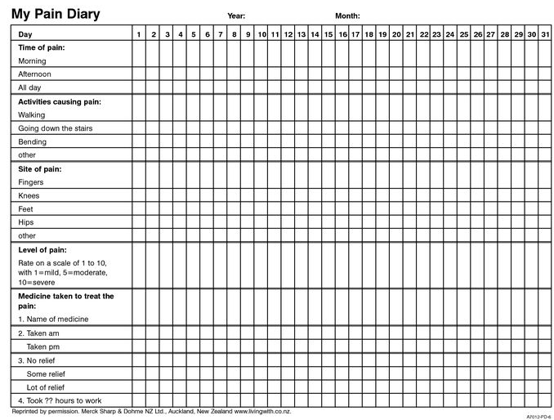

Figure 2 Visual analogue score 0-5

be helpful. Given that your time with some professionals are short, the more succinct you are, the more effective the care might be as
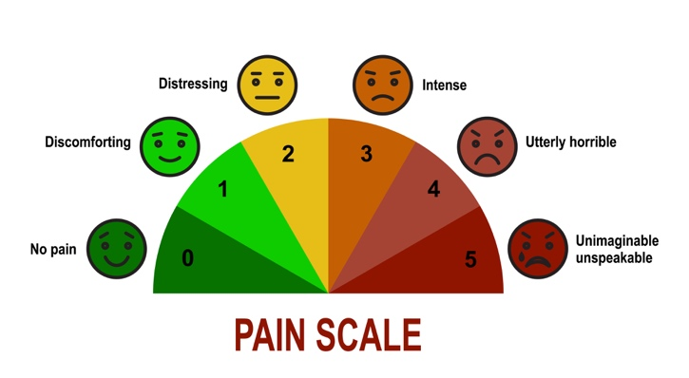
‘How are you?’ or ‘what have you been up to?’ does not mean that you should describe what you have been doing with the family, or your latest project. It means tell the clinician what your problem is and how it is affecting you.

Timelines & Diaries

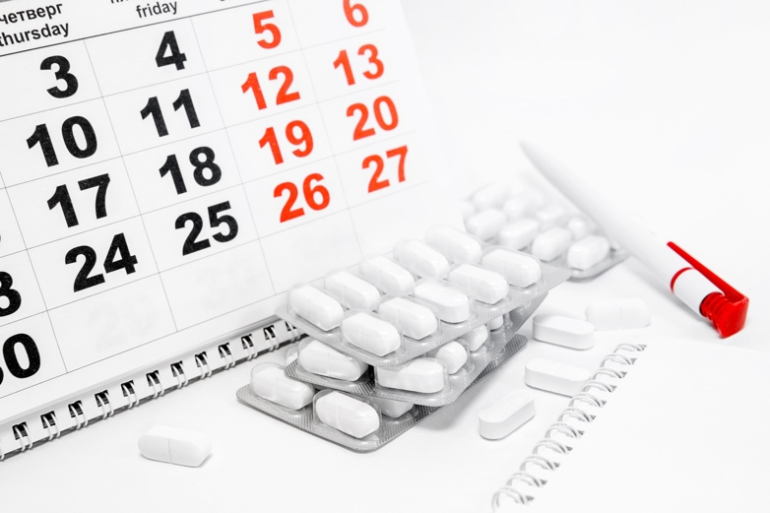
Figure 3. The Diary; simple calendar

While the picture of a table provides an example of a pain chart, Source: Merck, Sharp & Dohme. New Zealand , not all people might wish to use this.

You could use the Excel feature on your PC if you are computer minded and design your own chart. Here are some good points that one author wrote on the internet. I have edited out quite a bit that didn’t seem relevant by the writer who suffered from endometriosis.

I think it provides a personal view and fits in with the philosophy I want to portray in my foot journey books. The post below has been marginally edited.

Example of a patient’s post on pain

“It is a great time to get into the habit of keeping a pain diary. It’s sometimes very hard to talk about pain, and people don’t always want to listen. However, pain diaries are great because they make your pain very visible to people that have no idea how much pain you’re in. Once you realise the benefits from your own self compiled evidence it is very hard for others to deny this exists and it enables you to report on how your pain is progressing. Pain is a deeply emotive experience, but in my experience emotions do not always help you when it comes to getting treatment.

Doctors see pain every day, and they have to keep themselves somewhat distanced from it in order to remain
professional. So while emotions may not always help you in a consultation hard evidence does.

Doctors (any healthcare professional) develop a picture of how you’re doing based on what you tell them and how you impart this information. If it’s filled with unknowns, gaps in your memory, or if you contradict yourself without meaning to it’s so much harder for them to put a finger on what’s wrong.

Our illnesses symptoms actually make it harder for professionals to help. If you take the time to log your pain and develop a picture of what your pain and other symptoms look like it’s far easier for a doctor or consultant to focus on what’s causing your quality of life to reduce.

For me it’s often meant the difference between getting the treatment I needed immediately and waiting months while your consultant asks you to complete one for a few months to help them out.”

This post can be access at https://endohope.org/2015/01/01/the-importance-of-keeping-a-pain-diary/

The points I would highlight can be bulleted:

  - People don’t want to know (or hear) about your pain
  - Our minds often fail to appreciate the timeline (see next section)
  - Getting the best out of your GP is a two-way process
  - We forget so much
  - Trying to resolve issues faster

The second piece of help comes from work carried out by people working with the NHS. It comes as a tool kit but the diary comes under Tool 9 as shown and can be downloaded

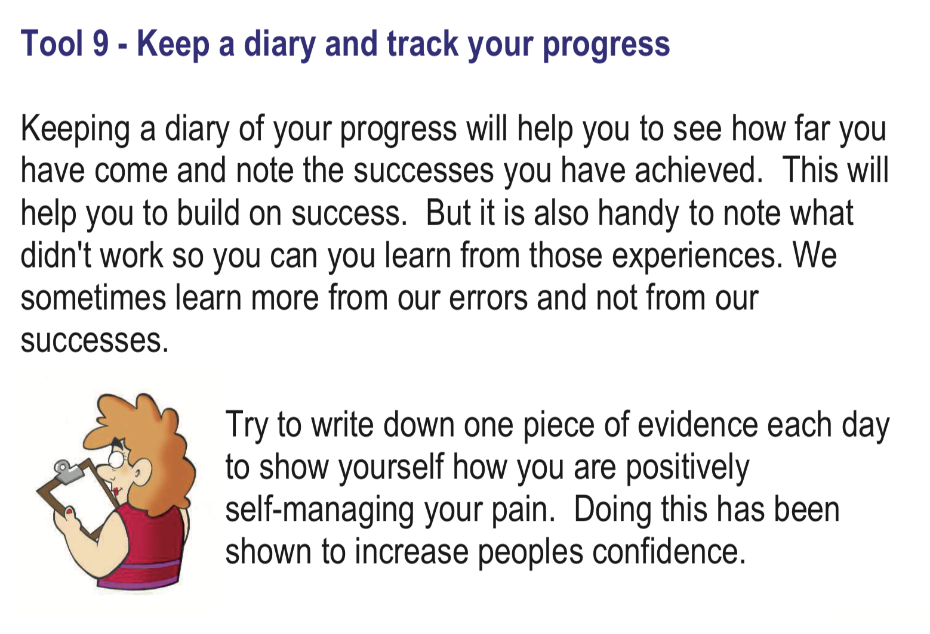

I keep a regular diary and wrote about my post surgery foot pain it in a book called Morton’s Neuroma. Podiatrist Turned Patient: My Own Journey. This amount of detail is not needed for the average patient unless they like writing as a professional author.

Diary: 8th December 2016

Day 3: Better comfort in the night, no extra tablets needed; the stinging sensation lasted five minutes. When walking, the dressing acted like a stone under my foot causing discomfort. I showered comfortably with the LimbO cover; my heel was tender. The reference to my heel was important; I had used the heel when heavily anaesthetised and had favoured this in walking, thinking it made sense without crutches. I now suffered unexpectedly. Because information was not getting to my brain when the foot was anaesthetised, I could not control the pressure applied and the heel soon became bruised with 11.5 stone (73 Kg) loading it. Again the Aircast helped enormously. I found some crutches as well so thankfully I had all the aids required.

Diary styles

The style of keeping a diary might be best as a chart or use a standard diary to keep entries separate. If you prefer you can even download a diary but diaries are cheap especially ones mid year or even the year before. Just cross out the day and relabel. Make notes

- When does it occur?
- Is the discomfort at the same time(s) of day?
- How long after waking does the pain take to emerge?
- Does it come and go?
- What makes it better (or worse)?
- Do you have one or more pair of shoes that make it worse?
- Is there an activity, social, athletic or professional action, that causes the problem?
- Could it be a change in your job?
- Does it happen when you drive?
- Is there a difference if you use an automatic gearbox over a manual gearbox

Case histories

It is probably a fact that we cannot recall when something happened unless it was big. My cousin fell twenty feet out of a window when he was small and survived. The effect of this could have manifested later on, even into adult life. Fortunately, he survived. Injuries do not have to be so dramatic. His story was in the local paper but often minor injury means we recover, ignore the effects which still remain. Scar tissue is the biggest contributor to long term pain problems but no-one can see it early enough.

Consider a 16-year-old boy or girl playing sports at school. An incident takes them off the playing field. A twist of the foot or ankle, a limp for a while, pain settles with pain medication and ice. The student returns to normal and then years later repeats the injury. The damage which was initially mild left a weakness and the later repetition has not recovered so well. This is common to joints and their supporting ligaments. Most people, even doctors, will put this down to arthritis, a horrible term which provokes a label associated with ageing.

The diary associated with the timeline becomes important because it determines the chances of recovery. Human nature assumes all injuries can be returned to former normal function. Athletes are the worst group to ignore the effects and depth of body damage. Both mental attitude, high expectations, need to continue supplying endorphin highs which then drive a return to similar activity and further injury. When the attraction of financial gain exists, particularly in the professional, then the individual can expect payback later in life. Payback comes in the form of chronic long-term pain which may even require medication or surgery.
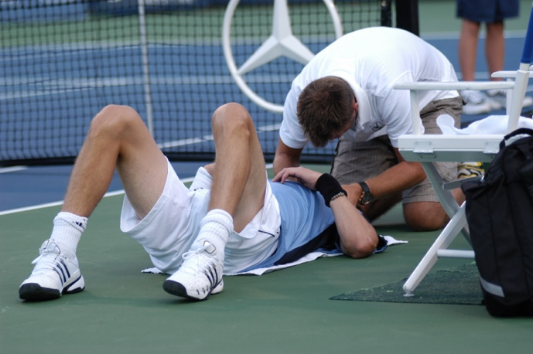

Figure 5 Injuries such as above sustained when young may have longer term implications.

There are certain conditions and tissues which need repair early on and alteration to activities. No-where is this more noted than in the foot and ankle. It would be wrong to suggest this does not apply to other key joints like the knee and shoulder for example.

Inflammation

The last part of the timeline I want to highlight is the effect of treatment and benefit when delivered at the right time. The picture Figure 3.1 shows a blister packet of pain medication. Managing pain is only one element to limit progress. The affected part swells normally. A body reaction preventing movement. It is wise not to ignore this key feature of INFLAMMATION. The first GP consultation often results in pain medication being given. Well you can do that for yourself and the pharmacist can guide you all at little expense and time wasting. When pain medication fails or is used for too long many patients descend into a spiral of despair.

How long should pain medication be used for?

Having assessed your foot for injury and taken other action is needed, let’s assume the pain is relatively invisible, maybe some swelling? Taking pain medication will be preferred because you will find it convenient. If this works and you can carry on that may be fine. Different medications work differently. To keep it simple we can create two categories:

- Analgesic
- Non-steroidal anti-inflammatory

Both groups of medication are available from all types of stockists from garage forecourt shops and supermarkets to the traditional pharmacist. The commonest drug is paracetamol (acetaminophen) but in the UK has a limited supply. Eight tablets taken 2 at a time gives a dose of 1 gram (or x2 500mg). It has a bitter taste and can be crushed with honey to make it more palatable. Paracetamol will cause liver damage if taken in excessive doses. Packets of all these type of drugs have something on them to warn of the dangers and also that you should see your doctor if matters do not improve. The three days on these packets is a good guide as pain should be better after this period. The frequency of taking such medication is clearly stated with respect to age. Every 4-6 hours is the best guide relative to the pain experience.

While paracetamol will help pain, a non-steroidal ant-inflammatory drug will offer pain relief and reduce inflammation. There are two key drugs on the market that are effective. Like paracetamol, some precautions are important.

Allergies can arise with anything so if you develop any of the following stop the medicine

CHECK LIST

- Rashes
- Itching
- Sickness
- Stomach pain
- Bleeding in stools (poo) or urine (piss)
- Breathing problems
- Yellowing of the whites of the eyes

Aspirin is an old and yet understated medicine which is really effective in reducing fever, pain and inflammation. Ibuprofen also has a good track record but there are press reports of it affecting the heart. As we are taking such medicine for short periods most problems are not too likely. Heart burn can arise and if you have a history of a stomach ulcer then seek medical advice before using the medication.

These medicine work by blocking a chemical reaction process within inflammation associated with prostaglandins. The argument about masking pain is realistic because an unwise person does not re-engage in the same activity until all swelling and discomfort has subsided.

Other pain managing strategies

It is easy to think that taking tablets is a solution but generally this is not ideal. Physiotherapy, orthoses, steroid injections, electrical therapies, local application of medication all play a part. Feedback mechanisms associated with psychotherapy have a place in managing pain as well as nutrition, self help and organised support groups. Electrical therapies include nerve stimulation, ultrasound, heat and cold.

Special medications are constantly being explored and used as patches, rub it on medications, often licensed for other conditions but can help pain. One must always be aware of side effects.
Download the simple pain diary grid above here:

In Footlocker next month

Part 2: Where pain comes from?

You can read more at consultingfootpain.co.uk

