November 2018
Special Remembrance Issue

Feet and Immersion foot. Learning from the Great War
David R Tollafield
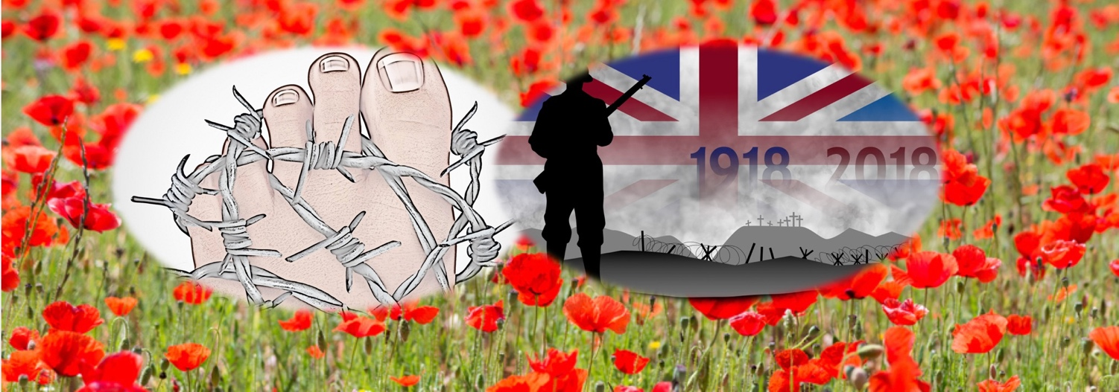

This article touches on the Great War because it was a war that taught us about the devastating effect that simple medical conditions could lead to terrible consequences. One such condition was known as Trench or Immersion foot. It would seem fitting to publish the horrors of this foot manifestation at a time when we are commemorating our memories of World War 1. As I took on a great character for the Axe Valley Players this November, I could not resist the temptation to support our Director, Roy Jones, with some writing of my own. The audience would have been pleased to know that feet had no part in the play.

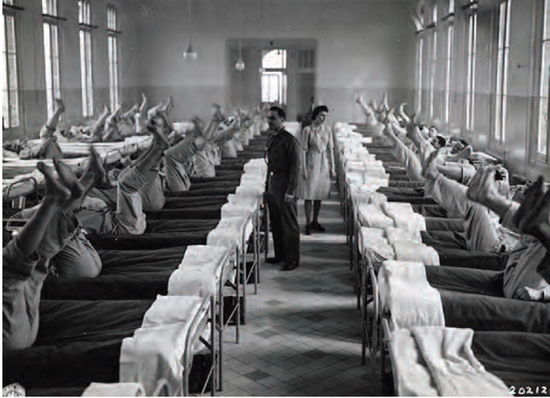
A war to end all wars

It has been generally accepted that medical care in the French army was better than that which existed in the British army, a true fact around the Napoleonic Wars (1803-1815) and the later the Crimean War (1854-6) of the 19th century.

It is hard to escape from 4 years of media coverage that that on Sunday, 11th November 2018, at 11am, we mark 100 years since the cessation of hostilities. It was a war to end all wars, so it was said, and one that was thought to be a short one and indeed over by christmas 1914! Picture on front page ‘Foot inspections in a hospital’, taken from Podiatry No. Ashcroft 2014’

As an amateur historian I have to tear myself away from a strong desire to write more effusively about the mechanics of wars but I must revert back to podiatric clinician, journalist, educator and even part time actor! This year I get to play in the black comedy the role of Captain Edmund Blackadder.
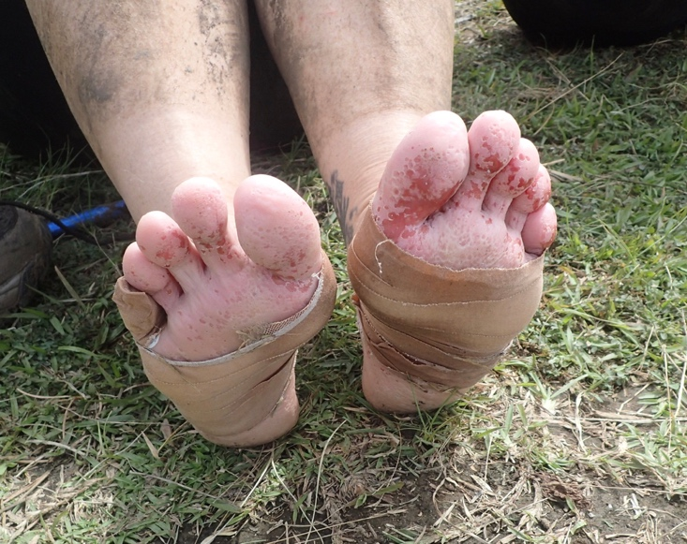

Modern day immersion (Trench foot)

The condition called Trench Foot

Trench or immersion foot was recognised by French army surgeons before the Great War, but it was not just cold that caused the problem but immersion in damp conditions; hot and cold. Twenty thousand British and Colonial soldiers were treated for trench foot in the first year of the war. Ashcroft wrote about the condition in Podiatry Now, the UK College of Podiatry monthly journal. The article highlighted a condition not just associated with war trenches. Battersby (2015) pointed out that the mud baths seen at the Glastonbury music festival had as many as 90 cases of trench foot reported in 2015.

From Napoleonic war in the 19th century to a festival in peacetime we identify with a condition thought to typify the Great War.

I can recall reading about trench foot as a student but I never saw this in clinic although I was to see conditions that had a parallel range of signs. A condition that has some parallel with Trench, or Immersion Foot is Pitted Keratolysis. It is not the same condition but some of the immersion characteristics are similar. Keratolysis is far more common than trench foot and is caused by loss or pitting of the top skin layer but does not lead to the fatal consequences of trench foot. The fact that a sweating condition or hyperhidrosis is the common link and if you forgive the pun, ‘to boot’, both conditions cause a pretty unpleasant, if not offensive odour. This is bacterial infection working on stale sweat and damaging the skin in patches.

Skin damage

During the Great War managing trench foot was an uphill struggle (Simpkin, J 1997). Officers would inspect their soldiers’ feet and it was a crime to fail to care for feet. Specialists did not exist as they would today although a fledgling ‘chiropody service’ was attached to battalions, largely to deal with common conditions that created pain and disability. Soldiers’ footwear impacted on existing foot deformity and changes in skin and nails, and while minor in civilian life, would become exacerbated in adverse conditions. Today, and unlike the US Army, the UK does not have a dedicated podiatric branch within the army medical core. Mr EVG Runting, an early educationalist for what was to become podiatry in the UK, helped many battalions and produced a book giving
advice for essential care (Hardiman, S 2014).

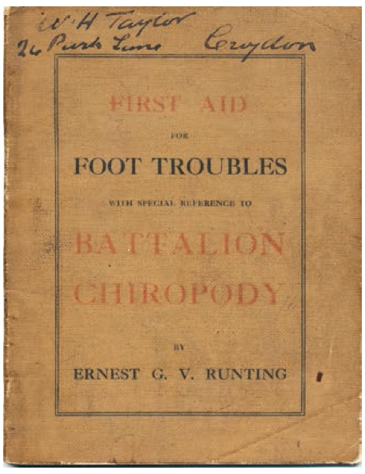

Reproduced from Podiatry Now 2014. Copy held in the archives of the College of Podiatry.

The ventilation of the foot became an important topic for prevention of sodden skin. While this was part of the solution the secondary problem was to prevent bacteria thriving for many microbes thrive in climates where the skin cannot cope well. This includes warm humid areas.
First aid for battalions written by surgeon chiropodist Ernest Runting for the war on foot problems. (Hardiman, S 2014)
The skin is an important barrier to harmful organisms. Once breached, a range of different micro-organisms can get through, challenging the immune system. The immune system is responsible for identifying foreign material and dealing with it promptly, but bacteria do not exist alone in the definition of foreign material. Parasites, fungi, viruses, protozoa as well as bacteria are the general agents of destruction. Even without ballistic injuries from shrapnel and war material these bugs are forever seeking out opportunities to reek havoc. Once the quality of the skin changes, the circulation can alter adversely and feet loose sensation, becoming painful and die off leading to gangrene. Some soldiers were recorded as screaming with the agony associated with trench foot. It was known, in other cases, that a bayonet could be pushed into the skin and the soldier would feel nothing, another deadly sign of deterioration. Soldiers feared the condition as it often led to amputation and a death sentence as there were no antibiotics in 1914-1918.

Materials that make up shoes and boot materials, as seen in modern hiking, would certainly have helped these early 20th century soldiers. However, having to cope with water immersed trenches was principally an Allied problem as the Germans held the high ground and had better designed trenches. The Germans were defending, the Allies attacking, and so it was deemed unnecessary to engineer structures that would last. The flooding of the Belgian dykes did little to help some of the trench system that was thrown up, and cold weather added to the inferior shoe materials and construction used by the troops. Chilling and frost bit were to follow.

Treatment

The men were required to change from wet socks and so carried spare pairs and trench rotations allowed some basic housekeeping, like drying out socks. The average Tommy (a term that came from the days of the Duke of Wellington of Waterloo fame, and a fictional recruit, Tommy Atkins), had leather boots and a bandage like legging called a Puttee. In Hindi this was ‘Patti’ or ‘bandage’ Even Khaki is a term borrowed from the Indian continent. Puttees helped to seal the trousers to the boots but of course while helping were best when dry. Boots often fitted badly and created some of the problems that Runting was trying to educate battalion chiropodists over. Runting was praised by senior medical staff;

‘Surgeon General Sir Hayward Whitehead acknowledges with many thanks the receipt for Mr Runting’s booklet on ‘First Aid for Foot Troubles.’

Many soldiers were given rudimentary education but were not trained to the same level as were surgeon chiropodists. One, James Kelsey, reported on the conditions of feet in France. There were few trained chiropodists at the time and so the army implemented in-house training.

By 1915 the Tommy was smothering his feet in whale fat at the cost of 10 gallons a day. Grease repelled water and helped the skin due to loss of its own natural oils. Once the skin softened the pliable and the usually resilient barrier was exposed to pressure and skin complaints. Smell would have been another problem as leather rots and skin takes the brunt of any bacteria or fungi. Malnourished soldiers were at even greater risk from poor immune defence.

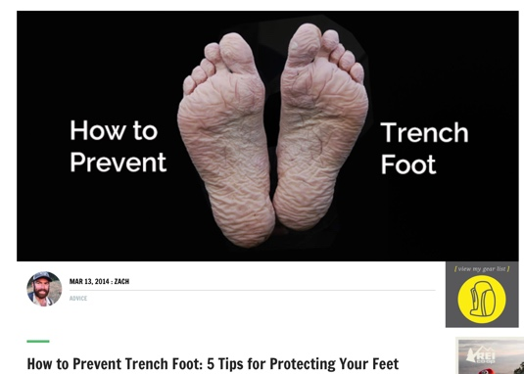
Gum boots were finally allowed, gum being from natural rubber latex and rather different to modern flexible synthetic rubber boots. The linings were unrefined and did little to insulate feet from the cold. Men in these conditions looked after each other and care extended to rubbing feet which helped with circulation and improved skin provided that it had not already blistered. The skin would
‘One battalion, the 49th (West Riding) Division, had the (ignominious) distinction of losing nearly half its soldiers to trench foot (more than 400 casualties) in the winter of 1915.’ Ashcroft (2014)

become raw and blisters would bleed.
Marching distances added to the burden as well as the heavy packs, rifles and ammunition they had to carry in their bandoliers.

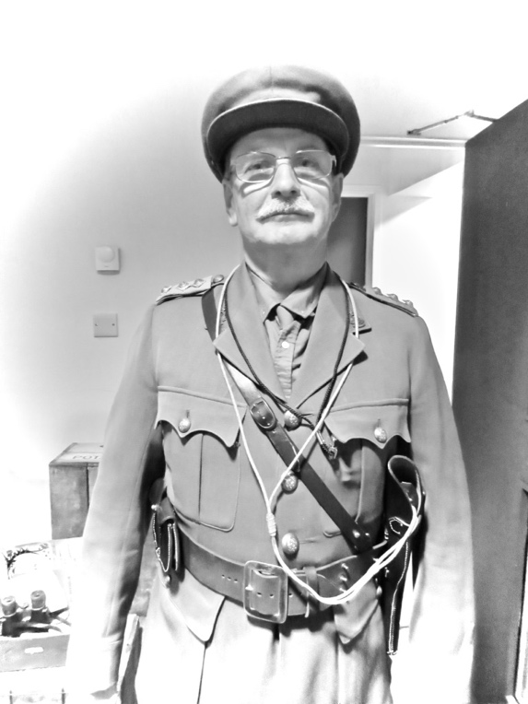

The author ‘without mud’. 10th November 2018. Roy Jones’ production of Axe Valley Remembers. Scene from Blackadder ‘Cpt. Edmund Blackadder.

What can we learn from all these events today?

Modern footwear materials can make a difference, but basic care of feet is essential to avoid calamitous problems. Fast forward to the 21st century where medical care and technology could not be better. Ignorance and overindulgence at poorly located festivals can bring avoidable problems. The soldier will always have to travel to inhospitable places, but it is the government agency, the forces and the government itself that bears responsibility for the welfare of its troops who give their life for their country (and Sovereignty).

Today’s hiker should be aware of the dangers of exposure when setting out into areas poorly inhabited with dramatic weather systems which can alter at a moments notice. For some years, having had an interest in boating in the English Channel I was all to aware of rapid changes to our coastal weather fronts. It is easy to fail to appreciate the effect of weather, cold, humidity and terrain. The foot is exposed but we often pay more attention to the rest of the body.

Zach provided five tips from his trek along the Appalachian trail. There are plenty available website addresses to check out information about modern day protection and health care whilst walking.

Epitaph

As we mark the centenary of one of the worst acts of international involvement I give thanks that my own grandfather and great uncle returned safely from the war. I wear Robert C Blyth’s medals, called colloquially ‘Mutt and Jeff’, with pride this year as I enact a scene from the successful ‘Blackadder Goes forth’.

Who can forget the black comedy of the characters, Blackadder, George and Baldric, but of the feet that suffered, like the real men, this was never a laughing matter.

References

Ashcroft, D Trench foot – Is it still relevant in 2014? Podiatry Now. 2014:17,3(17-19)
Battersby, M. Glastonbury. Medics prepare for cases of trench foot. The Independent 2015:25 June
Hardiman, S. Best Foot Forward. Chiropody Provision in the First World War. Podiatry Now. 2014:17,9(20-21)
Simkin, J (john@spatacus-educational.com) Sept 1997 (Updated 2014)
Morrison, W What you should know about trench foot. Accessed Nov. 2018
https://www.medicalnewstoday.com/articles/320780.php

Footlocker is part of ConsultingFootPain and published by Busypencilcase Communications Ltd. Articles covering information about foot conditions and direct readers to information sheets

David R Tollafield is a retired Consultant Podiatric Surgeon and now full time writer. His publications can be found on his website and his regular Footlocker articles.

Supports the British Legion
Find Military & War Records!

