Communication – a bit about the service

Progress through the art of communication. Let’s promote podiatry together?

Content
Introduction 3
Printing 3
Leaflets and practice information 3
Websites 3
Launching your information off my platform 3
Publishing 4
Reflective Podiatric Practise 6
Editing 6
Other exclusions 6
Prices 6
Printing 7
Articles for Reflective Podiatry Practise 7

Introduction

Hi, I am David Tollafield and my mission is to promote podiatry through podiatrists. I have set out a few ways and to help you better you should complete my form so I have a better idea in the way I can assist you.

Printing

I can assist with this but I am not a printer. I can help with the design but the idea is to support you achieve what you want within your own budget. You write and I will help with editing, re-enforcing information. Help you build the information and support your goal

Leaflets and practice information

This is the major part of the service. To ensure you have the tools tailored to your own practice whether this be a visiting practice, MSK / sports business, general practice, skin and nail surgery or special high risk. The information needs to be top notch so we can present your materials as patient education

Websites

I am not a web designed but have used and maintain my own website. Populating websites with information is the area I can assist with. Give patients information to educate them rather than just promote for business. The softer approach can be just as successful and less imposing as the hard sell.

Launching your information off my platform

If you do not have a website, then any information you want to publish can be freely published on my website for YOUR patient access. There is no catch, but you will be sharing this with the profession. It may be worth checking the College website, www.feetfirst.org

You will be credited for any material you submit but the website will not promote your practice as it does not have an advert intent within the business plan. Remember I want to promote your work for everyone’s benefit. You will own the placement article and can remove it, update it. There can be no copyright because it is accessible on the world wide web.

Publishing

It is important everyone tries to publish a little in their career if nothing else to show they can review cases and literature as part of CPD. There is another reason to publish and that comes down to governance, peer review, audit and evidence that you reflect within your own work. A profession is measured by its publication rate and control over its destiny. You do not have to be a researcher to achieve this end.

I desire for you to publish in the key journals that spread the word about podiatry and our image but not all journals are friendly to submissions that fall outside ever growing high standards. These standards although highly needed are based on the top of the tree research methods. This means there is a research methodology that has a hierarchy. Case reports and studies are somewhere at the bottom. The top of the pyramid looks at randomly controlled - double blind studies with powerful statistics.

We can all undertake percentages, standard deviations and apply the odd test but the market place has changed and that includes podiatry where competition for high quality work is supported by grants within institutions geared for this type of work.

My information sheet is focused on the clinician who may have one or two degrees but will still struggle to find a population of patients, let alone be able to apply a random controlled study with enough sample power. Funding by self is very difficult and so if you have something to ask the question about do it with the College’s Research & Development Committee. All podiatric surgeons must complete some form of research and many tutors of course can assist. Research design is the biggest obstacle and it is so easy to make the project too difficult and broad.

I am sure I have made the point.

- Publish if you can in a reputable journal
- Submissions may require help at the point of design
- If you cannot publish and feel your words are lost, try Podiatry Now.

Podiatry Now, the membership newsletter and journal bulletin, plays a dual role in delivering information and publishing new materials as well as advertising. As a reviewer and writer for P.N I know does not accept all articles, but does like case histories. Their standards have also grown in recent times so you can find your submission rejected. Now this is where I might be able to help.

- Audit article
- Reflection through a case history (histories)
- Clinical comment
- Patient feedback
- New technique and clinical tips
- Ability to offer up to 10,000 words

These subjects are very useful and can be incorporated into my article section for your use.

Reflective Podiatric Practise

This is my home article bulletin publication just launched at the March Podiatric Surgeon’s conference. We have one on consent and another on reflecting on communications in podiatric surgery for those signing up.

Editing

The idea is to have minimal editing, spell checking, content, layout and format. Offensive or critical language used will be excluded and/or rejected. Opinions are best used with references. Read-through will be included. You will be given advice of course if it is unsuitable and help for any modification. Professional re-writes however will incur a charge starting at £25.00 (e.g 500-1000 words) depending upon size and complexity.

Other exclusions

No work is accepted if it is part of a degree submission. If you want to use work submitted to a formal journal you will need their permission to have the article re-printed. JFAR likes publicity and will allow advertising back to its own platform. You can write summaries of your published article without the need for permission as you hold the intellectual copyright or put another way the original material that would have to be written to a journal’s specification.

Prices

Everything is tailor made for you so costs can vary but will not be based on time. New ideas are exciting and I may develop these free for the opportunity to work with you so it is always worth communicating.

Once we agree work is needed, you will pay for this at the agreed amount in advance. If an item is not to your standard you can have a full refund. You are protected through membership arbitration through The Society of Chiropodists & Podiatrists if there is a dispute.

Because the market is changing so will be the variations in demand for different products. Essentially a single or two sided leaflet produced from scratch with artwork and narrative will cost between £35-70.00. I hold a license with a stock art company and can produce professional leaflets to the level of proof.

Beyond this point the decision for printing is down to your preference. Local printer, national printer service or self-publish. The cost for printing and set up is not part of my service unless you request me to organise this for you. You hold the copyright on leaflets.

Printing

I will charge you the cost of standard printing plus 10% handling. When it comes to other products like cards and logos I would recommend sourcing these. Design your own or have a professional design done. There are some really clever, innovative logos for podiatrists, not all with feet.

Articles for Reflective Podiatry Practise

The only cost to you is if you want artwork or imported photographs to make your piece look even more innovative. These start for as little as £5.00 for single artwork / photo. Articles can be anywhere from 500 – 10,000 words. It is recommended using a recognisable format which I can advise on, but includes a summary about what the article is about. A beginning, middle and end, the latter being a conclusion. References numerical in the text.

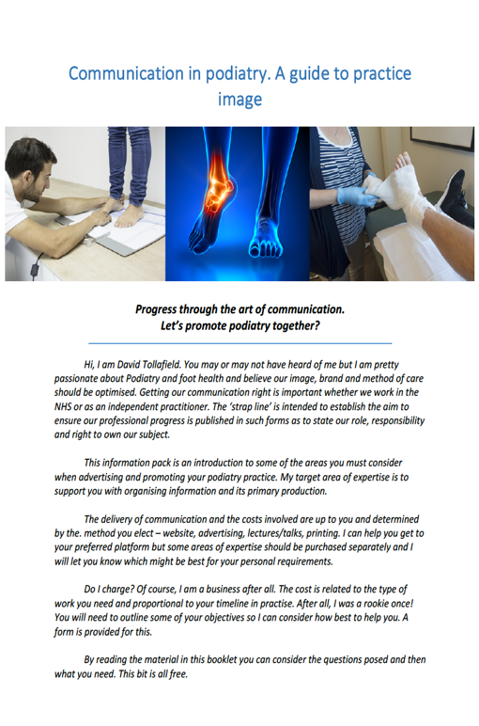
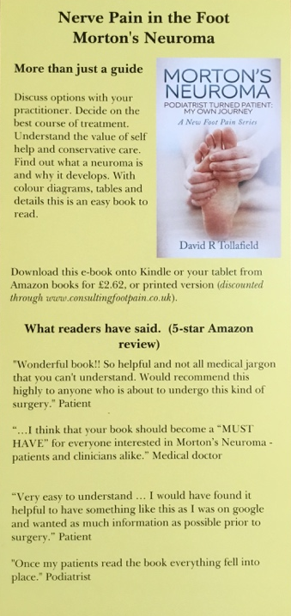
Please see my free guide about
setting up your podiatry practice image and free patient leaflets

